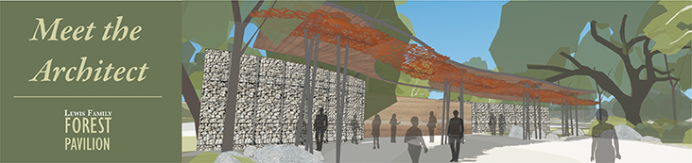
Naming Opportunities
The following elements of the Forest Pavilion + Center for Sustainable Garden have been named:

The Lewis Family Forest Pavilion
The Ann and Richard Walker Classroom
Carl E. Wynn Foundation Event Space
The Scaff Family Gardens

Additional Naming Opportunities are available:

$650,000 Level
- The Name Education and Gardens Complex – opportunity to name the entirety of the project
$125,000 Level
- Support Building – containing green rooms, restrooms, storage for educational materials
and prep kitchen
- Center for Sustainable Gardening – opportunity to name the collection of Demonstration Gardens
and sustainability features
$100,000 Level
- Sustainability Elements – irrigation, water capture features, permeable pathways
- Rammed Earth and/or Gabion Walls – architectural features that define the pavilion space
$45,000 Level
- Sun Demonstration Gardens
- Dry Demonstration Gardens
$25,000 Level
- Green Rooms (2 available)
- Rest rooms
- Prep kitchen
- Educational Storage Area
- Irrigation systems for individual demonstration gardens (4 available)
- Each of Main Access pathway, Pathway to Tongva Village, School Children Access pathway
- Gathering Circle for school children
$10,000 - $24,999 Level - Paving element with three lines of inscription
$5,000 - $9,999 Level - Paving element with two lines of inscription
$1,000 - $4,999 Level - Paving element with one line of inscription
All donors at the $250 level and higher will be recognized at the site, and on the Annual Honor Roll of Donors.

