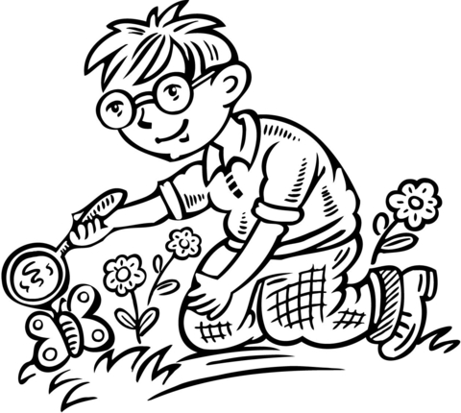
Transitional Kindergarten: Eye Spy
(A one hour walk through the Rancho Santa Ana Botanic Garden)
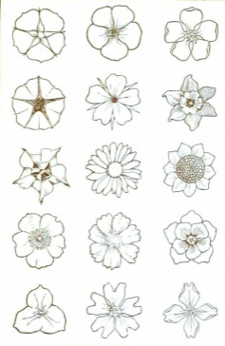
Minds on! Hands On! Investigate garden pathways in search of special plants and animals that inhabit this area. Identify the needs of all living things that live in unique places. Learn your role as a superhero for our planet.
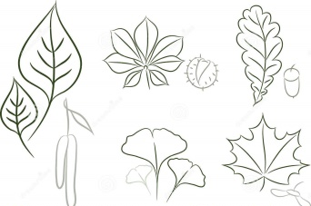
This is an inquiry driven tour focusing on observations using the senses of sight, hearing, touch and smell. Shown garden examples emphasize using higher level thinking skills of asking questions, identifying similarities, and comparing and contrasting key features in animals and plants-(flower & plant color, leaf shape, size & edges, smell).

Highlights from CDE may include:
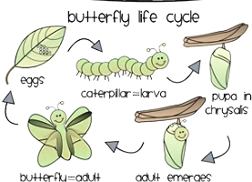
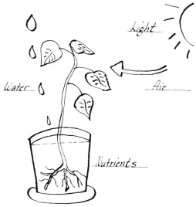
a. Comparisons between babies & adult birds, lizards & squirrels compared to insects (egg-larvae-adult)
b. Note different habitats in the garden- desert, woodland , oasis… (plants & soil differ)
c. Identify the basic needs that plants have- water, sun, space. Humans and others get food from plants & animals and also need water and space.
d. Compare shape, colors and arrangements of plant specimens- leaf surface, bark, leaf arrangement, flowers and seeds.

Resources:
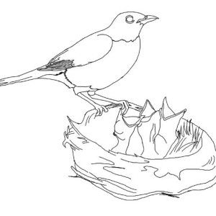
2016 California Department of Education Science Framework
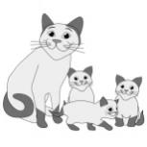
https://www.cde.ca.gov/ci/sc/cf/documents/scifwch2prepub.doc

Preschool Foundations Volume 3 - California Department of Education
https://www.cde.ca.gov/sp/cd/re/documents/preschoolfoundationsvol3.pdf

The Alignment of the California Preschool Learning Foundations
https://www.cde.ca.gov/sp/cd/re/documents/psalignment.pdf
National Academies Press - "Every Child a Scientist"
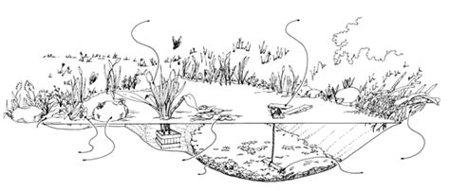
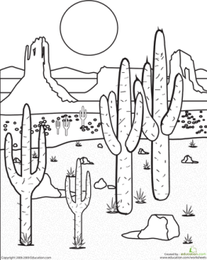
http://www.nap.edu/catalog.php?record_id=6005#toc

