April Fools 2016 — Project Brief

Objective
To produce a fun, creative, and engaging April Fools prank through a parody Champlain College website, shared with the public on April 1.

Goals
Raise the visibility of Champlain College brand through social reach and engagement.
Increase overall positive brand sentiment.
Drive website traffic.
Gain media attention and recognition in higher education publications.

Summary

A duplicate version of Champlain’s current website is created. The page, while still functioning and operating like a homepage, will have the large panel images replaced with photoshopped or handcrafted scenes using marshmallow peeps. The headlines and calls to action within each panel will promote key areas of interest to our target audience, including Burlington/Vermont, Academics, Student Life, and Career Success. Creative copy will be used with marshmallow peep puns. Calls to action within each panel will be clickable and will lead back to the real website and its corresponding pages.

The mock homepage will be shared on social media throughout the day on April 1, soliciting engagement on social and driving traffic to the mock website (and the real site).

Additional supporting parody content such as student profiles will be shared on social channels, featuring peeps (in place of students) and witty quotes about their Champlain education experience. Parody news stories could be written and added to the Champlain College News Blog incorporating marshmallow peeps or a similar theme.

Mockup/Ideas

The mock homepage will consist of four panels, similar in style to the panels currently on the homepage: a large, hero image in the background; a headline, and two clickable calls to actions with copy. The panels will be as follows (please excuse the in-the-car, hand drawn thumbnails):

Panel 1
Focus: Views, Burlington, About Champlain
Headline:
Take a peep at our beautiful views.

Calls to action:
Our radically pragmatic education + Your success = Two peeps in a pod.
Links to: http://www.champlain.edu/about-champlain-x570

Just a hop, skip & a jump to downtown Burlington, VT.
Links to: http://www.champlain.edu/student-life/burlington

Hero Image:
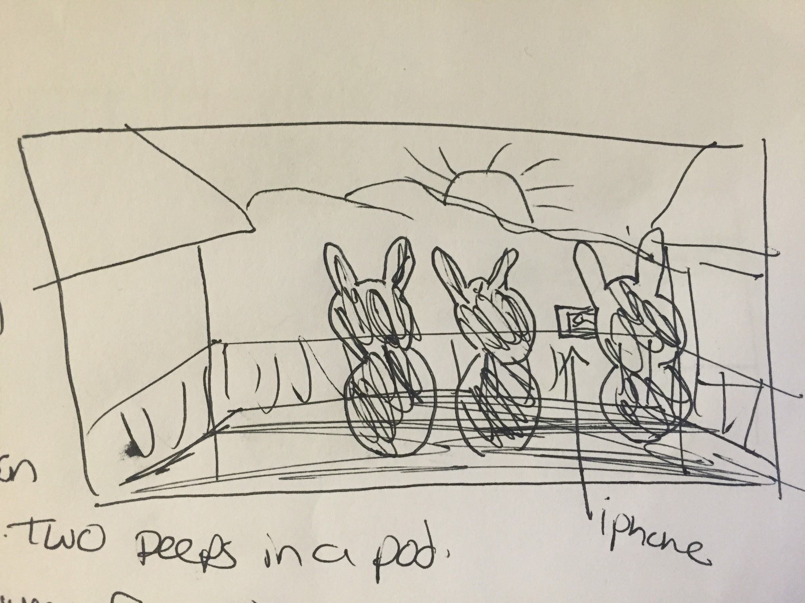
Depicted: Three peeps on library 3rd floor balcony looking at sunset. One has an iPhone taking a photo of the sunset.

Panel 2
Focus: Academics; upside-down curriculum, faculty
Headline:
Engaging academics in a mallow atmosphere.

Calls to action:
Our Upside-Down Curriculum means a no-fluff education.
Links to: http://www.champlain.edu/academics/undergraduate-academics/upside-down-curriculum

Champlain Faculty: Skilled peep-le in their respected fields.
Links to: http://www.champlain.edu/academics/our-faculty

Hero Image:

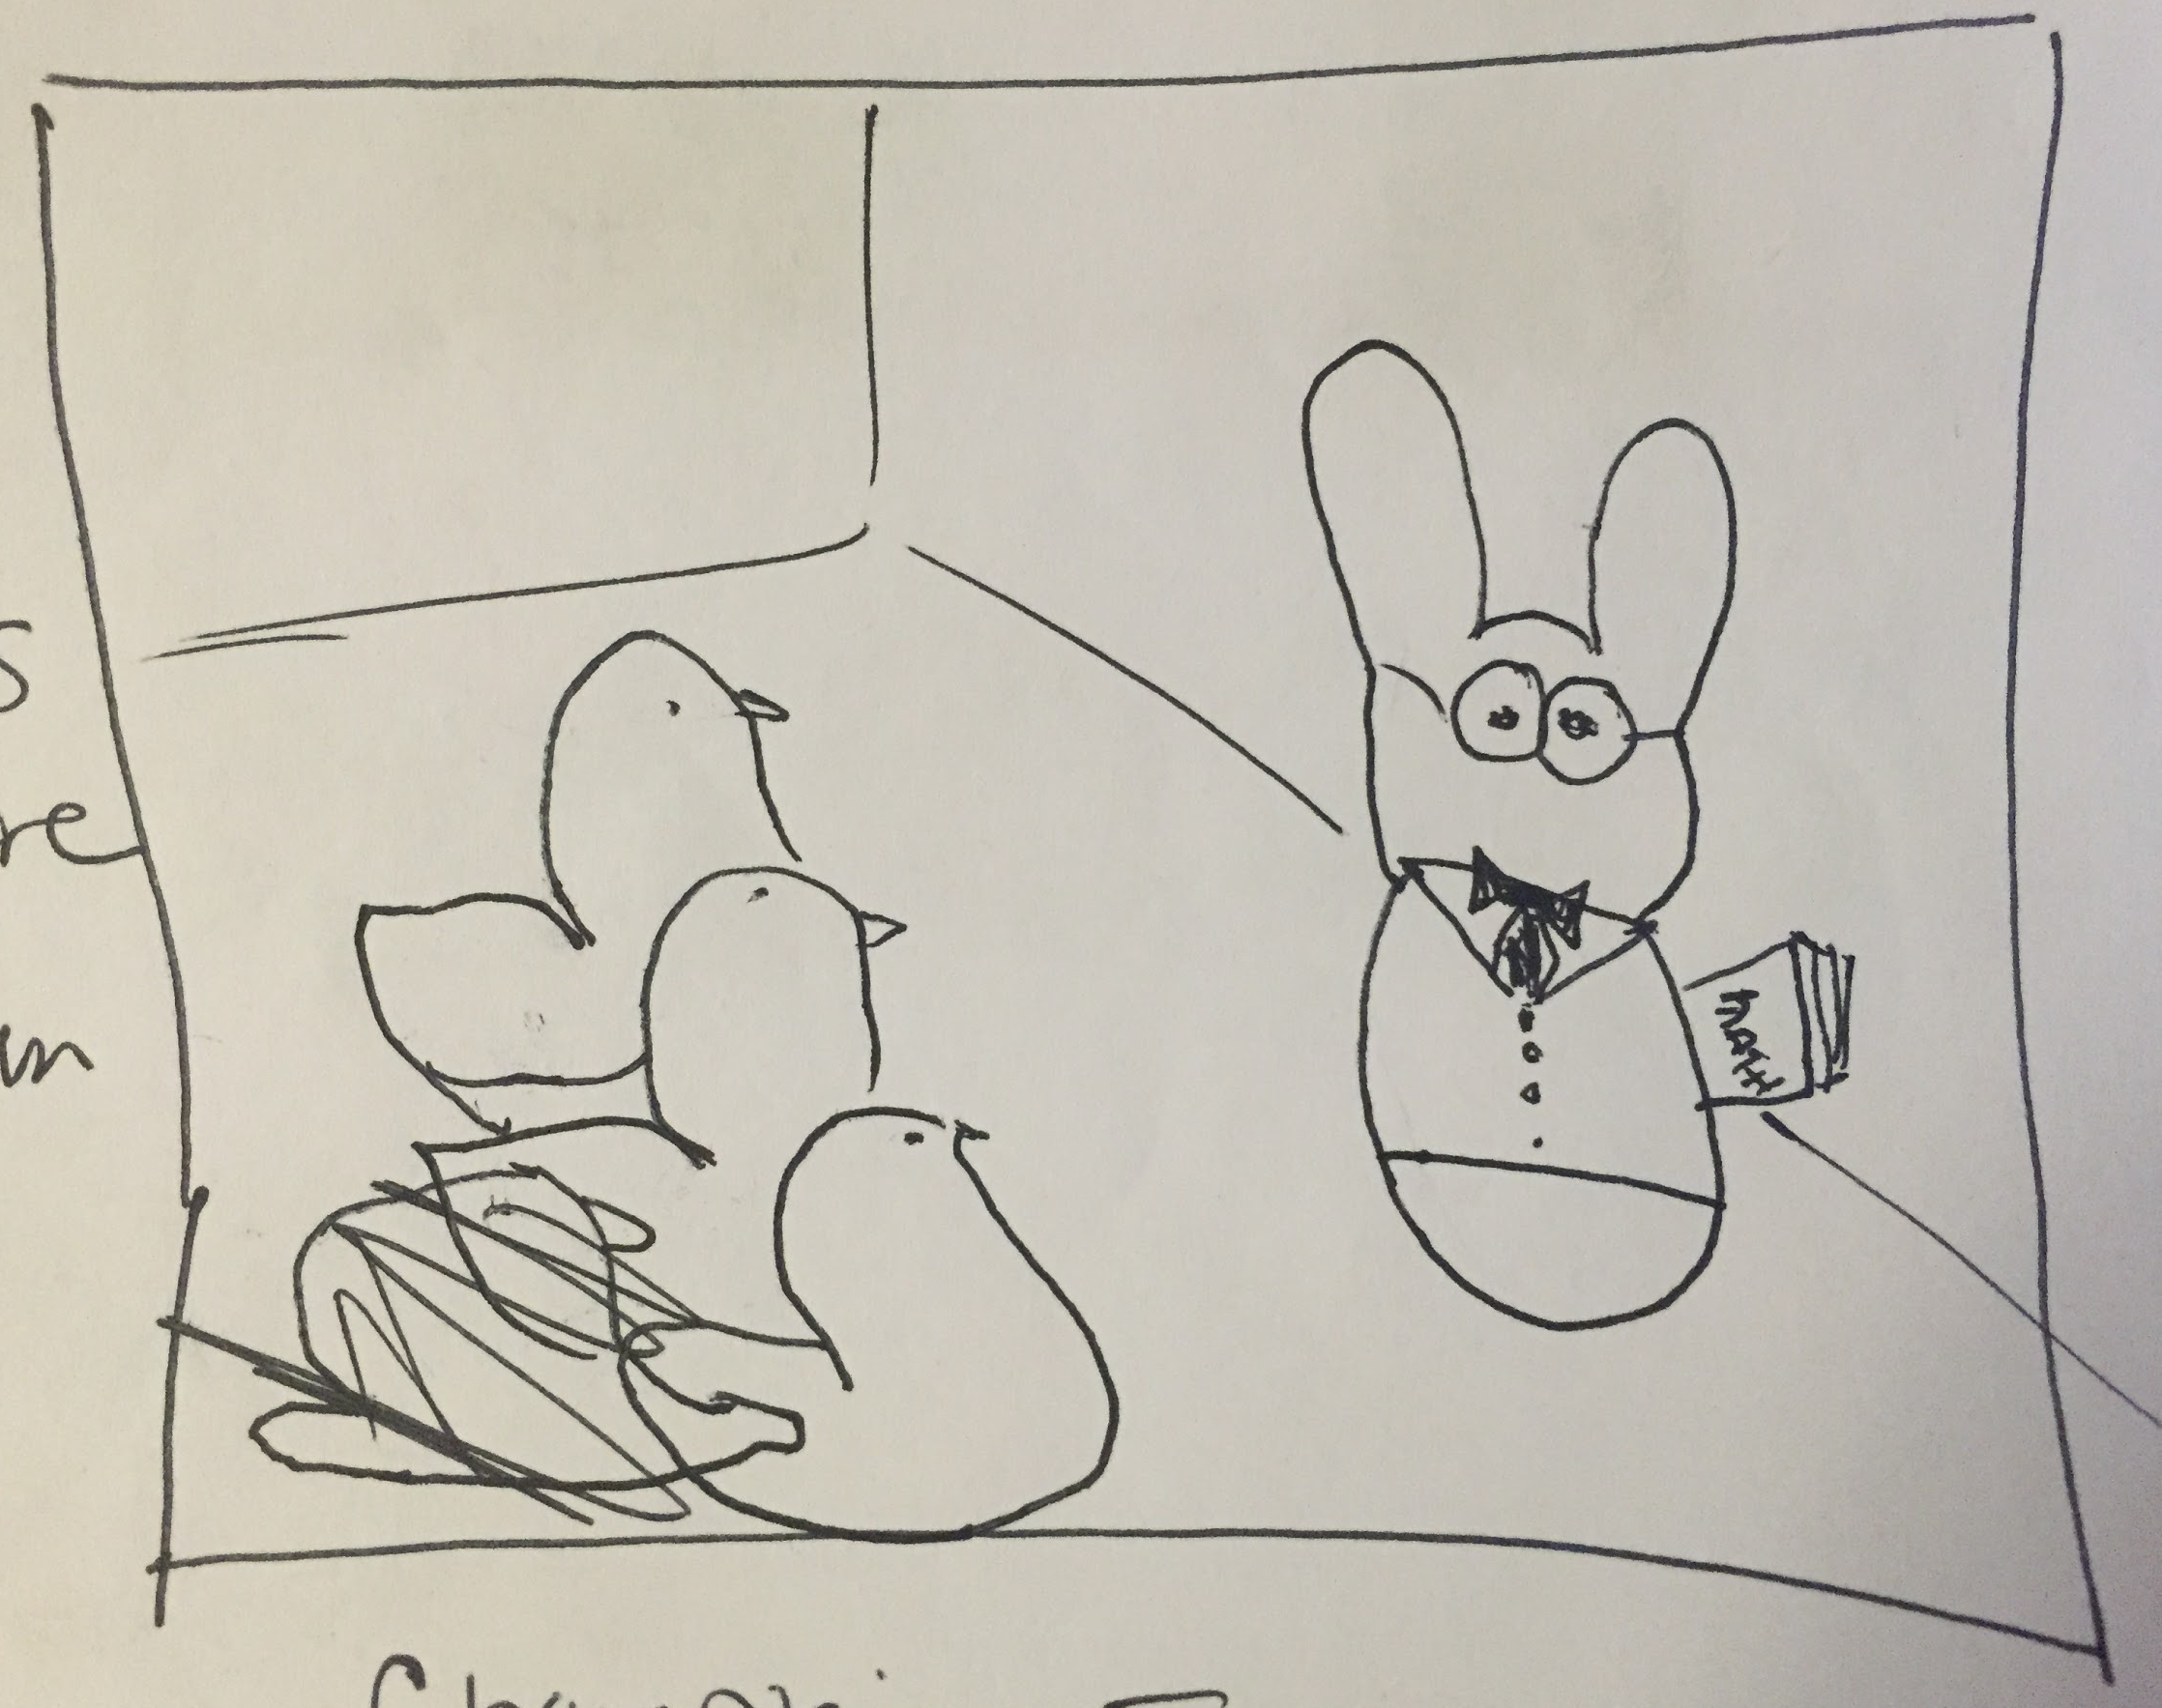
Depicted: A classroom of peeps looks on as a professor peep teaches the class.

Panel 3
Focus: Student life; campus life, residential housing
Headline:
Hang with your peeps on campus.

Calls to action:
There’s always some bunny new to meet.
Links to: http://www.champlain.edu/student-life/campus-life

You’ll eat up our Victorian era mansions.
Links to: http://www.champlain.edu/student-life/campus-life/residential-life-and-student-activities/housing

Hero Image:
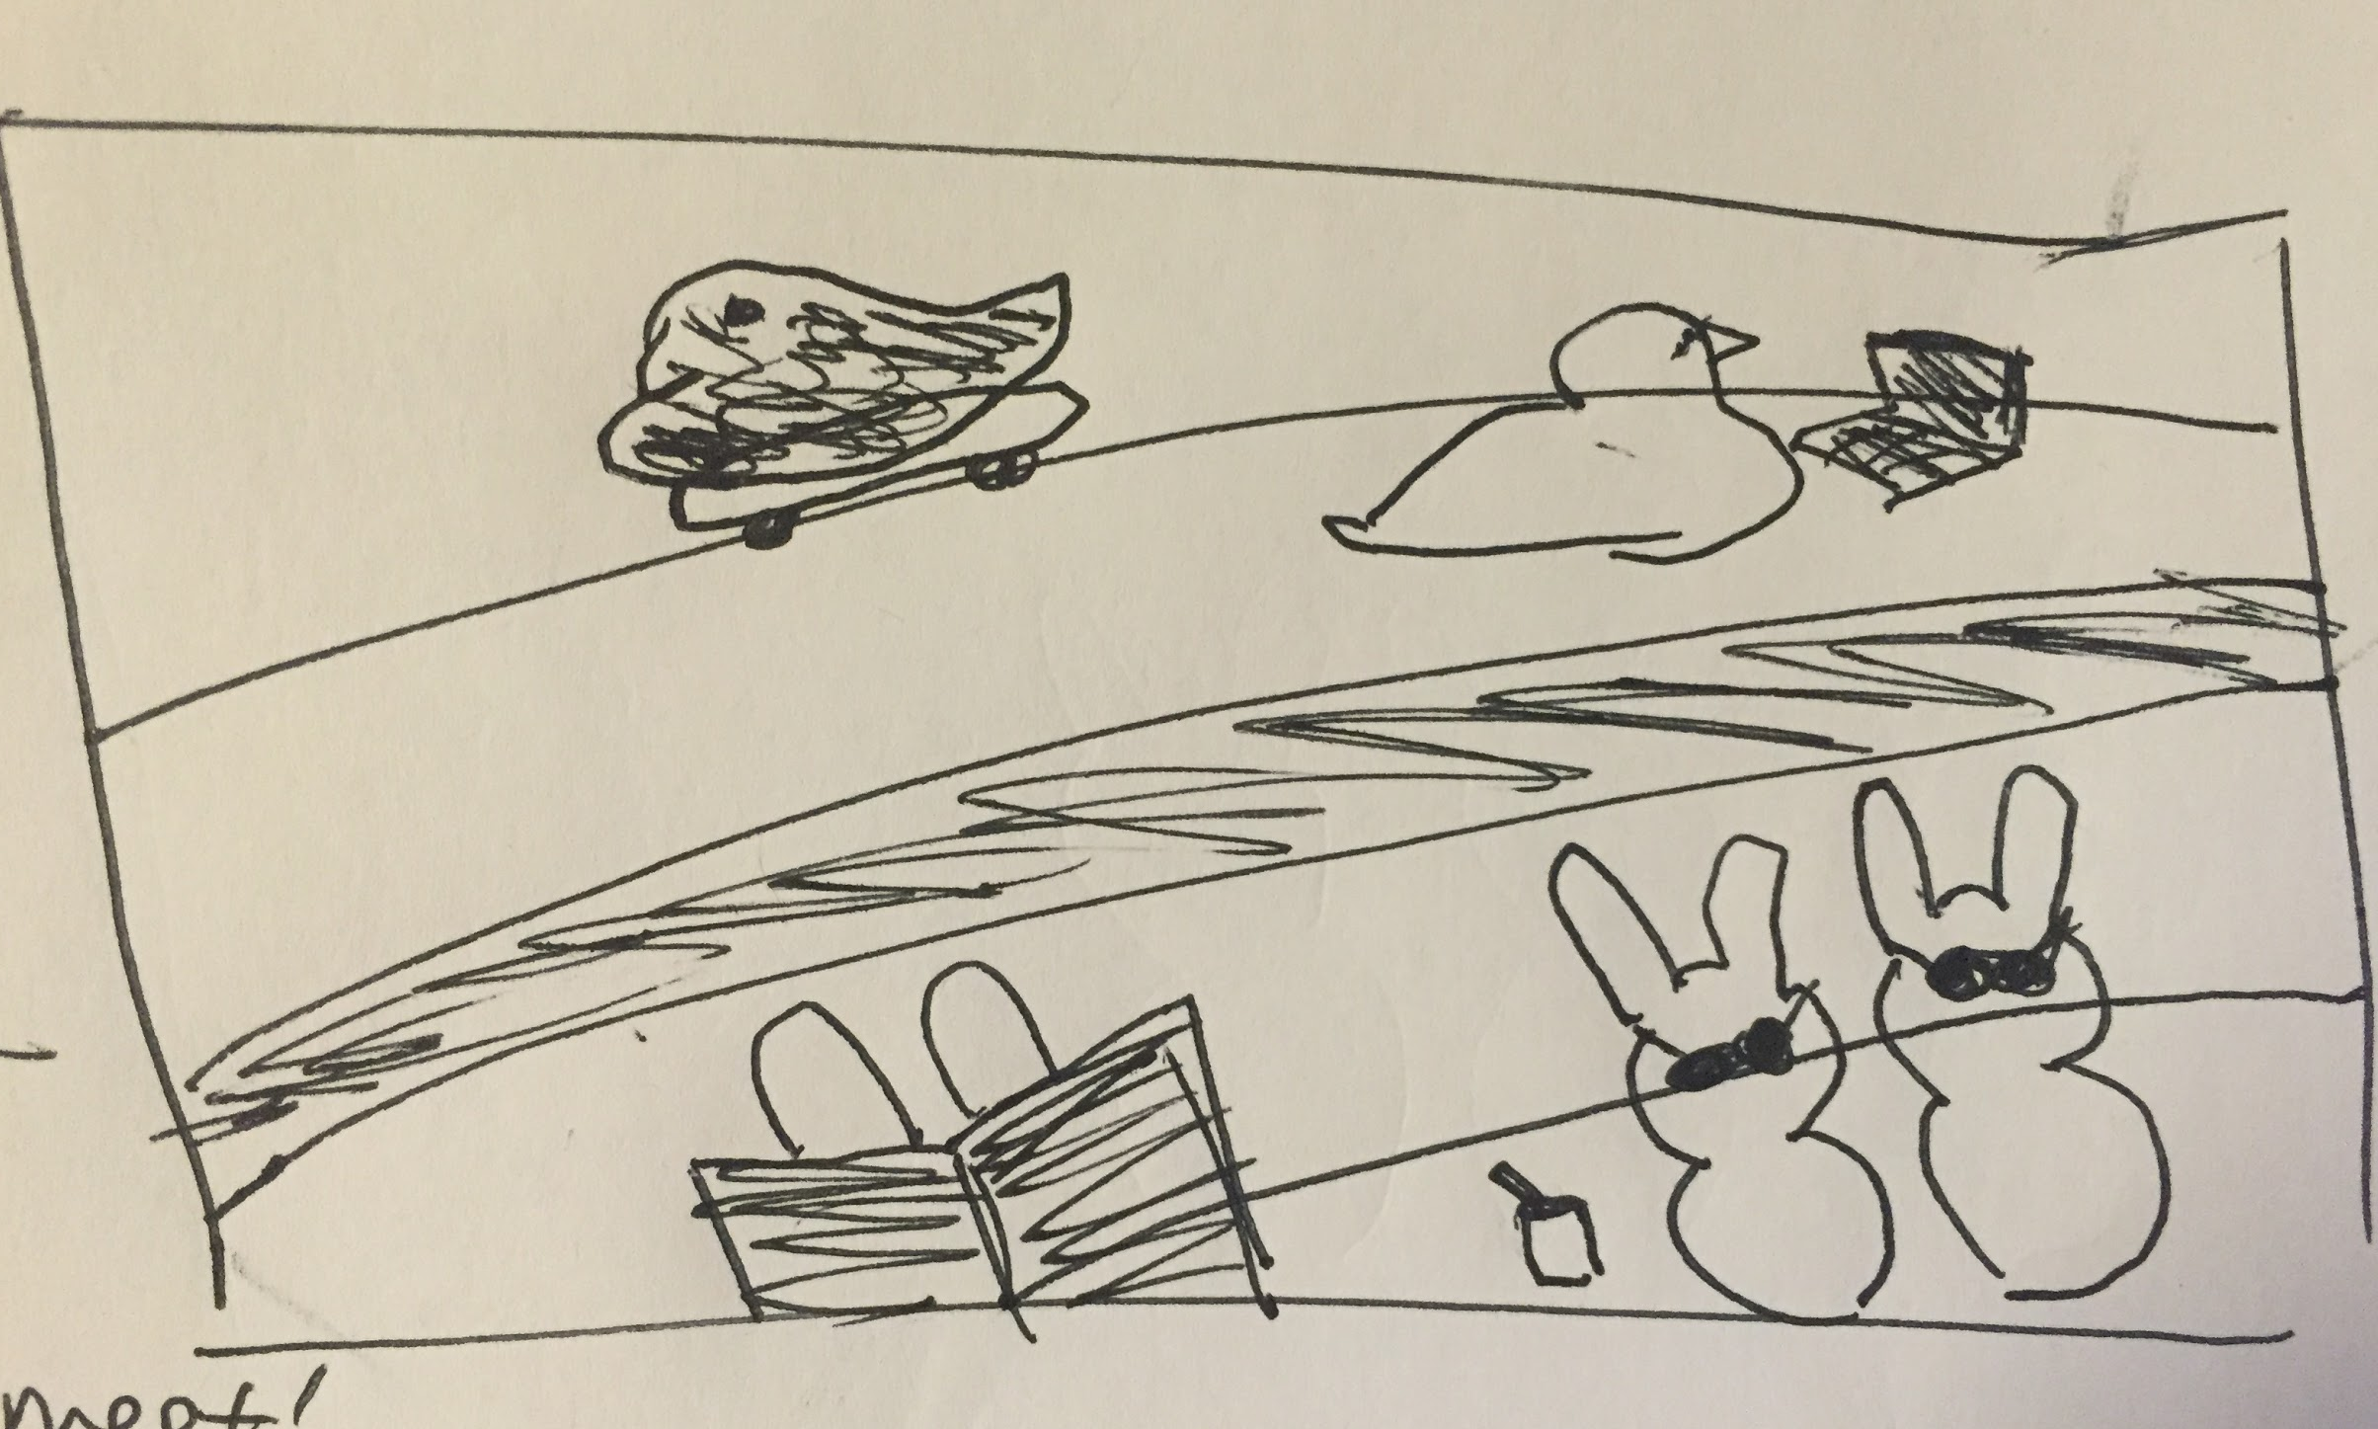
Depicted: A section of Finney Quad amphitheater: a peep on tiny skateboard; a peep on a tiny laptop. One peep reading a large book, with only ears showing. Two peeps wearing sunglasses soaking up the sun. Optional: small selfie stick with the two sunbathing peeps.

Panel 4
Focus: Commencement
Headline:
Hoppy Commencement 2016!

Calls to action:
Our new Career Collaborative is sweet.
Links to: http://www.champlain.edu/career-success/career-collaborative

You’ll be peeps & bounds above the competition after graduating.
Links to: http://www.champlain.edu/career-success/success-statistics

Hero Image:
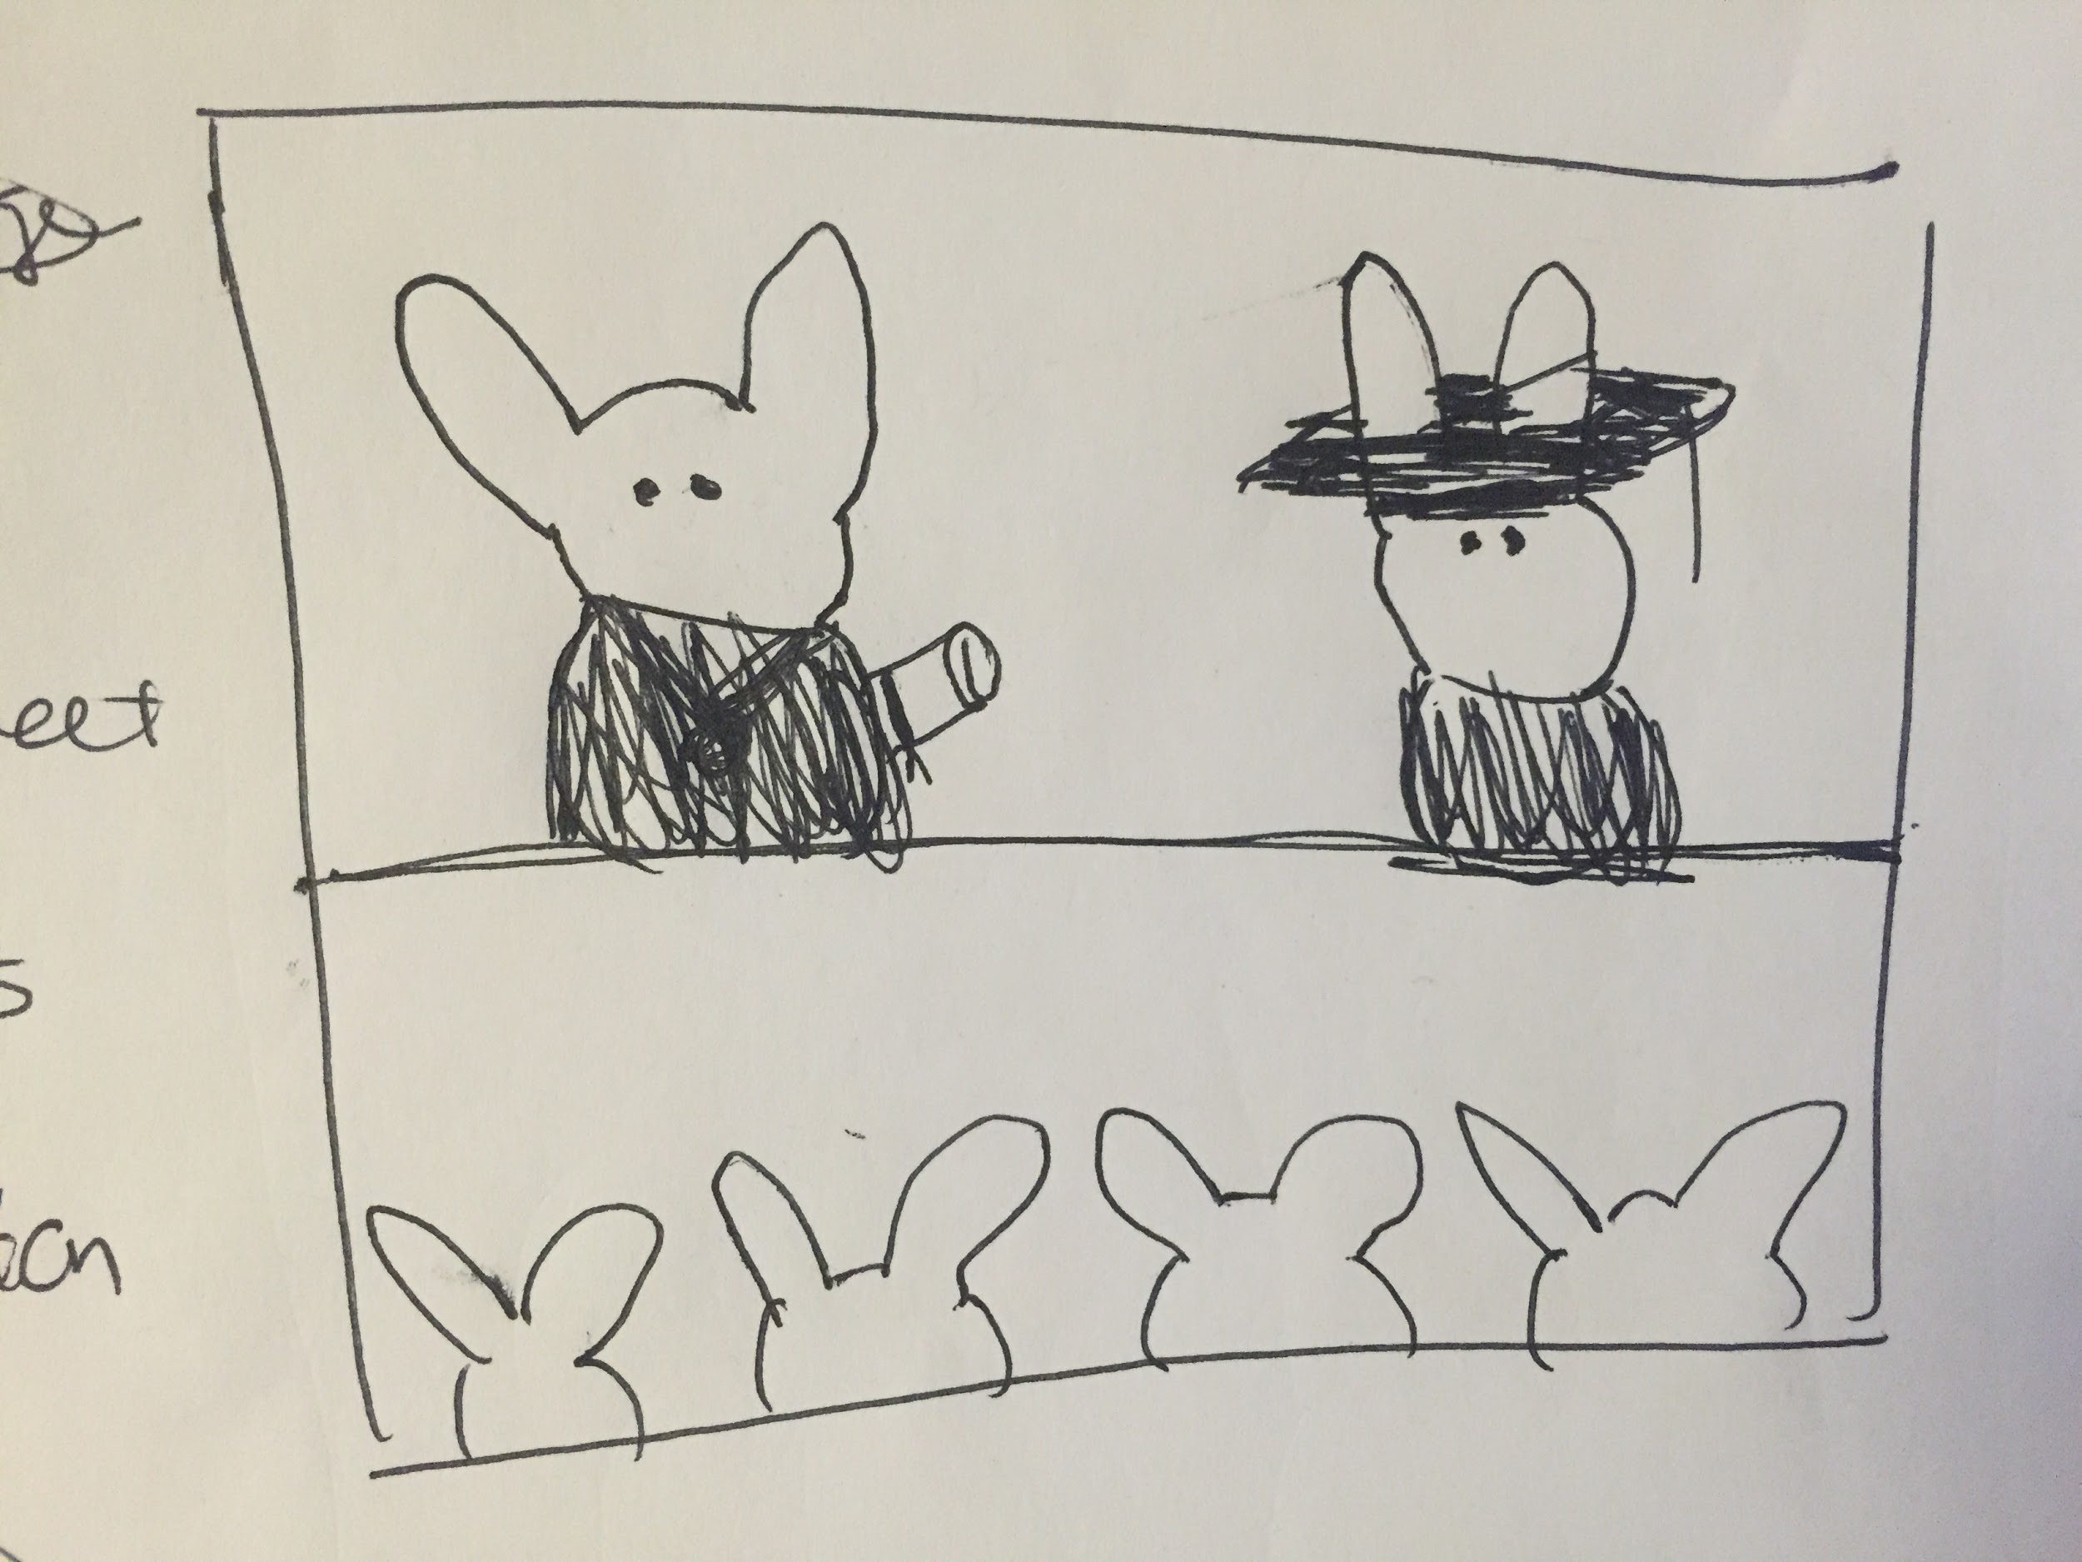
Depicted: Graduation stage; peep bunny in a crafted gown and cap crossing to receive its diploma from bunny peep Don Laackman. Crowd of bunny peeps watch on.

Deadlines
Other deadlines for production completion?
Final deadline: March 30

Success Measurements
Raise the visibility of Champlain College brand through social reach and engagement.
- Social reach
- Shares, Retweets

Increase overall positive brand sentiment.
- Likes; “love” or “haha” reactions on Facebook
- Positive copy accompanying shares such as “I love my school”, “this is so cool”, etc…

Drive website traffic
- Unique visits
- Page visits
- Call-To-Action Clicks
- Time on Site
- Bounce Rate

Gain media attention and recognition in higher education publications
- Included in any Higher Education blogs, websites, etc... covering Higher Education April Fools jokes/pranks
- Any local media attention

