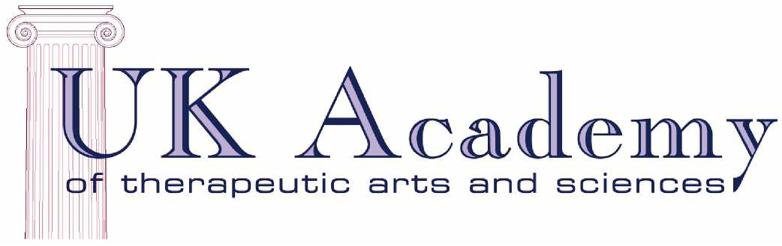
incorporating the Washington School of Clinical and Advanced Hypnosis

PROSPECTUS

Diploma in Clinical and
Advanced Hypnosis
Our outcome is your achievement

Head Office: Richmael House, 25 Edge Lane
Chorlton, Manchester, M21 9JH (UK)
Tel: +44 (0)845 2578735
Fax: +44 (0)161 882 0376
Email: info@hypno-nlp.org
Web: www.hypno-nlp.org
Table of Contents
Foreword 3
Our School 4
The Course 5
Syllabus 7
Accreditation 10
Clinical Supervision 10
Continuing Professional Development 11
Why train with the UK Academy? 13
Staff 16
Shaun Brookhouse .............................................................................................................. 16
Fiona Biddle ………………………….....………………………………………………………… 18
Hilary Norris Evans: Bristol/Bath ……………………………………………………………….. 19
Neil Foster: Liverpool ……………………………………………............................................20
Will Lord : South Wales ..………………………………………............................................. 21
Heather Hutchison: Scotland ………………………………............................................. 22
Ian Fielder: Hampshire ………………………………............................................................ 23
Josie Odber: Devon and Cornwall…………………………………………………………….24

Foreword

Welcome to the prospectus for the Diploma in Clinical and Advanced Hypnosis from the UK Academy of Therapeutic Arts and Sciences. I am delighted that you are interested in training in this exciting profession with us. Until June 2006 we were known as the Washington School of Clinical and Advanced Hypnosis, and at that point this was merged into our continuing professional development school, the UK Academy.
This prospectus is designed to give you all the information that you need to make a decision as to whether to train with us. The field of hypnotherapy in the UK is complex; it is our aim to enable you to take your place as a fully qualified and supported professional, so that you can find fulfilment in your chosen career.
At the UK Academy, we pride ourselves on our on-going commitment to our students, and the profession as a whole. If at any time you need to ask questions or seek advice, please speak to either your local trainer, myself, or our Vice Principal, Fiona Biddle. Contact details for all staff can be found in the “Staff" chapter within this prospectus.
Here, we detail all the requirements that must be met in order for you to satisfactorily complete the Diploma and associated specialist certifications, and obtain your qualification to practice. All requirements are set so that we can be sure that anyone who qualifies with us is fit to practice. The profession of hypnotherapy involves the creation of significant relationships with often vulnerable people. Therefore ethics are of extreme importance and will be emphasised throughout.
I very much hope that this prospectus gives you the information you seek and that we will soon be able to welcome you to our school.
Best wishes

Shaun Brookhouse, GCGI, MA, CertEd, ACoT, DHyp, DipProfCouns, ADHP(NC), HPD, FNCSAG, UKCP(H)
Principal

Our School

The Washington School of Clinical and Advanced Hypnosis (WSCAH) was founded in 1996 and has been training successful hypnotherapists ever since. Now the UK Academy, our mission remains to be a “Centre of Excellence” for the training of Clinical Hypnosis and Neuo-Linguistics.
Shaun Brookhouse is the Principal of the School. Each centre is run by a qualified trainer or trainers chosen specifically by Shaun for their expertise, commitment and skill. All trainers have a lively and provocative style of lecturing which makes training a memorable experience. Our trainings are about empowerment, both on an individual and professional level.
The UK Academy is actively involved in the hypnotherapy profession on both a National and International Level. We support efforts into the standardisation of hypnotherapy training standards and professional ethics and practice via our involvement in key hypnotherapy bodies in the UK and with an International arm too. Shaun and Vice Principal, Fiona Biddle, were part of a small group of professionals who drafted the National Occupational Standards for Hypnotherapy in 2002.
The UK Academy is staffed by certified professional instructors of hypnotherapy (via either the National Guild of Hypnotists or the National Society of Hypnosis, Psychotherapy & Mindfulness). We are the only school, as far as we are aware, committed to having our programmes delivered by qualified trainers as well as qualified clinicians.
The UK Academy is accredited by the National Council for Hypnotherapy and the National Society of Hypnosis, Psychotherapy & Mindfulness. We choose these accreditations over any others that would be available to us due to the benefits they provide. The NCH is a members’ co-operative and offers the Hypnotherapy Practitioner Diploma (see p#). Both offer our students free membership (NCH while students and NSHP&M student membership and the first year in practice). Both have very high standards which are fully enforced by their codes of ethics and complaints procedures.
Shaun and Fiona are both past Chairs of the National Council for Hypnotherapy and are past Chairs of the UK Confederation of Hypnotherapy Organisations.
Other UK Academy staff have been represented in the political field of hypnotherapy:
- Hilary Norris-Evans (Bristol) was the Company Secretary of the National Council for Hypnotherapy from 2005-2007 and its specialist advisor for self esteem and confidence
- Neil Foster (Liverpool) was Marketing Director of the National Council for Hypnotherapy from 2010-2012
We are recognised to award the Hypnotherapy Practitioner Diploma through the National Council for Hypnotherapy. The HPD is also accredited through NCFE. For more information see p13.
In 2006 we have incorporated the UK Academy’s specialist certifications in Smoking Cessation, Anxiety and Ericksonian Hypnosis into our programme, so our course now offers you the opportunity to get SIX qualifications in one!

The Course

Our Diploma Course is run part time over one year and has 450 hours of combined classroom tuition and directed independent study.
Most UK Academy Centres operate run the course over 10 or 11 weekends, typically following this structure:

- Introductory (see below)
- Traditional hypnotherapy practice
- Self-hypnosis, pain and IBS
- Smoking and weight control
- The therapeutic process
- Anxiety and stress
- Ericksonian hypnosis
- Practice management
- Regression
- NLP 1
- NLP 2

Some centres have rolling entry, whereby you may take module one (usually on a Friday) and then join the group on the next weekend. Some centres allow intake at only one or two points in the year. Please contact your local training director for details of how their centre runs.
Hypnotherapy is both a theoretical and practical based study. The UK Academy believes that it is very important for a student to not only know the information taught, but also to be able to use this information in a practical way. To this end, a large proportion of the course is dedicated to practice sessions.
In addition to the classroom attendance, students will be required to submit a portfolio of work which includes a question paper, a series of hypothetical situations for which you plan treatment and a statement of personal and professional philosophy.
The UK Academy Diploma is recognised by several national and international professional associations. Our Diploma Course meets the requirements for the externally accredited Hypnotherapy Practitioner Diploma awarded by the National Council for Hypnotherapy. This is a level 4 Vocational award, which you will receive upon successful completion of this course.

Qualifications
Upon successful completion of the course you will receive:
- Diploma in Clinical and Advanced Hypnosis
and
- Hypnotherapy Practitioner Diploma
and
- NLP Practitioner Certificate

and you will be eligible to use the letters DipCAH, HPD and PNLP after your name.
If you successfully pass optional tests you will also receive:
- Specialist Certificate in Smoking Cessation
- Specialist Certificate in Treating Anxiety
- Ericksonian Hypnotherapy Practitioner Certificate

This means that you will be able to start up immediately with all the skills and knowledge that you need to build a successful practice!
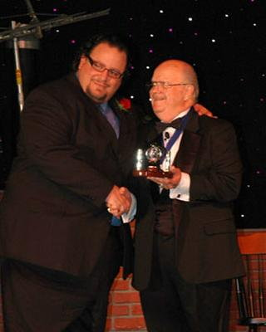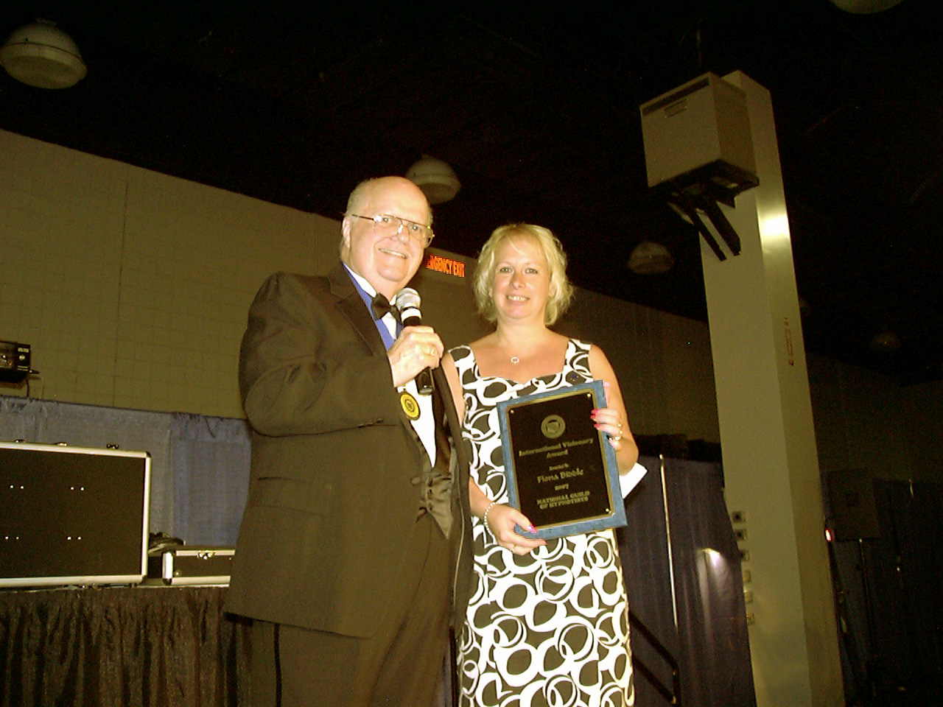
Shaun and Fiona receiving the International Visionary Award from Dr Damon in 2005 and 2007 respectively

Syllabus

The syllabus includes the following topics:

- History of Hypnosis
- Treatment Design
- Post Hypnotic Suggestions
- Practice Management
- Script Design
- Regressions
- Pseudo Orientation In Time
- Work of Dave Elman
- Indirect Suggestions
- Direct Language Usage
- Neuro-Linguistic Programming (NLP)
- Rapport Building
- Contra Indications
- False Memory Syndrome
- Systematic Desensitisation
- IBS
- Phobias
- Stammering
- Milton Model
- Performance Enhancement
- Truisms
- Utilisation Language
- Clinical Applications of Hypnosis
- Brookhouse's Three S's
(Smoking, Slimming & Stress)
- Behavioural Assessment Pain Control
- Work of Milton H Erickson
- Traditional Hypnotic Phenomena
- Eye Patterns
- Meta Communications
- Abreactions
- Symptom Removal
- Insomnia
- Eating Disorders
- Nail Biting
- Obsessive Compulsive Disorders (OCD's)
- Self Hypnosis
- Effective Hypnosis

As this course is constantly updated, this list only represents a sample of what is covered. Other cutting edge techniques will be taught in order to keep the student at the forefront of hypnosis for therapeutic change work.
The DipCAH/HPD course has now been combined with the Certified NLP Practitioner Training, giving graduates two internationally recognised credentials when they complete their training. If the student completes additional assignments they are entitled to receive extra certifications in smoking cessation, anxiety and Ericksonian Hypnotherapy.

What is NLP ?
Neuro Linguistic Programming (NLP) is a model of communication that focuses on identifying and using patterns of thought that influence a person's behaviour as a means of improving the quality and effectiveness of their lives. It offers a paradigm of how the brain works (neuro), about how language interacts with the brain (linguistic), and how we use this interaction to get the results we want for ourselves and others (programming). It is an effective, proven vehicle for accelerated human change, radically altering the "old way" of lengthy psychotherapy.
NLP was initially created by linguist Dr. John Grinder and computer scientist and Gestalt therapist Dr. Richard Bandler. Together they produced a linguistic model that identified the language patterns of a few gifted individuals such as hypnotherapist Milton Erickson, MD., Fritz Perls of Gestalt therapy, anthropologist Gregory Bateson and Virginia Satir of family systems therapy. The synthesis of their findings, a blend of cognitive and behavioural science, resulted in the technology known as Neuro Linguistic Programming. In the 20+ years since it was first developed, NLP has grown, changed and expanded, and it continues to do so today.
The UK Academy of Therapeutic Arts and Sciences' NLP Practitioner 10 and Master Practitioner Courses cover both traditional and non traditional NLP techniques and models.
For students who wish to go beyond Master Practitioner Training, we can support you becoming a Certified Trainer of NLP.
Both the Practitioner and Master Practitioner Courses are stand alone courses in their own right, but the Practitioner Course is also contained within the Diploma in Clinical and Advanced Hypnosis.
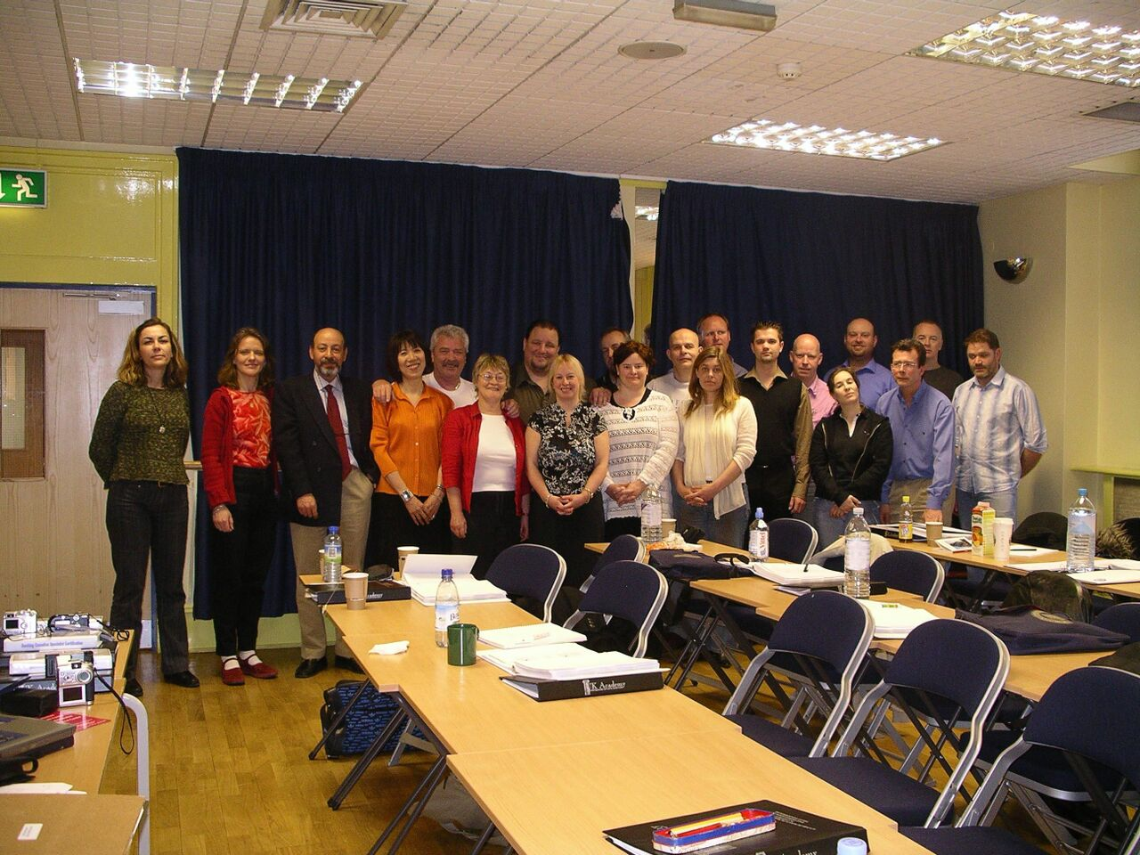

The International Certified Professional Instructor course 2005

NLP Syllabus
Practitioner (Certified through the UK Academy):
- Behavioural integration of the basic presuppositions of NLP
- Rapport, establishment and maintenance
- Pacing and Leading (Verbal and Non Verbal)
- Calibration (Sensory Based Experience)
- Representational Systems (predicates and accessing cues)
- Meta Model
- Milton Model
- Elicitation of well formed, ecological outcomes and structures of present state
- Metaphor creation
- Frames contrast
- Relevancy
- As if
- Backtrack
- Anchoring (VAK)
- Anchoring Techniques
- Dissociation and Association Chunking
- Submodalities
- Reframing

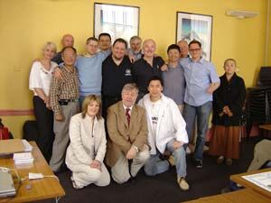
A group from 2003

Accreditation

It is important to understand that because of the UK's legal tradition of common law, there are no formal regulations regarding the practice of Hypnotherapy. However, The UK Academy feels that external validation is a very good way to assess the quality of training provided.
Some enquirers have asked why the UK Academy is not affiliated with certain "hypnotherapy organistations". It is our policy to align ourselves only with organisations which have meaningful and verifiable means of accreditation and thus we are recognised by the following organisations:
The National Council for Hypnotherapy: The NCH is one of the oldest independent hypnotherapy organisations in the UK. It was originally formed as the Hypnotherapy Register in 1973.The NCH provides practice insurance and a referrals system, which is very useful to the newly graduated hypnotherapist. Additionally, the NCH also provides a comprehensive Code of Ethics and Practice. The National Council for Hypnotherapy is one of the premier organisations for hypnotherapists in the UK having a membership of more than 1500.
The National Society of Hypnosis, Psychotherapy & Mindfulness: The NSHP&M is the membership arm of our sister school, the National College of Hypnosis and Psychotherapy. Students of the UK Academy can have free student membership of the NSHP and graduates can have their first year as a full member free. The NSHP&M runs an annual conference; always an exciting and enjoyable learning experience!

Clinical Supervision

Students will be placed in Clinical Supervision at a time decided by the tutor based on progress. It is hoped that students will maintain this relationship post-diploma. UK Academy will provide a list of recognised Supervisors for the student's use. Supervised practice is an integral part of the Course.

Continuing Professional Development

Although the Diploma in Clinical and Advanced Hypnosis is a full practitioner qualification, The UK Academy believes that Continuing Professional Development is vital for the hypnotherapy practitioner and for the profession as a whole. With this aim, we are proud to offer the following training opportunities. Most of these courses are only open to qualified, practising therapists.
Courses include:
Professional Coaching Course (CPC): This special certification programme is designed to equip students to set up in practice as a professional coach, or to employ coaching theory and skills in another setting, such as within a work related role.
Specialist certifications in working with pain, stress, trauma and weight control.
Psychotherapy Training: for those interested in becoming registered psychotherapists, a route is available that recognises your hypnotherapy training and experience to gain registration with the United Kingdom Council for Psychotherapy.

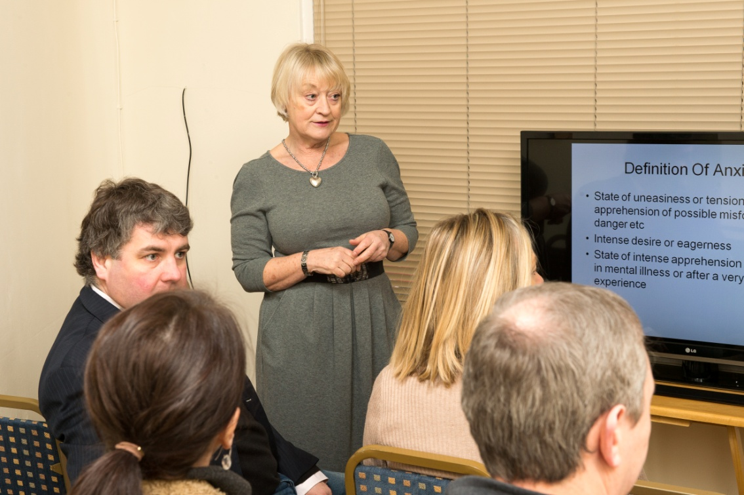
Hilary training a group in 2013

Eligibility
Hypnotherapy is a profession that incorporates a significant responsibility to the public who seek our services. As such, we do not simply allow anyone who applies, to do the course. We feel that it is of the utmost importance that anyone who undertakes this course must:
- be of suitable character to take on a career of working with vulnerable people
- be sufficiently mature in order to be able to listen to traumatic material without being unduly affected personally
- have sufficient background and experience to be able to meet the academic demands of the course.
All applicants will be interviewed to determine their suitability for the course. Course Fees:
Unless otherwise arranged, tuition fees will be due on or before the commencement of the course. A deposit will be required upon enrolment, with the balance payable on the first day of the course. The total fee includes a £100.00 Certification Fee and this is payable with the tuition fee. If you require special dispensation, please contact our National Headquarters for a confidential discussion. While our fee includes all tuition and certification, students should be aware that additional expenditure will be incurred for books and supervision.
As of September 2015 our fees are £2220
Each centre is owned and operated independently by licence. VAT is included in the fee at the appropriate rate for centres which are registered for VAT.

Hilary training a group in 2013

Why train with the UK Academy?

When choosing to train as a hypnotherapist, we are well aware that you have many choices and that it can be very confusing and difficult to determine which course would suit you best. To help, we have listed the primary benefits of training with us, including some questions that you might like to ask other schools if the issues raised are important to you.
- The UK Academy is a national group of training centres, so you can be sure of a secure structure with plenty of support available before, during and after your course, not just from your tutor(s), but also from the other tutors, Principal and Vice Principal. We can offer supervision and on-going training, if you want to do this with us, but you are free to move on to others if you choose. If support matters to you, you may like to ask other schools about the breadth and depth of their support structures, and whether you are tied to them for supervision or on-going training after your diploma.
- All UK Academy tutors have undertaken specific training in the education of hypnotherapists through the National Guild of Hypnotists (USA) or the National Society of Hypnosis, Psychotherapy & Mindfulness. This means that not only do we know our subject, but we also know how to teach you so that you learn efficiently. If this matters to you, check out the educational credentials of other trainers that you are considering.
- While there is no statutory regulation of the profession of hypnotherapy in the UK, there are National Occupational Standards. The Principal and Vice Principal of the UK Academy were on the panel of eight who created these standards, so you can be sure that your training will meet these standards. If this matters to you, check if other courses are geared to meeting the NOSs
- In 2001 the National Council for Hypnotherapy inaugurated the Hypnotherapy Practitioner Diploma: the first nationally accredited qualification in hypnotherapy open to all regardless of background. Our Principal and Vice Principal were instrumental in this development, and in the intervening years the HPD has gone from strength to strength. It is a "level 4" qualification, and is validated by the NCFE awarding body. If you study with us, you will produce a portfolio of work which, when satisfactorily assessed will give you this important credential. You will also gain the school's own Diploma in Clinical and Advanced Hypnosis. The HPD is, by many, considered to be the "gold standard" in hypnotherapy qualifications, and we at the UK Academy strive to be a beacon of excellence in the delivery of this qualification.
- The UK Academy course offers you the chance to gain six qualifications in one. Not only will you, on successful completion of the course, gain the DipCAH, HPD and NLP Practitioner Certificate, but you may also submit assignments to be awarded Specialist Certifications in Smoking Cessation, Treating Anxiety and Ericksonian Hypnotherapy.
- Within the UK Academy we have a philosophy that ensures that all tutors are full-time practitioners in addition to their training. By this we mean that they derive their primary income from seeing clients: this ensures that they "walk the walk" as well as "talk the talk". You will find that we often have examples of current clients to tell you about that illustrate theoretical points. There are some trainers who set up a school because they can't make it as practitioners. Would you want to be trained by them?
- We believe it is vitally important that you see demonstrations of techniques and also get to practice. This gives you the confidence to practice with "real people" as soon as (if not before) you qualify. We say before, because you will be given permission to work with certain issues at certain points in your training. Not all trainers demonstrate, and not all give you a chance to practice and build your confidence.
- The UK Confederation of Hypnotherapy Organisations which was created in 1997 by our Principal, Shaun Brookhouse, insists that schools train to minimum standards of 120 hours face to face and 450 hours of total study time. Naturally, we agree that courses should be of this length, to ensure that you have time to learn and consolidate your knowledge and experience. These standards have been adopted by the Complementary and Natural Healthcare Council, the voluntary regulator of hypnotherapy in the UK.
- It is important that you are able to see a full syllabus before you start the course and that this has sufficient depth to enable you to start in full practice as soon as you qualify. Our prospectus lists all elements of the course, and not only do you get full coverage of hypnotherapy, but Neurolinguistic Programming is covered to Practitioner level too.
- Our course also includes business/practice management. So often hypnotherapists fall at the first hurdle because, while they may be wonderful at what they do, they don't know how to get the clients. The UK Academy has a great depth of knowledge and experience in this area that you can draw on. All our tutors around the country are willing to share with you what works and what doesn't so that you can learn from our successes, and our mistakes!
- We do not take just anyone onto our courses. You will be interviewed to ensure that you are suitable for this profession of working with vulnerable people, and, very importantly, to ensure that the UK Academy is right for you. If we feel that another course would be better for you (and this does happen), we will tell you, and advise you of who to approach.
- We actively enforce all our policies, including equal opportunities. We will make any reasonable adjustments to ensure that anyone can take our courses, if suitable, and we do not discriminate on any grounds. Any special leaning needs will be catered to if possible. For example a student with dyslexia would be able to provide portfolio evidence in recorded rather than written form if they wished to do so. The learning environment is safe, confidential and supportive.
- We are happy to receive student feedback: questions, comments or suggestions at any time in the course and will do our best to adapt to any requests that are made. Hypnotherapy is an "individual" profession in that it is important that you are encouraged to be yourself as a therapist and to find your way to practice. So your opinions matter!
- Ethical considerations are all important in a field where one is working with vulnerable people. We cover these in depth. Check with other schools as to which, if any, code of ethics they subscribe. They should be bound by a training code of ethics as well as teaching you one for practice.
- As previously stated there is no regulation of hypnotherapy in the UK, but we still believe it is vital to your career for you to belong to strong professional bodies that can give you long term support. Our course is accredited by the National Council for Hypnotherapy in the UK (you receive free trainee membership while studying), and you are also entitled to free student membership, and your first year in practice of the National Society of Hypnosis, Psychotherapy & Mindfulness.
- In the UK Academy we have a belief in the importance of teaching small groups which ensures that you get personal attention. Ask other schools about their class sizes.
- In Dec 2010 hypnotherapy in the UK gained voluntary self-regulation through the Complementary and Natural Healthcare Council. On graduation from the UK Academy you will be eligible to join this body and claim the credibility that this recognition gives.

Staff

Shaun Brookhouse  Principal  MA, PGCert(ClinSup), CertEd, HPD, ADHP(NC), FNSHPM(Hon) , UKCP(Acc)  Phone: 0800 849 6327  Email: shaun@hypno-nlp.org | Shaun Brookhouse has earned:
- Graduateship in Hypnotherapy and Counselling, City and Guilds of London Institute
- Masters Degree in Education Studies from Liverpool John Moores University.
- Certificate in Education (Further, Adult and Higher) from Manchester University
- Post Graduate Certificate in Clinical Supervision

Shaun has been a professional hypnotherapist since 1989 and a respected trainer of hypnotherapists since 1993.
 | His professional credentials include:
- Diploma in Hypnotherapy and Psychotherapy, Post Graduate Diploma in Hypnotherapy and Psychotherapy and Certificate in Supervision from the Centre Training School of Hypnotherapy and Psychotherapy,
- Diploma in Clinical Hypnotherapy from the London College of Clinical Hypnosis,
- Diploma in Hypnotherapy from the American College of Clinical Hypnosis,
- Diploma in Advanced Hypnotherapy, Hypnotism Institute of Los Angeles
- Advanced Diploma in Hypno-Psychotherapy, National College of Hypnosis and Psychotherapy
- Diploma in Professional Counselling from the Australian Institute of Professional Counsellors
- European Certificate of Psychotherapy, European Association for Psychotherapy
- European Certificate in Clinical Hypnosis, European Association for Hypno-Psychotherapy
 | Shaun is also a
- Certified Trainer of NLP through Advanced Neuro Dynamics
- Master Trainer of NLP through the National Federation of NLP

Shaun was also one of the first two people to receive the externally accredited Hypnotherapy Practitioner Diploma (HPD) through the NCFE Awarding Body and the National Council for Hypnotherapy
 | Shaun is a professional member of the following organisations:
- The Guild of Professional Consultants (Coaching)
- The College of Teachers
- The United Kingdom Council for Psychotherapy (reg no 00960061)
- The Complementary and Natural Healthcare Council (reg no 000531-L10)
- Australian Hypnotherapy Association (Honorary)
- Accredited Member, European Counselling Association
- Accredited Member, UK Association for Solution Focused Practice

 | Shaun is a Fellow of:
- The National Society of Hypnosis, Psychotherapy & Mindfulness (reg no 1406)
- European Association of Hypno-Psychotherapy
- American Psychotherapy Association

 | Shaun has received the following awards:
- The Rexford L North Memorial Trophy from the National Guild of Hypnotists, their highest honour for Life Time Achievement (2004)
- The Hartland Memorial Award, from the National Council for Hypnotherapy (2005)
- International Visionary Award (First Recipient) National Guild of Hypnotists, First Recipient, (2005)
- Order of Braid, National Guild of Hypnotists, (2005)
- The President's Award from the National Guild of Hypnotists, their second highest honour. (2002)
- Hypnosis Journalism Award from the National Guild of Hypnotists (2003)
- Hypnosis Pioneer Award from the American Council of Hypnotist Examiners (2003)
- The Sealah Award from the International Hypnosis Hall of Fame (2001)
- The Honorary Service Award from the International Medical and Dental Hypnotherapy Association
- The Hypnosis Research Award from the American Association of Professional Hypnotherapists
- A Special Commendation from the Centre Association of Psychotherapists
- The Hypnotherapy Research Society's Special Award for Contribution to the Profession of Hypnotherapy. (1998)
- Outstanding Contribution to Complementary Medicine Award-Highly Commended from the Institute for Complementary and Natural Medicine

 | Shaun is the author of:
- Hypnotherapy Training: An investigation into the training in Clinical Hypnosis post 1971 (ISBN 1899836179) published by Crown House Publishing Company
- Motivational Hypnotism (ISBN 0954460413) co-authored with Fiona Biddle
- Building a Successful and Ethical Practice (ISBN 09554460405) co-authored with Fiona Biddle
- Hypnotic Coaching (ISBN 09554460421) co-authored with Fiona Biddle
- Clinical Hypnosis Textbook: a guide for practical intervention (ISBN 9781910272459) contributing author

He is a contributing author to the New Consumer's Guide to Hypnotism.
Shaun is available to students at all centres for advice and support.

Fiona Biddle  Vice-Principal  BSc. (Hons), MSc, DipCouns, DipCAH, HPD,CPC, ADHP(NC), CI, FNSHP, UKCP(H)  Phone: 0845 076 3724  Email: fiona@hypno-nlp.org | Fiona Biddle has earned
- BSc in Computing from Loughborough University
- Diploma in Counselling from Exeter College
- Certified Professional Coach, International Institute of Coaching (US)
- Diploma in Clinical and Advanced Hypnosis from WSCAH
- Certificate in Hypnotherapeutic Supervision from the National Council for Hypnotherapy
- HypnoBirthing Practitioner Certification from the HypnoBirthing Institute
- Board Certified Hypnotherapist from the National Guild of Hypnotists (US)
- 7407 (part 1 & 2) Teaching Certificate from City and Guilds
- Certified Instructor from the National Guild of Hypnotists (US)
- Advance Diploma in Hypno-Psychotherapy from the National College of Hypnosis and Psychotherapy
- MSc in Medical and Health Sciences (existential psychotherapy) from Sheffield University

She has been in the therapeutic profession since 1993 and was one of the first two people to receive the externally accredited Hypnotherapy Practitioner Diploma (HPD) through the NCFE Awarding Body and the National Council for Hypnotherapy

 | Fiona is a professional member of the following organisations
- The United Kingdom Council for Psychotherapy (reg no 07159394)
- The Complementary and Natural Healthcare Council (reg no 000455-L10)
- The EMDR Association of UK and Ireland

 | Fiona is a Fellow of
 | - The National Society of Hypnosis, Psychotherapy & Mindfulness
 | Fiona is the author of
- Motivational Hypnotism (ISBN 0954460413) co-authored with Shaun Brookhouse
- Building a Successful and Ethical Practice (ISBN 09554460405) co-authored with Shaun Brookhouse
- Hypnotic Coaching (ISBN 09554460421) co-authored with Shaun Brookhouse
- Being Active: A guide for hypnotherapy weight control clients (ISBN 095446043 ) co-authored with Stuart Biddle

She is a contributing author to the New Consumer's Guide to Hypnotism.

Fiona is an ex-chair of the UK Confederation of Hypnotherapy Organisations (UKCHO), and of the National Council for Hypnotherapy. In 2004 Fiona received the President’s Award from the National Guild of Hypnotists (USA), their second highest honour, for her work on the Core Curriculum and Certified Instructor Training Course. In 2007 she received their International Visionary Award.

Fiona is available to students at all centres for advice and support.

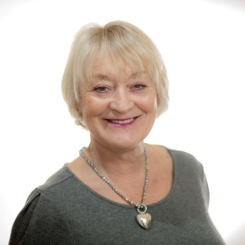  Hilary Norris Evans  BA(Hons), PGCE, DABCH, BCH, CI, HPD, CPC, MNCH (Acc.), MNSHP&M  Phone: 07887714892  Email: hilary@hypno-nlp.org | Hilary Norris Evans has earned
- BA (Hons) in languages from the University of Manchester
- L-es-L in linguistics from the University of Dijon
- PGCE from the University of London
- Dip from Atkinson Ball College of Advanced Hypnotherapy
- BCH (Board Certified Hypnotist) National Guild of Hypnotists
- CI (Certified Instructor National Guild of Hypnotists
- Certificate in Hypnotherapeutic Supervision from the National College of Hypnosis and Psychotherapy
- AccHypSup Accredited Hypnotherapeutic Supervisor National Council for Hypnotherapy
- Assessor qualification NVQ level 3 from OCR
- HPD from the National Council for Hypnotherapy
- Certified Professional Coach from the UK Academy
- Practitioner in NLP from Training Changes
- Master Practitioner in NLP from UK Academy.

 | Hilary is a professional member of the following organisations
- The National Council for Hypnotherapy
- The National Guild of Hypnotists
- The National Society of Hypnosis, Psychotherapy & Mindfulness (reg no 3840)
- The Complementary and National healthcare Council ( reg no 000066-A13)
- The Corporation Of Advanced Hypnotherapy

Having spent the first part of her career life in teaching and training, Hilary has been a full time hypnotherapist and NLP practitioner since 1997. She was the NCH Specialist Advisor For Confidence and Self Esteem and The NCH Internal Verifier For The Diploma In Supervision. She is also a supervisor and was company secretary of The National Council For Hypnotherapy from 2004-2006.

Hilary is an enthusiastic , pragmatic teacher/trainer, who loves inspiring students with an enduring passion for hypnotherapy in all its forms and uses an eclectic mixture of hypnotherapy, NLP, stress management and life coaching in her therapy work. A specialist interest is in helping problem gamblers and inspiring other hypnotherapists to take an interest in working with them. She is also very keen on Easibirthing and Post Natal Mental Health , the place of rapid inductions and self confidence in hypnotherapy practice and the relationship between Mindfulness and Hypnotherapy

Hilary teaches the UK Academy course in Bath/Bristol/Cirencester.

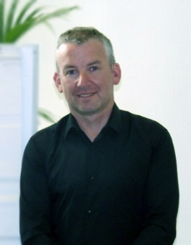  Neil Foster  Dip CAH, HPD, MNLP, RTS, CPC, MNSHP&M  Phone: 0151 2018167  Email: neil@hypno-nlp.org | Neil Foster has earned
- Diploma in Clinical and Advanced Hypnotherapy (UK Academy of Therapeutic Arts and Sciences)
- Hypnotherapy Practitioners Diploma (NCFE)
- Master Practitioner Certificate (UK Academy of Therapeutic Arts and Sciences)
- Certified Critical Incident Debriefing (National Council for Psychotherapy)
- Certified Professional Coach

Neil has been in full time practice since 2006 and has a thriving Hypnotherapy and Coaching Practice in Liverpool City Centre.

 | Neil is a professional member of the following organisations
- National Society of Hypnosis, Psychotherapy & Mindfulness (reg no 3828)

Neil teaches the UK Academy course in Liverpool

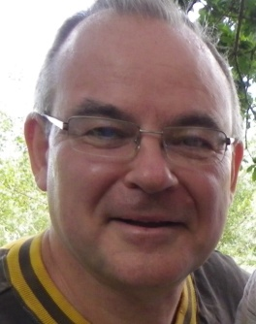  Willam C.V. Lord (Will)  BSc. (Hons), MBA, MA, DipDiab, DipClinHyp, ADH, MNSHP&M.  Phone: 07813872019  Email: will@hypno-nlp.org | Will Lord has earned
- BSc in Biochemistry from Aberystwyth University.
- MBA in business from Swansea Institute.
- MA in Shakespeare Studies from Swansea Met.
- Diploma in Diabetes from Warwick University.
- Diploma in Clinical hypnotherapy from BST Foundation out of St. Mary’s London
- Advanced Diploma Hypnotherapy, Oxford School of hypnotherapy.

Will worked for two large pharmaceutical companies for 30 years in sales, management, marketing and training for 30 years. He ran his own training company Medical Education Services Ltd. He now runs his hypnotherapy company 8thsense Ltd.

 | Will is a professional member of the following organisations
- National Society of Hypnosis, Psychotherapy & Mindfulness (reg no #)
- General Hypnotherapy Register

Will teaches the UK Academy course in South Wales

Heather Hutchison  MA(Hons), DipCAH, HPD, PNLP, AccSup, MNCH(Acc), MCNHC  MNSHP&M.  Phone: 07787 807609  Email: heather@hypno-nlp.org | Heather Hutchison has earned
- MA (Hons) Degree in Psychology from Glasgow University
- Diploma in Clinical and Advanced Hypnosis from UK Academy & Hypnosis Scotland
- Hypnotherapy Practitioner Diploma from UK Academy & Hypnosis Scotland
- Certificate in Neuro-Linguistic Programming from UK Academy & Hypnosis Scotland
- Certificate in Hypnotherapeutic Supervision from the National Council for Hypnotherapy
- HypnoBirthing Practitioner Certification from the HypnoBirthing Institute
- Diploma in Cognitive Behaviour Therapy from Academy for Continued Hypnosis Education

Heather has been a fulltime hypnotherapist since 2010 and runs a busy practice in Polmont on the outskirts of Falkirk in Central Scotland. She has a special interest in working with clients who suffer from depression and/or anxiety. She also enjoys working with children on the autistic spectrum (high functioning) having personal experience of bringing up an autistic child.

 | Heather is a professional member of the following organisations
- National Society of Hypnosis, Psychotherapy & Mindfulness (reg no #)
- General Hypnotherapy Register
- National Council for Hypnotherapy (NCH)
- The Complementary and National healthcare Council ( reg no 000023-F11)

Heather teaches the UK Academy course in Scotland

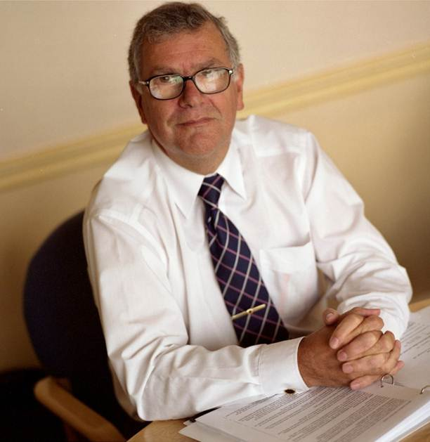  Ian Fielder  FRSA, MHS (Acc), Dip Hypnotherapy and Counselling, Dip Adv Hypnotherapy and Psychology, Dip NLP, Dip CBT, Higher Int Dip Holistic Therapy and NADTp, MNSHP&M  Phone: 01489 787170  Email: ian@hypno-nlp.org | Ian Fielder has earned
- Diploma in Clinical Hypnotherapy and Counselling Skills (Chrysalis)
- Diploma in Advanced Hypnotherapy and Psychology (School of Natural Health)
- Diploma in Cognitive Behavioural Therapy (School of Natural Health)
- Diploma in Neuro Linguistic Programming (School of Natural Health)
- Higher International Diploma with Distinction in Holistic Therapies (School of Natural Health)
- Certificate in Neuro Affective Desensitisation Techniques

 | Ian is a professional member of the following organisations
- National Hypnotherapy Society
- Anxiety UK
- Fellow of the Royal Society of Arts
- National Society of Hypnosis, Psychotherapy & Mindfulness (reg no #)

Ian began his career working in the Health Service followed by a period in IBM and then with a service provider before running a no for profit organization for seven years. After retraining he runs his clinic from Botley in Hampshire and specializes in working with people who wish to dramatically improve their lives.

Ian enjoys working with people suffering with a variety of anxiety disorders including panic attacks, obsessive compulsive disorder, generalized anxiety disorder, specific phobias and work related stress.

As an approved therapist with Anxiety UK, he offers an individually designed intervention to suit the requirements and specific problems of each person.

Ian teaches the UK Academy course in Hampshire.

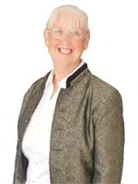  Josie Odber  PhD, MLitt, BSc (Hons), CPsychol, AFBPsS, AMRSM, HCPC, MNSHP&M  Phone: 01752 82260/ 07974704899  Email: josie@hypno-nlp.org | Josie Odber has earned
- PhD in the faculty of Medicine from the University of Glasgow
Master Degree (Master of Letters) in Experimental Psychology from the University of Glasgow
- BSc Joint Honours in Physiology and Psychology from the University of Glasgow
- Certificate in Counselling, Central School of Counselling, Glasgow
- PGC in Higher Education from Teesside University
- Diploma in Hypnosis and Psychotherapy from the National College of Hypnosis and Psychotherapy
- Licentiate of The Institute of Biology from University of the West of Scotland
- BTec Professional Development Award in Holistic Therapy Skills for the Health Practitioner, Middlesbrough College
- Personality Assessment Certificate and Certificate of Competence in Occupational Testing from PSYCTEC International
- Advanced Clinical Weight loss Practitioner Diploma from the Health Sciences Academy

 | Josie is a
- Chartered Psychologist
- Associate Fellow of the British Psychological Society
- Associate Member of the Royal Society of Medicine
- Member of the Health and Care Professions Council
Affiliate of the American Psychological Society
- Member of the National Society of Hypnosis, Psychotherapy & Mindfulness

Josie has been a qualified Psychologist since 1986 and was awarded a Royal College of Physician’s Fellowship for research into the biochemical correlates of premenstrual depression.

Josie teaches the UK Academy course in Devon and Cornwall.

