December 15, 2020

Canadian Vaccine Catalogue releases critical standardized terminology for COVID-19 vaccines

OTTAWA, ON – Standardized vaccine terminology and product information will be critical in the rollout of COVID-19 vaccines to ensure consistency across Canada.

The Canadian Vaccine Catalogue (CVC) is the comprehensive, standards-based resource for vaccine terminology and vaccine product information in the country. CANImmunize, which created the CVC, has updated the resource with the latest COVID-19 vaccine codes and information.

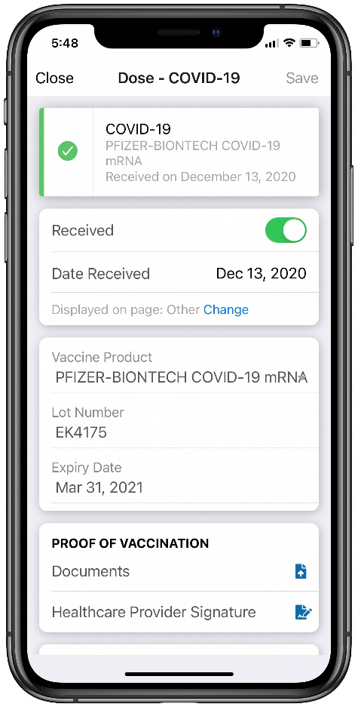
“It is essential that digital systems tracking COVID-19 vaccinations use the standardized terminology in the Canadian Vaccine Catalogue to ensure people receive the correct vaccine for their second dose, and to help with safety and effectiveness assessments,” says Cameron Bell, Chief Technology Officer, CANImmunize.

This standardized vaccine terminology is essential for governments, electronic medical record vendors and any organization tracking COVID-19 immunization data, as it will permit the timely aggregation and reporting of data across the country for surveillance purposes.

Features
- Standardized terminology and COVID-19 vaccine product information to allow real-time capture and digital exchange of immunization records across healthcare domains and jurisdictions.
- Includes vaccine DIN, lot and expiry information directly from Health Canada, Global Trade Item Numbers to support vaccine barcode scanning, and leverages the SNOMED CT Canadian Edition Immunization codes published and maintained by Canada Health Infoway.
Tradename COVID-19 vaccine codes:
- 28581000087106 – PFIZER-BIONTECH COVID-19 messenger ribonucleic acid 30 micrograms per 0.3 milliliter suspension for dilution for injection Pfizer Canada ULC-BioNTech Manufacturing GmbH (real clinical drug)
- 28571000087109 – MODERNA COVID-19 messenger ribonucleic acid-1273 100 micrograms per 0.5 milliliter liquid for injection Moderna Therapeutics Inc. (real clinical drug)

Generic COVID-19 vaccine codes:
- 28531000087107 – Vaccine product against disease caused by Severe acute respiratory syndrome coronavirus 2 (medicinal product)
- 1119349007 – Vaccine product containing only Severe acute respiratory syndrome coronavirus 2 messenger ribonucleic acid (medicinal product)

COVID-19 Antigen code:
- 840536004 – Antigen of Severe acute respiratory syndrome coronavirus 2 (substance)

COVID-19 Disease code:
- 840539006 – Disease caused by Severe acute respiratory syndrome coronavirus 2 (disorder)

British Columbia Provincial Health Services Authority and the Ontario Ministry of Health and Long-term Care currently use the CVC to configure their immunization repositories. The CVC also populates the vaccine information in the CANImmunize Clinic Flow product and the public CANImmunize app.

The catalogue is maintained and made available for national use through funding from Canada Health Infoway.
Explore the Canadian Vaccine Catalogue here.
ABOUT CANImmunize
CANImmunize is a technology company specializing in immunization software. It developed the CANImmunize platform, a pan-Canadian digital immunization tracking system that helps Canadians keep track of their vaccinations with a mobile app and web portal. The team offers digital solutions to businesses, health care organizations and governments for vaccinations and tracking, and is preparing for the COVID-19 vaccine rollout.

Media contact:
Kim Barnhardt
CANImmunize
kim@canimmunize.ca

