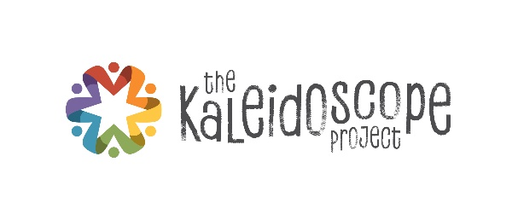
Kaleidoscope Connections
Great Ideas from September 18, 2018

Project Enlightenment
Ashley Lindsay, Triple P
Beth Tyler, Parent Teacher Resource Center

Wake Young Child Mental Health Collaborative
Norah Roehm, Developmental Therapist
Veronica Marmaud, Alliance Behavioral Health
Sarah Stevens, Lucy Daniels Center

We got a great overview of Project Enlightenment, which has been serving Wake County for 49 years. Here are the summaries of Prevention Services and Parent Workshops.

The library and the production area are open daily from 8 – 5 pm for teachers, families and kids. Some of the resources include:
- Children’s books – some on issues about calming, relaxation, sharing, hitting/biting, friendship, discipline, etc. Many of these are not found in the public library.
- Teaching and child development books
- Videos, DVDs, books on tape
- Grief kits that can be checked out
- Laminators, die cuts, book binder, and many other production supplies. Groups can reserve the whole area.

Triple P
- The Triple P - Positive Parenting Program ® is a parenting and family support system designed to prevent - as well as treat - behavioral and emotional problems in children and teenagers. It aims to prevent problems in the family, school and community before they arise and to create family environments that encourage children to realize their potential.
- Triple P draws on social learning, cognitive behavioral and developmental theory as well as research into risk factors associated with the development of social and behavioral problems in children. It aims to equip parents with the skills and confidence they need to be self-sufficient and to be able to manage family issues without ongoing support. While it is almost universally successful in improving behavioral problems, more than half of Triple P’s 17 parenting strategies focus on developing positive relationships, attitudes and conduct.
- Funding from John Rex Endowment for initial implementation (2013-2017)
- Received additional funding from John Rex Endowment and Wake County Smart Start to expand efforts through 2020
- Initial focus on Raleigh families with children ages birth through five - Now ALL of Wake
- Currently have approximately 260 active providers
- (Levels 2-5, English/Spanish, individual and group delivery including Stepping Stones)
- Community partners in conjunction with WCPSS/Project Enlightenment will provide Triple P services to families at all levels of need
- Evaluation provided by Dr. Mary Haskett, NCSU Department of Psychology
- Enhanced implementation support from The Impact Center (Frank Porter Graham Child Development Institute at UNC-CH)
- Two Triple P Parent Educators at Project Enlightenment - Particular focus on supporting families experiencing homelessness and assisting in project implementation/coaching
- There are other sites in Wake County with trained parent educators

Learn More!

Wake Young Child Mental Health Collaborative
The Wake Young Child Mental Health Collaborative (WYCMHC) started 20 years ago, and this think tank continues to meet on the 4th Thursday at Wake County Smart Start. Their work includes:
- Considering community needs around young child mental health and identifying gaps
- Staying abreast of what’s going on in the community
- Looking at lack of mental health services for young children led to a statewide assessment of child mental health and development of NCIOM recommendations about training, etc.
- Creating a training series in Wake County with AHEC
- Some of the other projects this collaborative initiated include:
  - Trainings
  - Mentor-Mentee training
  - Teen mother project at YWCA
  - Doula project
  - Pediatric surveillance in offices
  - Project CATCH
  - Project Launch at WakeMed
The meetings are held at Wake County Smart Start on the 4th Thursday of every month from 8:30 – 10:00 a.m. Those interested in attending should contact Nora Roehm at nora.roehm1@gmail.com.

