What is right is right, even if no one is doing it. What is wrong is wrong, even if everyone is
doing it.
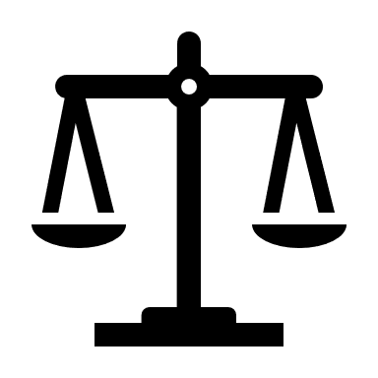
Unknown

