Kindness Chains
Cut paper chain strips of various colors. When children are caught being kind by a teacher or peer, put the child’s name and deed on the paper strip and continue to add to a paper chain.
This is a good project for the entire school You can connect one end of the school to the other!
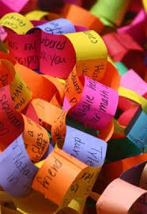
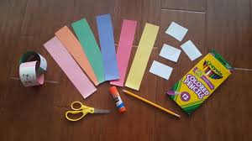

Kindness Chains
Cut paper chain strips of various colors. When children are caught being kind by a teacher or peer, put the child’s name and deed on the paper strip and continue to add to a paper chain.
This is a good project for the entire school You can connect one end of the school to the other!

