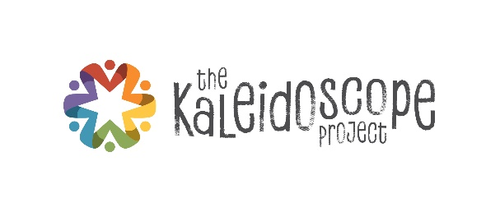**Kaleidoscope Connections**

Great Ideas from August 21, 2018

**Making Changes Sustainable: Policies that Matter**

Anna Troutman, Director of Programs, Wake County Smart Start

Michelle Hughes, Executive Director, NC Child

**Social Ecological Model**

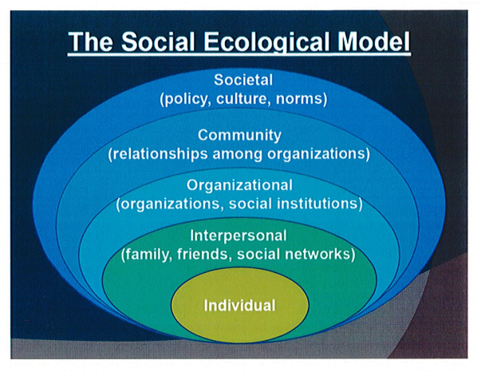

Research tells us that to make change at the population level, we must intervene on multiple levels. Examples include:

* Helping individual children
* Working with the people who serve children
* Using evidence based programs in your organization
* Engaging the whole network in a common goal
* Enacting public policy such as the tobacco prevention policies that eventually changed social norms

**Implementation Drivers**

The National Implementation Research network (now at Frank Porter Graham Child Development Institute) created the following framework for successful implementation of something new. Go to <https://nirn.fpg.unc.edu/learn-implementation/implementation-drivers> for more information.

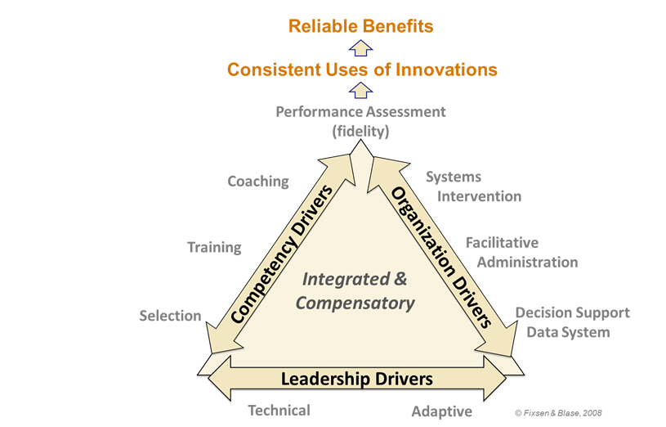

Examples of successes from the group:

* Strong organizational policies at Parks and Rec ensure that every child has the best experience. Training, coaching, and data tracking are important.
* Triple P is supported by Frank Porter Graham coalition, and fellow organizations use assessments of all pieces of the above framework. It has helped change the culture of organizations. Go to <https://ictp.fpg.unc.edu/resource-search> and search for Implementation Drivers Assessment (IDA-TP) and Community Capacity Assessment (CCA-TP)

Examples of challenges:

* In a large organization, there is no control over hiring of staff and training. Possible to compensate with supervision? coaching? influencing pool of candidates?
* Challenge of defining “most competent person” as the person with most education and hard skills. Shifted to 50% of hiring qualifications and performance being based on soft skills: Circle of Eight. **Circle of Eight document is attached.**

**Policy and Advocacy**

NC CHILD is the only advocacy organization focused solely on the welfare of children in the state. ([www.ncchild.org](http://www.ncchild.org))

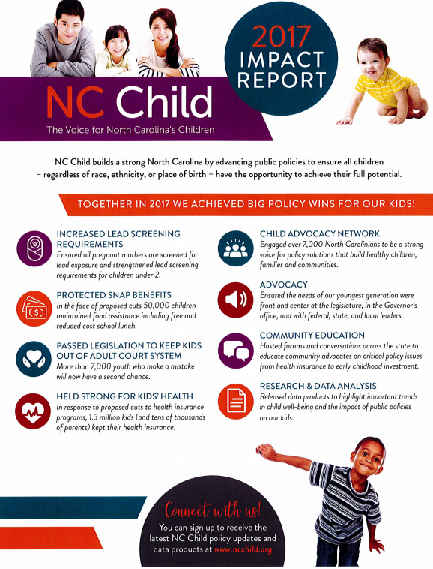

There are many challenges ahead for Medicaid transformation for child mental health, particularly for services for 0 – 3. There is an opportunity to better address the social determinants of health with the co-location of primary and mental health care providers. It is important to connect families with community based preventative services. For Wake County programs for school age children and teens, connect with Youth Thrive ([www.youth-thrive.org/](http://www.youth-thrive.org/)) See the website for more info about the Suicide Prevention Campaign in September and Bullying Prevention month in October.

Other resources:

* Check out Ready Set School which is provided by Marbles at Wake County Libraries. Family Play Dates start in September. (<https://www.marbleskidsmuseum.org/>)
* Contact the Poe Center if you would like to have a presentation about Bullying in October. Other programs, such as substance abuse prevention, are also available. ([www.poehealth.org](http://www.poehealth.org))
* There is a Back to School backpack giveaway and haircuts event at Lions Park this weekend from 10 – 2 on Saturday, Aug 25. <https://www.eventbrite.com/e/the-official-haircut-giveaway-sponsored-by-nigel-king-foundation-tickets-48511546341>

[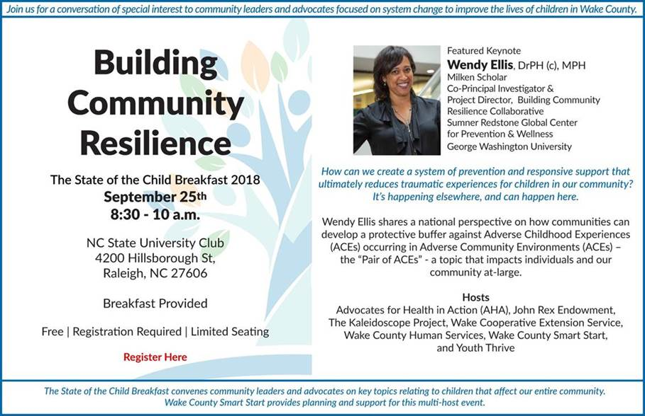](https://na01.safelinks.protection.outlook.com/?url=https://www.eventbrite.com/e/the-state-of-the-child-breakfast-building-community-resilience-tickets-48620081974&data=02|01|awelsh@kaleidoscopewake.org|c8429f3bbd914cbd0f8d08d5fedddce8|3811577ce7f546c48a5d336118a8b5bf|1|0|636695154344077959&sdata=QsXmnqNOmx5uYnjjLvwn/iG6nc5Kol36EIHZeLOz9x8%3D&reserved=0)

