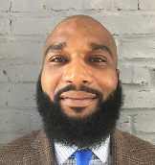
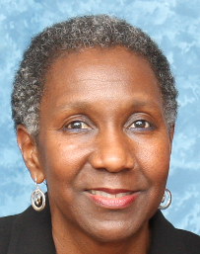
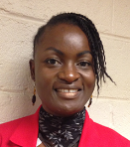
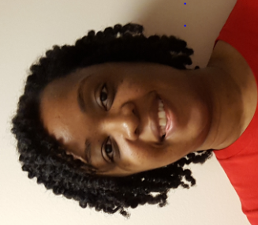
Helpful Tips for Taking This Course
The
Diabetes Team
Welcome to the African American Health Program’s (AAHP) online diabetes education sessions. You now have access to the DMeetings comprehensive diabetes management course at the tip of your fingers AND the support of AAHP’s Diabetes Team to enhance your learning experience.

As a user of this course, here are a few tips to help you be successful:
Reliable Internet Access
You must have reliable internet access to participate in this course. If you have trouble accessing the course, please contact one of the administrators listed at the end of this document.
Manage Your Time
Time management is an important skill to use while taking this 9-session course. Set aside about an hour to view each video, complete the test and evaluation, and reflect on how you will use your newly acquired information to set a personal goal. After session 1, you may shave a few minutes off each session by double clicking on the 2:40 time on the slide progress bar to skip the introduction.
Set a Goal for Completion
Setting a goal for completion puts you in the driver’s seat of your journey through this course. Following the webpage course guide will aide you in completing each lesson. It is best to do at least 2 lessons per week to keep re-enforcing the information you are learning. You can use either of the 2 options below:
-On Your Own
Watch the videos anytime and call Linda Goldsholl, RD at 240-777-1701 with your questions during the hours of 8am – 3pm.
-Join the “One Month and Done!” Group Schedule
Watch the videos assigned for that week and join a conference call for added support on the following Monday at 12pm or 7pm. To receive any handouts, send an email to Linda.Goldsholl@montgomerycountymd.gov to let us know you will be on the call. The phone number is: 301-476-1987 - Pass Code: 714-386-568
Any Month | Review These Sessions | Conf Call  Discussion* | Support Provided
Week 1  (starts the 1st full week) | 1. Introduction to Diabetes  2. Healthy Eating - Part 1  2. Healthy Eating - Part 2 | Monday  Week 2 | Test question review  Review of evaluations  Q & A  Making your goals  Recommend food documentary films  Nutrition Action

Week 2 | 3. Being Active  4. BG monitoring  5. Medications | Monday  Week 3 | Test question review  Review of evaluations  Q & A  Making your goals, Plus more
Week 3 | 6. Problem Solving  7. Coping and Reducing Stress | Monday  Week 4 | Test question review  Review of evaluations  Q & A  Making your goals, Plus more
Week 4 | 8. Reducing complications  9. Putting it all together | Monday  Week 1 the following month | Test question review  Review of evaluations  Q & A  Making your goals, Plus more
*Conference calls will be held on Tuesday following a Monday holiday
Don’t Fret Over the Tests
Each session includes a 10-question test that must be taken to complete the session on your progress record. If you find the tests difficult, it might help to review each test prior to watching the video. Our goal is to provide this course so that you can learn, and apply what you learn, to your everyday life. Unfortunately, because it is copyrighted material you cannot make a handout of the slides. You can copy and paste a slide into a new document if you wish.
Keep the Focus: Remember Why You are Taking this Course
Think about why you are taking this course and what you hope to accomplish. Is it to gain insight into your health or the health of someone else? Is it to have a better handle on managing your diabetes? Whatever the reason, keep that in mind as you work towards your personal goals!
Bonus Feature!
Once you have completed at least 5 modules with scores of 70% or more, you may request an appointment with Dr. Myers, MD; Linda Goldsholl, RD; or other AAHP staff to discuss your personal concerns.
Health assessments and follow-up of weight, BP and A1c can be done at the AAHP office, or meet us at a class or community health screening event.
Ask for Help if You Need It
If you need assistance regarding the material, contact Linda Goldsholl, RD at 240-777-1701 or linda.goldsholl@montgomerycountymd.gov.
For technical assistance, contact Linda Goldsholl at 240-777-1701 or linda.goldsholl@montgomerycountymd.gov; or Tonja Rice at 240-773-0396 or trice@mcfarlandassociate.com.
The Diabetes Team
Dr. Myers, MD
Robina,
Food for Life
Instructor
Linda,
Dietitian
Beri, Nurse
Tonja,
Community
Health Worker
Aiysha,
Social
Worker

