Young People’s Centre
69 Ship Street
Brighton
BN1 1AE

T: 01273 721211
E: recruitment@allsortsyouth.org.uk

November 2020

Dear Applicant,

Thank you for expressing an interest in this role*. We are looking to recruit an enthusiastic Black, Asian, Minority, Ethnic (BAME) Lesbian, Gay, Bisexual or Trans (LGBT+) youth support worker to induct young people into the project, facilitate 2 x monthly groups, offer one-to-one support and network/connect with other projects. You will also act as positive LGBT+ role-model for our service users.

You will join a growing, professional and passionate team who supports LGBT+ and unsure children, young people and their families and challenge exclusion, prejudice and discrimination in all areas of their lives.

Over the last few years, Allsorts has been consulting and working with members of the LGBT+ BAME community to address the lack of racial diversity within the project and ensure that Allsorts is an inclusive, representative and understanding project. Whilst we’re a long way off where we’d like to be, we are committed to ensuring BAME inclusion project wide, from the board to the young people, volunteers, staff team and people we work with. We are at the early stages of this journey and with BAME inclusion being very much at the heart of the new strategic planning that is currently underway, it is the responsibility of all trustees and staff at to ensure we all actively engage with & work towards BAME inclusion here at the project.

Applications will be judged according to the criteria of the job description and person specification as required by our Equality, Diversity & Inclusion and Recruitment Policies. Please make sure you answer the points in the person specification on your application form.

Allsorts Youth Project is an equal opportunities employer and welcomes applications from all sections of the community. We particularly encourage applications from people from intersectional and minority groups, including trans and/or non-binary; intersex; gender-variant; and/or those with disabilities, and/or who are neuro-diverse.

If you would like this information in another format, e.g. large print or audio, please email recruitment@allsortsyouth.org.uk

We look forward to hearing from you and wish you luck with your application.

Yours sincerely,
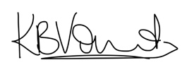

Katie Vincent
Chief Exec

*This role is deemed to be a genuine occupation requirement under Schedule 9, Paragraph 1 of the Equality Act 2010. for protected characteristics, in this case, to be Black, Asian, Minority Ethnic and Lesbian, Gay, Bisexual, Trans or non-binary (LGBT+) youth workers who will reflect the membership criteria of the target group.

ABOUT ALLSORTS

ALLSORTS YOUTH PROJECT LISTENS TO, SUPPORTS & CONNECTS CHILDREN & YOUNG PEOPLE UNDER 26 WHO ARE LESBIAN, GAY, BISEXUAL, TRANS (LGBT+) OR UNSURE OF THEIR SEXUAL ORIENTATION AND/OR GENDER IDENTITY.

Vision:
We want to see a world where LGBT+ young people are free to thrive.

Mission statement:
To support lesbian, gay, bisexual, trans (LGBT+) and unsure children and young people and challenge exclusion, prejudice and discrimination in all areas of children and young people’s lives.

Aims of the project:
  - To support LGBT+ children and young people in Brighton and Hove and the surrounding area who are LGBT+ or unsure of their sexual orientation and/or gender identity
  - To provide empowering volunteering opportunities for LGBT+ children and young people to run events and awareness raising campaigns
  - To provide social and cultural activities for LGBT+ children and young people to develop friendships and have fun
  - To deliver peer-led homophobia, biphobia and transphobia awareness and anti-bullying workshops for young people in schools, colleges and youth organisations
  - To provide LGBT+ awareness training for adults and agencies working with young people
  - To provide resources and educational materials relating to LGBT+ children and young people and promoting their well-being

ALLSORTS TEAM

Staff Team
We are a growing team and have a total of 12 team members. 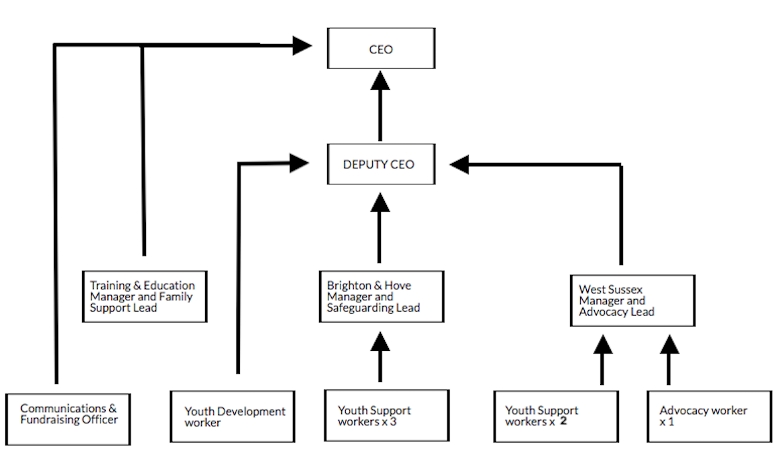

Volunteer Team
We currently have approximately 42 youth volunteers and 38 community adult volunteers working across our groups and age ranges in Brighton, Chichester, Horsham and Worthing.

Board of Trustees
We currently have 8 members on the Management Committee which is led by our Chair, Trudy Ward. For more information about the Trustees, please visit the website.

How we are working due to COVID-19 restrictions
The Allsorts team have been working from home since the 17th March with all staff having undertaken an individual risk assessment and work station assessment, which are reviewed regularly.

All services (groups, one-to-one support, advocacy, training), fundraising and events have been delivered online via zoom (pro accounts) since early April.

In line with the National Youth Agency guidelines and Government guidance, and with the appropriate PPE & protocols in place, Allsorts has been delivering ‘walk and talks’ and in-person groups to those most in need.

PROCEDURE FOR APPLICATION

- Closing date for completed applications is 14th December 2020 at 9am.

- Shortlisted applicants will be informed via email by 16th December by 6pm. Please note that you will only be contacted if you are invited for interview.

- Interviews to be held in the afternoon on Friday 18th December, via zoom.

- Start Date: January 2020.

- Assessment Process: there will be two interviews:

    - formal panel made up of an Allsorts young person, staff member, trustee, volunteer and the CEO which will take 30-40 minutes.
    - young people’s group interview lasting 20-30 minutes.

- Sending us your application form:
Please fill out the application form and return it to us as an email attachment to recruitment@allsortsyouth.org.uk with Private & Confidential in the subject line.

OR

A paper copy by post marked as Private & Confidential to Recruitment, Allsorts Youth Project, Young People’s Centre, 69, Ship Street, Brighton, BN1 1AE.

- Filling out your application:
Applications will be judged according to the criteria of the job description and person specification as required by our Equality, Diversity & Inclusion and Recruitment Policies. Please make sure you answer the points set out in the person specification on your application form, paying attention to essential & desirable criteria and what will be assessed at application or interview stage. All successful applicants are subject to an enhanced DBS & reference checks. Please follow these guidelines with care - application forms may be rejected if they fail to adhere to them.

Should you need any more information or would like to discuss the role, please email recruitment@allsortsyouth.org.uk to arrange a call back.

JOB DESCRIPTION

Job Title: | BAME LGBT+ Youth Support Worker
Term: | Fixed for 6 months, extension subject to funding.
Salary: | £25,295 per annum pro rata (£5,469 actual)
NJC Scale: | Scale 6
Accountable to: | Brighton & Hove Project Manager
Hours of work: | 8 hours a week, part time
Annual Leave: | 27 days (pro rata), plus bank holidays.  Our leave year runs in line with the financial year.
Pension: | Allsorts Youth Project is part of Royal London’s pension scheme and contributes 8% towards your pension.
DBS & References: | Please note that successful applicants will be subject to an enhanced Disclosure and Barring Service (DBS) check & references.
Training & development: | Allsorts Youth Project aspires to be a learning organisation that supports its staff to improve their skills and knowledge. This may be through informal means such as mentoring, work shadowing or more formal training courses. You will be invited to reflect on your own training needs in discussion with your line manager, initially as part of the probation process and then ongoing through the regular supervision and our annual appraisal process.
Staff wellbeing | For this role, we will be offering supervision with a qualified LGBT+ specific psychodynamic psychotherapeutic counsellor whose work also takes into account intersecting and oppressive structures and post-slavery syndrome.  We also offer physical and mental health & wellbeing support via Bright Wellbeing and Counselling service with access to:  - Face-to-face counselling  - Online support, webinars & mini-health check.  - Open 24/7, 365  - Confidential advice line

AREAS OF RESPONSIBILITY
A | Front Line Responsibilities  - Assess, greet & induct young people into the project as per Allsorts procedures.  - Facilitate a group session once a month for Lesbian, Gay, Bisexual, Trans (LGBT+) and unsure young people under the direction of the Brighton & Hove Manager and Safeguarding Lead.  - Create & deliver a monthly BAME LGBT+ group for young people.  - Develop & deliver fun, engaging social & educational activities for LGBT+ and unsure young people addressing, intersectionality, mental, physical & sexual well-being and resilience.  - Provide one-to-one support to LGBT+ and unsure young people, including check-ins at groups.  - Engage, connect and network with other agencies, youth organisations, BAME projects and other LGBT+ organisations in order to support BAME LGBT+ young people access services at Allsorts.  - and attend meetings in intersectionality, mental, physical & sexual well-being.  - Attend activities outside of Allsorts such as, but not limited to: residentials, events and outings for LGBT+ young people; Allsorts AGM; Pride events.  - Work with the comms worker to ensure social media platforms are inclusive and up to date.  - Co-facilitate other groups, if and when needed within the project.
B | Performance Management, Monitoring & Evaluation  - Support & contribute to quarterly highlight reports, the annual report & and annual funders reporting.  - Keep up to date and accurate records of one-to-one work and group work and oversee gathering of monitoring data (statistics, surveys, etc)
C | Training & Education  - Contribute to LGBT+ inclusive educational and support resources as and when requested.
D | General Responsibilities/ Requirements  - Attend line management supervision, peer supervision, team meetings, annual appraisal and external clinical supervision.  - Keep up-to-date with issues and best practice developments within the LGBT+ community and generic youth work, guide and advise the organisation accordingly.  - To maintain strict confidentiality with regard to information given by and about service users. To work to the legal requirements of child protection and safeguarding legislation.  - Attend mandatory safeguarding training and refresher sessions, as well as other relevant staff development/ learning sessions, and undertake research to fulfil the requirement of the post.  - Provide information and guidance for LGBT+ and unsure young.  - Ensure that a high standard of information and support is available to LGBT+ and unsure young people using the service.  - Network with local & national youth professional organisations both statutory & voluntary and attend meetings.  - To liaise with other statutory and voluntary sector support services on referrals and issues arising from joint working.  - Work pro-actively to involve LGBT+ and unsure young people in all aspects of the work of the project and enable, where possible, LGBT+ youth leadership.  - Attend relevant events to promote Allsorts Youth Project.  - Commitment to adhere to & implement the policies and procedures of Allsorts Youth Project.  - A commitment to the success, values and ethos of Allsorts Youth Project.  - Promote the project through digital & social media platforms, events and resources.  - To work closely as part of a team with Allsorts staff, trustees & volunteers.  - To work on your own initiative, often under pressure, with and at times, without supervision.  - All staff may be asked to undertake other duties and responsibilities as determined by the management team, on an occasional basis.

PERSON SPECIFICATION

ESSENTIAL CRITERIA
Experience | - Working with individuals and/or small groups in supportive and empowering ways.  - Designing and delivering fun, social and educational activities.  - Working as part of a team and on own initiative.  - Lived experience as a BAME LGBT+ person.
Skills | - Ability to motivate, inspire and empower children and young people  - Demonstrable commitment to combating all forms of discrimination  - Ability to work in an environment dealing with challenging and sensitive issues  - Ability to prioritise and manage own workload  - Effective listening and communication skills, verbal and written (reports and monitoring)  - Ability to work flexible hours and evenings  - Basic IT skills, including gmail, google drive & basic word processing.
Knowledge/ Qualifications | - Excellent understanding of intersectionality and the range of issues faced by LGBT+ young people.  - An in-depth understanding of equalities and diversity and intersectionality.  - Good understanding of safeguarding.
DESIRABLE CRITERIA

- Having worked or volunteered in a youth setting
- Having worked or volunteered in an LGBT+ or BAME community setting
- A good understanding of effective youth support work
- Working with young people one-to-one and in group settings
- Professional qualification in youth work or similar field up to diploma level.
- 3+ years experience in youth work or similar field

Please complete this application form in type or black ink. If the space provided in any section of this form is insufficient, please continue on A4 paper. All applications are treated as confidential and in accordance with the principles of equal opportunities.

Title of post applied for:

PERSONAL DETAILS
Title |  |  |  | First name(s) |  |  |  |  |  |  |  |  | Last name
 |  |  |  | Preferred name:
Pronouns:
Address:

Telephone Daytime: |  |  |  |  |  |  |  |  |  | Mobile:
Email address:

EDUCATION AND OTHER QUALIFICATIONS

You can submit a CV for this section. Please give details, in chronological order, academic/ vocational/ professional qualifications
 | From | To |  |  | School/ College/University attended |  |  |  |  |  |  |  |  | Subjects  Studied |  |  |  | Examinations passed/Qualifications

OTHER TRAINING UNDERTAKEN

You can submit a CV for this section. Further relevant specialist training, short courses, in-house training etc.
 | Completion Date |  |  |  |  |  | Description of Training/Course
 | PRESENT EMPLOYMENT (or most recent) – you can submit a CV for this section
 | Name and Address of Employer |  |  |  |  |  | Post Title |  |  |  |  | Date Appointed |  |  |  |  | Grade & Present Salary |  | Notice Required
 | Please describe your duties and responsibilities (please continue on a separate sheet if necessary
 | PREVIOUS EMPLOYMENT (Please start with last post held) – you can submit a CV for this section
 | From |  | To |  |  |  |  | Name and Address of Employer |  |  | Position held/work undertaken |  |  |  |  |  |  |  | Reason for leaving

KNOWLEDGE, SKILLS, EXPERIENCE RELEVANT TO THE POST

Please use this space to tell us a little more about yourself and why you are interested in this post. The attached person specification describes the skills, knowledge and understanding we are seeking which you may have acquired through paid or voluntary work/ life experience. We will be assessing your application against each of the points in the person specification so please address each point separately. If you do not meet all the criteria it is unlikely that you will be shortlisted for interview. Please continue on a separate sheet if necessary.

APPLICANTS WITH DISABILITIES
Allsorts Youth Project is committed to employing people with disabilities. If called for interview of appointed in post, please state any arrangement we can make to assist you.
DISCLOSURE OF CRIMINAL RECORD
This post involves direct work with vulnerable adults and/or children and young people between the ages of 11-25. As such it is exempt from the Rehabilitation of Offenders Act (1974) and you are required to declare any criminal conviction, even if it would be defined as spent under the act. Any offer of employment will be subject to an “Enhanced Disclosure” from the Disclosure and Barring Service (DBS). If you falsely declare that you have no criminal record, this may be taken as a breach of contract and could result in dismissal. If you are offered this post confirmation will be subject to a check by the DBS. Existence of a criminal record does not specifically debar you from employment. Any information that you provide will be treated as strictly confidential and will be considered only in relation to your application. Please give details of any conviction, caution, bind-over order or pending prosecution or Court proceedings:

REFERENCES
Please give the name, address, occupation and telephone numbers of two people who can be approached for references. Your referees should not be related to you and would normally include your current and previous employer or college tutor where applicable.
Name:  Address:  Telephone:  E-mail:  Relationship to you: | Name:  Address:  Telephone:  E-mail:  Relationship to you:

DECLARATION
Information from this application may be processed for purposes registered by the Employer under the Data Protection Act 1998. Individuals have, on written request the right of access to personal data held about them.
I give my consent to Allsorts processing the data supplied in this application form for the purpose of recruitment and selection for the role. The information Allsorts will hold includes my contact details, application form, references, correspondence with or about me and my performance in any interview(s), if offered. Much of the information Allsorts will hold has been provided by me, however I understand that some information may come from other sources, such as referees.
I certify that the information given in this application is true and correct. I understand that if any false or misleading information is given or relevant information is deliberately withheld, this may result in the application being disqualified or the appointment being terminated. Due to the sensitive nature of the duties the post holder may be expected to undertake, I also understand that the Declaration will include details of any criminal convictions, cautions, reprimands and final warnings and any other information that may have a bearing on my suitability for the post. I understand too that an Enhanced Disclosure will be sought in the event of a successful application.

Signed:
Print Name:
Dated:

EQUAL OPPORTUNITIES MONITORING FORM
Allsorts Youth Project is committed to the Principle of Equal Opportunities and strives to be an Equal Opportunity Employer. To ensure that we comply with Equal Opportunity Legislation the organisation asks that all applicants complete the details below. This information will be used solely for monitoring purposes and will be treated as confidential; it will be separated from your application upon receipt and before any consideration of candidates takes place. Please complete this application form in type or black ink. Completion is entirely voluntary and is not required for consideration for employment.
APPLICATION FOR THE POST OF:

Please state here where you saw the post advertised

Age range: |  | 18-25  26-40  41-65  65+

How would you describe your gender? | _______________________________________

Is your gender different than the sex you were assigned at birth? |  | Yes |  |  | No

How would you describe your sexual orientation?
____________________________________

 | Which category best describes your ethnic or cultural origin?
Asian |  |  | Mixed |  | White
Asian British |  |  | Asian & White |  | British
Bangladeshi |  |  | Black African & White |  | Irish
Indian |  |  | Black Caribbean & White |  | European
Pakistani |  |  | Other |  | Other
Other
Black |  |  | Chinese or Other Ethnic Group
Black British |  |  | Chinese |  | Gypsy
African |  |  | Arab |  | Traveller
Caribbean |  |  | Jewish |  | Other
Sudanese

If you have a religious belief, please specify

Do you consider yourself to have a disability? |  |  | Yes |  |  | No

