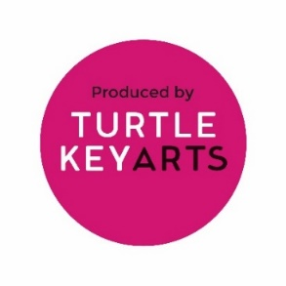
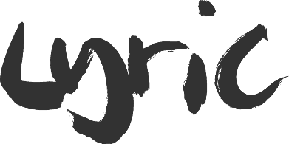
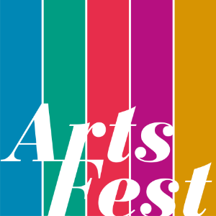
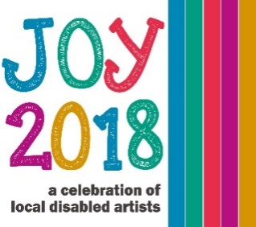
This application is for taking part in the JOY disability strand of Hammersmith and Fulham Arts Festival. This will be taking place at the Lyric Hammersmith between the 6th – 9th June. If you require any help with this application, or have any questions about JOY, please call Kelly on 020 8964 5060 or email kelly@turtlekeyarts.org.uk

CONTACT INFORMATION
- Your contact details
Name
Organisation
Email
Address

Phone Number
Mobile Number
Web Address (if applicable)

- Are you an individual artist or an organisation resident working in the Borough?
YES
NO

- Accessibility details
Are you disabled?
If yes, what is your disability?
What accessibility needs do you require?

EVENT INFORMATION
- Title of Event
Title
Company size
Description (50 words)

- Which Date and Times are you available:
Wednesday 6th June | Afternoon
 | Evening
Thursday 7th June | Afternoon
 | Evening
Friday 8th June | Afternoon
 | Evening
Saturday 9th June | Afternoon
 | Evening

- Suitable for Audiences (please specify)
0-5
5-11
11-25
All ages

- Does your event contain strong adult content such as nudity or explicit language?
YES
NO
If yes, please explain in more detail

Please be aware, if you are awarded a slot in the JOY performance programme, a small technician fee will be deducted from your box office takings. The rest of the box office will be divided amongst the artists.
Please return your completed application form and any other information to Kelly by the 31st March 2018 by either email or post:
kelly@turtlekeyarts.org.uk
Turtle Key Arts
Lyric Hammersmith
Lyric Square
King Street
London
W6 0QL
HF ARTSFEST IS COMMITTED TO EQUALITY AND INCLUSION IN ALL OF ITS ACTIVITIES AND ENCOURAGES ARTS PARTNERS TO FULLY COMMIT TO THIS ETHOS
Registered Charity Number: 1162116
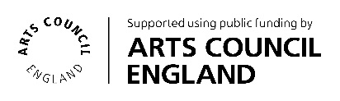
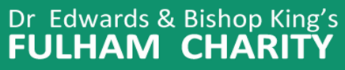
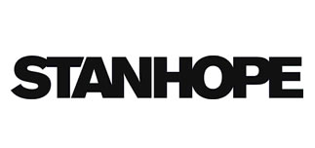
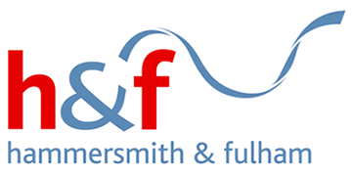
JOY is a strand of the Hammersmith and Fulham Arts Festival, produced by Turtle Key Arts and funded by Arts Council England, Hammersmith United Charities, Dr Edwards and Bishop King’s Fulham Charity, Stanhope and the Borough of Hammersmith & Fulham.

