For: ___________________________________________
EQUINE REPORT CARD
FIRST NAME LAST NAME
_____/_____/_____ ___________ _________
DATE HORSE AGE
Vaccination Program
- Up to Date Tetanus _____ EEE/WEE _____ Flu _____ Rhino _____ PHF _____ Strangles _____
- Vac. Due: Tetanus _____ EEE/WEE _____ Flu _____ Rhino _____ PHF _____ Strangles _____
- Vac. Given: Tetanus _____ EEE/WEE _____ Flu _____ Rhino _____ PHF _____ Strangles _____

1. Coat & Skin
- Appears normal  - Dull  - Scaly  - Dry | - oily  - Shedding  - Matted  - Tumors |  |  |  | - Itchy  - Parasites  - Other  _____________  ______________
2. Eyes
- Appears normal  - Discharge: L___ R___  - Inflamed: L___ R___  - Eyelid Deformities |  |  | - Infection: L___ R___  - Cataract: L___ R___  - Other _______________  _____________  ______________
3. Ears
- Appears normal  - Inflamed  - Itchy  - Mites |  |  | - Tumor: L___ R___  - Excessive Hair  - Other  _____________  ______________
4. Nose & Throat
- Appears normal  - Nasal Discharge  - Inflamed Throat |  |  | - Enlarged Lymph Glands  - Other ________________
5. Mouth, Teeth, Gums
- Appears normal  - Broken Teeth  - Sharp edges  - Ulcers  - Tumors |  | - Inflamed Lips  - Loose Teeth  - Pyorrhea  Other  ______________
6. Legs & hooves
- Appears normal  - Lameness (LF, RF, LR, RR)  - Damaged Ligaments  - Thrush |  |  |  | - Hoof Problems  - Joint Problems  - Other  _______________

- Diagnosis / Description | Recommendations
- Lab results by mail / phone / consult | - Recommend Teeth Float
- Injection given | - Recommend referral to a farrier
- Start medication at_____________ | - Recommend weight loss ___ weight gain ___
- Give second dose medication on / / | __________________________________________________
__________________________________________________ | __________________________________________________
__________________________________________________ | __________________________________________________
__________________________________________________ | __________________________________________________
__________________________________________________ | __________________________________________________
__________________________________________________ | __________________________________________________
DR. ___________________________________________ | Need ___________________________ in _______ days

2195 R2016NOV Your Animal Hospital
Street Address
City, ST ZIP
(555) 123-4567

7. Heart
Coggins Test
- Negative
- Positive
- Recommended

Fecal Test
- Negative
- Positive
- Recommended

- Appears normal  - Murmur  - Slow |  | - Fast  - Other _____________ __________________
8. Abdomen
- Appears normal  - Enlarged Organs  - Fluid | - Abnormal Mass  - Tense/Painful  - Other _______________
9. Lungs
- Appear normal  - Abnormal sound  - Coughing  - Congestion | - Breathing Difficulty  - Rapid Respiration  - Other _______________ _____________________
10. Gastrointestinal System
- Appears normal  - Palpation - OK  - Colic History  - Sounds: L ___ R ____ | 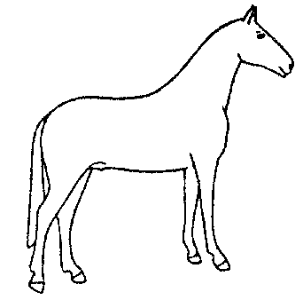  - Abnormal Feces  - Parasites  - Anorexia________________ _____________________
11. Urogenital System
- Appears normal  - Discharge  - Abnormal testicles | - Mammary tumors  - Other  _____________  ______________
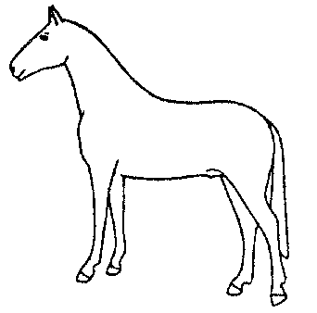
12. Central nervous System
- Appears Normal  - Seizures | - Depression.  - Behavior Problems ________________
13. Diet
- Excellent  - Good | - Vitamins needed  - Improvement necessary

