Small Mammal Report Card
Pet’s Name_________________ Owner’s Name_______________________
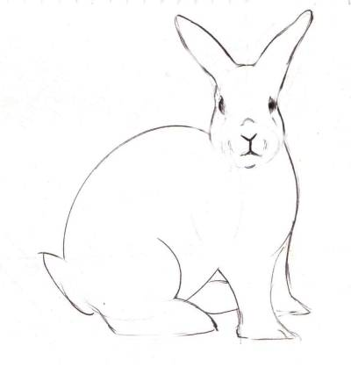
Reason for Visit ______________________________________________
Examined by __________________________________ Date ___/___/___

Weight ____________ Heart Rate ____________ Temperature_________________
Respiratory Rate ______________ Diet_____________________________________
Microchip/Tattoo _______________________________________________________

1. Coat/Fur & Skin
- Appears normal  - Scaly  - Dull/Dry  - Infection  - ____________ | - Matted  - Scabs  - Shedding  - Tumors |  |  |  |  | - Itchy  - Hair Loss
2. Eyes
- Appears normal  - Discharge: L__ R__  - Inflamed: L__ R__  - Eyelid Deformity  - Corneal Ulceration L__ R__ |  |  |  |  | - Infection: L__ R__  - Cataract: L__ R__  - __________________
3. Ears
- Appears normal  - Inflamed L___ R___  - Infected L___ R___  - Discharge L___ R___ |  |  |  | - Tumor L___ R___  - Excessive Hair  - Mites  - Painful L___ R___
4. Nose
- Appears normal
- Nasal Discharge
- Other__________________
5. Mouth, Gums & Teeth
- Appears normal  - Tartar Buildup  - Inflamed Lip(s)  - Broken Teeth  - Tumors |  | - Periodontal Disease  - Abscessed  - Overgrown Incisor(s)  - Overgrown Molar (s)  - Overgrown Root(s)
6. Legs & Paws
- Appears normal  - Joint Problems  - Nail Problems |  |  | - Limping  - Missing Toe(s)
7. Urogenital System
- Appears normal  - Mammary Tumor(s)  - Abnormal Testicle(s) |  |  | - Abnormal Urination  - Genital Discharge
- Diagnosis / Description  (Numbers below correspond to numbers above) | Recommendations
- Lab results by mail / phone / consult | __________________________________________________
- Injection given | __________________________________________________
- Start medication __________________________________ | __________________________________________________
__________________________________________________ | __________________________________________________
__________________________________________________ | __________________________________________________
__________________________________________________ | __________________________________________________
__________________________________________________ | ___________________________________________________

8. Gastrointestinal System
- pears normal  - Statis/Impaction  - Anorexia |  |  | - Abnormal Stools  - Parasites  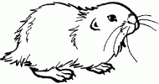  - _________________
9. Abdomen
- Appears normal  - Enlarged Organs  - Fluid |  |  | - Abnormal Mass  - Tense/Painful  - Swollen  - _________________
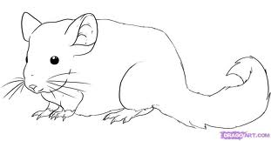
10. Heart
- Appears normal  - Murmur  - Irregular |  |  | - Fast  - Slow  - _________________
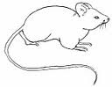
11. Lungs

- Appears normal  - Abnormal sounds  - Coughing  - Congestion |  |  | - Breathing Difficulty  - Rapid Respiration  - Dyspnea  - _________________
Recommended Care

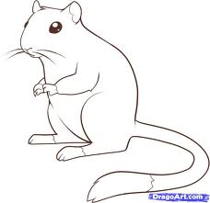
R = Recommended C = Current
= Given Today
___________Annual Blood Work
___________Urinalysis
___________Fecal Examination
___________Spay / Neuter
___________Microchip
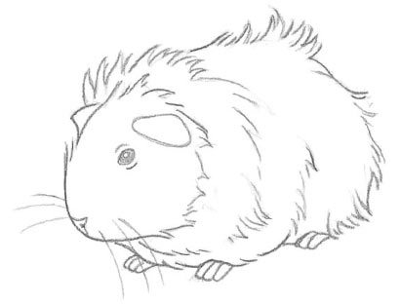
___________Skin Scraping
___________Fungal Culture
___________Ear Cytology
___________Other

