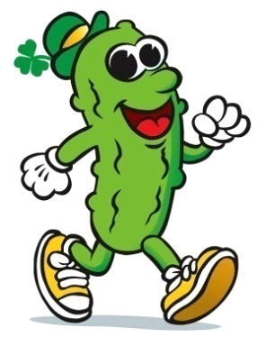
The World’s Only St. Paddy’s Pickle Parade & Palooza
Baby Parade Application
Mail completed entry form and fee to Pickled Mansfield Society, 900 N. Walnut Creek Drive, Suite 100, Box 270, Mansfield, Texas 76063.
The World’s Only St. Paddy’s Baby Parade will be held at 10 a.m. Saturday, March 17, 2018, on the Community Stage in downtown Mansfield. All children must have a parent/guardian present at all times. Babies and parents/guardians will need to check in at the Community Stage by 9:30 a.m. Saturday, March 17. Application fee is $10 per child. Entry is limited to 25 baby dills between age 6 months and 48 months. Deadline to enter is March 1 (or when entries are all taken). Entries will be judged in three categories: Most Creative, Best Use of Mardi Gras Theme and Most Pickled.
Child’s Name: _______________________ Parent’s Name: _______________________________
Child’s Age: _____ months _____ years Child’s Gender: _____ Male _____ Female
Parent’s Cell Phone #: _____________________ Email: __________________________________
As a prerequisite to participation in the World’s Only St. Paddy’s Pickle Parade, the undersigned, as a responsible party and representative for all participants of the aforementioned entry, knowingly and voluntarily assumes, on behalf of all participants, any and all risks inherent to participation in the parade and indemnifies Pickled Mansfield Society against any and all claims resulting from or related to their participation. Further, the undersigned waives on their behalf and all participants associated with this entry, any rights to claims against the Pickled Mansfield Society, City of Mansfield and their elected officials, sponsors, volunteers, agents or employees for any reason including but not limited to, loss of life, bodily injury, property damage and/or loss that may be sustained as a result of participation in the Parade. The undersigned acknowledges receipt of, and agrees on their behalf and all in said parade participants associated with the entry, to abide by the rules and regulations for participation in the World’s Only St. Paddy’s Pickle Parade. Acceptance of this application and participation in the parade is strictly subject to the discretion of Pickled Mansfield Society, and the Society reserves the absolute right to reject any application for participation in the parade. Submission of a signed application shall not be deemed as granting any applicant the right to enter or participate in the parade. In case of rain, Pickled Mansfield Society will make every reasonable effort to proceed with the parade. Pickled Mansfield Society reserves the right to cancel the parade at its sole discretion due to severe weather, act of God or other circumstances beyond our control, and there will be no make-up date or refund.
A Parent/Guardian signature is required for all minor entrants.

Sign: ______________________Print Name: __________________ Date: ___________

