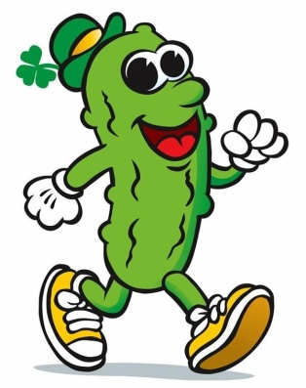
The World’s Only St. Paddy’s Pickle Parade & Palooza
Community Stage Application
Mail completed application to Pickled Mansfield Society, 900 N. Walnut Creek Drive, Suite 100, Box 270, Mansfield, Texas 76063.

The World’s Only St. Paddy’s Pickle Parade & Palooza’s Community Stage will be open from 10 a.m.-12:30 p.m. and 3-6 p.m. Saturday, March 17, 2018, in downtown Mansfield. Performances by choirs, dancers, theater groups, bands or other groups should be no more than 20 minutes. All performances must be in good taste and appropriate for all ages. Performers must bring their own music on a CD/thumb drive and submit to stage crew prior to performance. A chaperone must remain with youth groups at all times. All performances are free, but must be approved in advance by stage organizers.
Performer/Group Name: ________________________________________________________________
Type of Performance: ___ Choir ___ Singer ___ Dance Team ___ Ind. Dancer ___ Theater ___ Band
Other (please specify): __________________________________________________________________
Number of Performers in Group: ___________________ Length of Performance: ___________________
Have you previously performed at the Pickle Parade? ______________
Representative’s name: ___________________________ Phone#: _______________________________
Cell#: _______________________________ Email: ___________________________________________
As a prerequisite to participation in the World’s Only St. Paddy’s Pickle Parade, the undersigned, as a responsible party and representative for all participants of the aforementioned entry, knowingly and voluntarily assumes, on behalf of all participants, any and all risks inherent to participation in the parade and indemnifies Pickled Mansfield Society against any and all claims resulting from or related to their participation. Further, the undersigned waives on their behalf and all participants associated with this entry, any rights to claims against the Pickled Mansfield Society, City of Mansfield and their elected officials, sponsors, volunteers, agents or employees for any reason including but not limited to, loss of life, bodily injury, property damage and/or loss that may be sustained as a result of participation in the Parade. The undersigned acknowledges receipt of, and agrees on their behalf and all in said parade participants associated with the entry, to abide by the rules and regulations for participation in the World’s Only St. Paddy’s Pickle Parade. Acceptance of this application and participation in the parade is strictly subject to the discretion of Pickled Mansfield Society, and the Society reserves the absolute right to reject any application for participation in the parade. Submission of a signed application shall not be deemed as granting any applicant the right to enter or participate in the parade. In case of rain, Pickled Mansfield Society will make every reasonable effort to proceed with the parade. Pickled Mansfield Society reserves the right to cancel the parade at its sole discretion due to severe weather, act of God or other circumstances beyond our control, and there will be no make-up date or refund.
A Parent/Guardian signature is required for all minor entrants.

Sign: _______________________ Print Name: _______________________ Date: ____________

