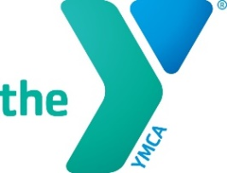 Camp Sequoia Lake 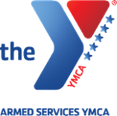
Hero’s Scholarship

The scholarship fund has been created to help Active Military Families to help send their children to YMCA Camp Sequoia Lake summer camp. The Hero’s scholarship fund is made possible by contributions from local businesses, individuals and by the Armed Services.
If you or anyone you know would like to make a tax deductible contribution to the Hero’s scholarship fund, it can be sent to the camp office. Please be sure to mark “Hero’s fund” on your contribution.

Personal Information:
Parent/Guardian: ______________________________________Phone: _______________________Cell Phone: _____________________
Street: ________________________________ City: ___________________State: _____________ Zip: ______________________________
Email Address: ___________________________________________________________

Child info:
Name: ___________________________________________________DOB: _______________________Age: _______________
Grade Entering: ________Sex: __________ Years at Camp: _____________ Camp: Youth ___________Session: _____________
Active Military Information:
Name of Military Parent: ________________________________________________________ Years of Service: ____________________
Rank: __________________________________ Stationed at: _______________________________________________________________
Commanding Officer: _______________________________________Phone number for commanding officer: ____________________

Application requirement:
A write letter from the parent or child about why they deserve to come to camp, there past experiences or how camp can help them with their future goals. You will need to submit the letter with your application.

Attention Parent:
Be sure to fill out this application in its entirely. Applications missing information, including letter requests will be returned. Scholarships will be awarded in march 2018.

Payment info:
Name on Card: _____________________________________Card Type____________________ Billing Zip: ______________
Card number: _________________________________________ Expiration Date: ___________________CVC Code: _______

By signing this campership application, I certify that the information on this form is true and complete. I understand that any person who knowingly and with intent files an application containing any false, incomplete or misleading information may have benefits revoked and be held responsible for the fees covered by the campership.
Applicants Name (printed)_________________________________________________________________________________
Applicants Signature _________________________________________________Date ________________________________
Mail to: YMCA Camp Sequoia Lake
320 N Akers Street
Visalia, CA 93291
YMCA Camp Sequoia Lake
P: 559-624-1110 F: 559-741-9563
For Office Use Only
Date Application was submitted: __________________________________ Verification Date: ________ Staff Initials: ________
Amount granted __________________ Amount owed _______________________ Date Applicant Notified__________________

