BANTON James

Name: James Banton  Born: 1921  Rank: Leading Aircraftman  Service Number: 956528  Regiment/Unit/Station: Royal Air Force  Died: February 2003 | 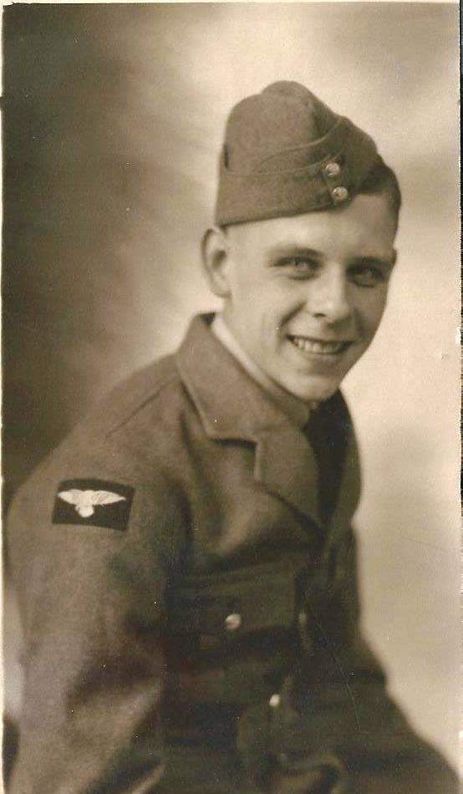

Wartime experience:

Born and lived in nearby Burton on Trent worked as a Loco Driver for Worthington’s. Enlisted 3rd March 1940 aged 19, at Burnaston Airfield now ironically the site of the Toyota Car Plant.
Trained at Blackpool and the passing out parade was conducted on Blackpool Beach. Stationed at RAF West Raynham, Norfolk before being posted overseas. Sailed from Gladstone Docks, Liverpool on board the Stirling Castle to Singapore. Sent to defend the Dutch Airfield at Kalidjati, Java with 2 younger airmen before being ordered to evacuate due to the invading Japanese Army. Finally captured in the hills of Java on 8th March 1942.
Civilian life after return:
Returned home to Burton to see his 3 year old son David (born while Jim was in captivity) for the first time however the 2 where quickly acquainted after Jim produced a large bar of chocolate from his kit bag.
Jim and his wife Dorothy went on to have 3 more children and where married for 62 years. Jim, Dorothy and all 4 children along with their grandchildren attended the opening ceremony of the Sumatra Railway Memorial just outside this building in 2001. Jim died in February 2003 aged 82 but not before writing down his life story.

