WATT Gordon David

Name: Gordon David Watt  Born: 1917  Rank: Gunner  Service Number:  Regiment: 88th Field Regiment, Royal Artillery  (351 Battery)  Died: 1994 | 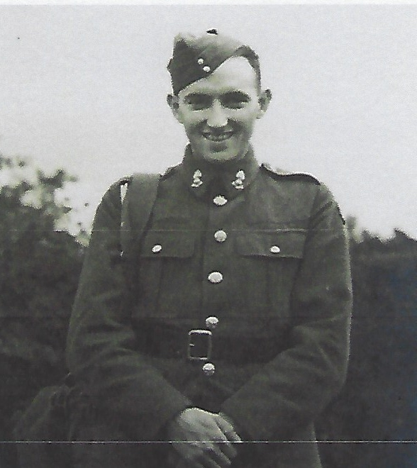

Pre-War:
Gordon David Watt was born in 1917 in Preston, Lancashire. He was educated at Hutton Grammar School, Preston, and went on to work as a clerk for Lancashire County Council.

Wartime experience:
Gordon volunteered for the Territorial Army and became a gunner in the 88th Field Regiment. He served in northern France, including the Dunkirk landings in May/June 1940. He sailed to the Far East on board the Empress of Canada and was taken prisoner by the Japanese just after the fall of Singapore on 17 February 1942, initially being held captive in Changi gaol. He remained in captivity for three and a half years, living in various camps, working on the Thai/Burma Railway and suffering, along with fellow prisoners, from malaria, dysentery and tropical ulcers.

Civilian life after return:
Gordon returned home to his mother, brother and sister, but discovered that his father had died during his captivity. Shortly after his homecoming, he resumed his work at Lancashire County Council where he remained until his retirement in 1977. He joined the FEPOW association and regularly attended meetings in the north-west. Gordon married in 1949, he and his wife later having a daughter. He died in 1994, age 77.

