FEWELL Reginald Roy

Name: Reginald Roy Fewell  Born: 11 January 1912  Rank: Captain  Service Number: 97354  Regiment: Suffolk Regiment  Died: 11 June 1995 | 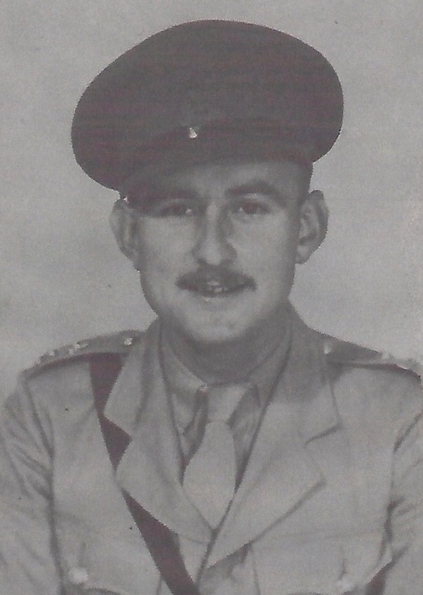

Pre War:
Roy, as he was known, was born in Dovercourt, Essex, a descendant of the Huguenots who settled there. His father died at Ypres in the WW1, when Roy was very young. Most of his youth and teenage years were spent in Saffron Walden, where he met his wife, Mildred. They had 3 sons, Peter William Charles (born 18 December 1937), Anthony Roy (born 10 May 940) and David Kevin (born December 1941 – deceased).
Wartime experience:
He fought in the jungle in Burma before being captured in Singapore and worked on the Thai/Burma railway, including the bridge over the river Kwai.
After the war and after a long period of silence he eventually started to tell stories about suffering torture, malaria and dysentery, such as these below:-
He witnessed Japanese soldiers taunting a truck load of injured Japanese soldiers, including officers – they were just as cruel to their own.
Roy had the utmost respect for the Ghurkhas. He told how, in the jungle before capture, he came across some Ghurkhas who had killed 10 Japanese soldiers because they had killed one Ghurkha and one Ghurkha was worth ten Japanese. He also said that after the Japanese had surrendered, the prisoners were still being ill-treated, a Ghurkha strode into the camp and saw a prisoner standing to attention. He asked the prisoner what he was doing and got the reply that as punishment he had to stand to attention until he dropped and then he would be beaten. The Ghurkha asked which of the Japanese soldiers was responsible and then strode over to the soldier I question and smashed his teeth with the butt of his pistol.

Roy said that one prisoner, possibly from the BBC, built a radio. Any information they got was dissipated days later to avoid detection.
He often woke up in the night with a giant rat on his chest.
He also said that one of the prisoners was a dentist, who not only treated the prisoners but also the Japanese. The Japanese soldiers had access to anaesthetics, and when they went for treatment, took it with them. The dentist injected the Japanese soldiers with water and saved the anaesthetic for the prisoners.
Civilian life after return:
When Roy came home, as a five year old, Anthony (also known as Roy) can still picture him coming round the corner of the road with his mother. He was incredibly thin and his skin was very yellow. In the morning David, the youngest son, who was only three, came down stairs and said to his mother, “There’s a strange man in your bed.”
Sadly, Roy passed away on 11 June 1995 at the age of 83.

