WADE Norman Harold Alan

Name: Harold Norman Alan Wade  Born: 1918  Rank: Gunner  Service Number: 836497  Regiment/Unit/Station:  118 Field Regiment, Royal Artillery  Died: 28 November 1943 | 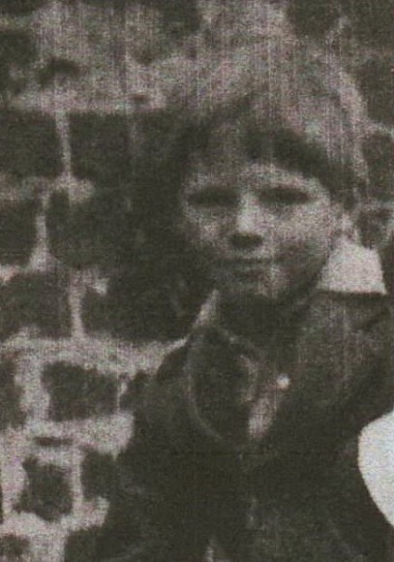

Wartime experience:
‘Wadey’, as Norman was known, was born in Poplar, London, and was living in Maidstone, Kent, with his parents Arthur and Lydia, at the time of his posting to the Far East.
He was captured at the fall of Singapore and sent to Changi prison camp and later worked on the Thai/Burma railway.

Wadey died on 28 November 1943, at the age of 25. He is buried at Kanchanaburi War Cemetery, Thailand (Grave 4.D.43).

