SPARROW Charles Raymond

Name: Charles Raymond Sparrow  Born: 30 October 1914  Rank: Leading Aircraftsman  1st Class  Service Number: 1308022  Regiment/Unit/Station: RAF Volunteer Reserve  Died: 25 May 1945 | 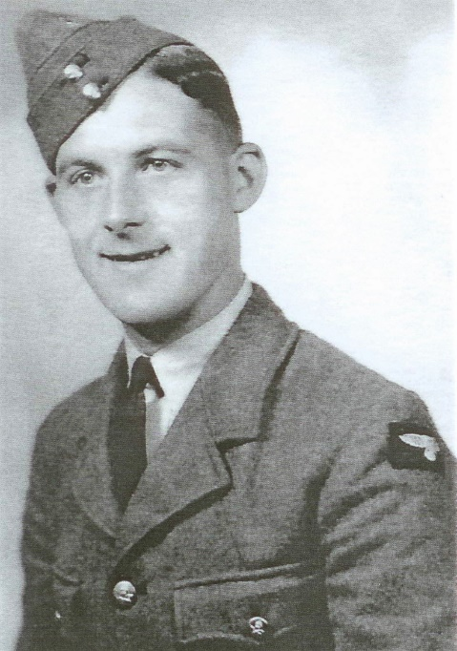

Early life:
Ray, as he was known, was the son of Charles and Ellen. They lived in Grantham, Lincolnshire.

Wartime experience:
Ray enlisted into the RAF on 31 July 1940. He was posted to the Far East, to be based in Singapore, leaving behind his wife, Hilda.
With the onslaught of the Japanese forces down the Malay peninsula, Ray would have evacuated Singapore and escaped to Java, probably via Sumatra. He was one of 450 RAF personnel who were hastily armed and re-deployed as infantry.
Ray was captured on 20 March 1942 after the fall of Java and was held there until March 1944. During this period he was successfully treated for Avitaminosis and many other conditions by a Dutch Navy medical officer. After recovery, on 27 June 1944, he was sent by hell ship to Singapore as part of Java Party 22, which arrived on 1 July 1944. Ray remained in Singapore where the party was split into five separate groups to go to Pakan Baroe and left with the first party on 7 July 1944 arriving in Sumtra on 10 July 1944, where he laboured on building the Sumatra railway.
Ray died as a result of Beri-beri at Pakan Baroe in Sumatra on 25 May 1945, at the age of 30 – so near the end of the war.
Ray was buried at Cemetery Camp 2 (Grave A/208) but his body was later transferred firstly to Medan Dutch War Cemetery, north Sumatra – and finally to Jakarta War Cemetery, Java (Grave 1.B.4).

