SIBLEY Frederick Charles

Name: Frederick Charles Sibley  Born: 14 February 1913  Rank: Bombardier  Service Number: 1075174  Regiment: 85th Anti-tank Regiment (281st Battery)  Died: 11 December 1995 | 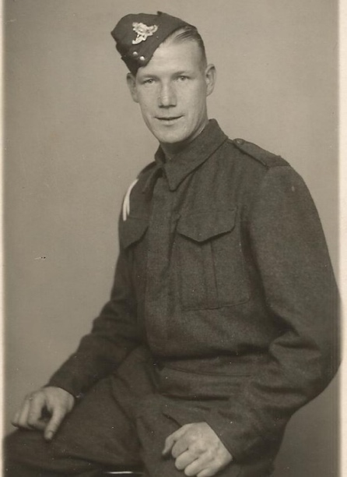

Wartime experience:

Fred was born in Notting Hill, London. Below is a summary of his war, from when he left the UK, the listing of the camps he was in and his return to the UK:

12/11/41 Left the Clyde on the 'Narkunda' - Part of convoy WS12ZM
13/1/42 Arrived Singapore - Part of convoy DM-1
15/2/42 Captured at the fall of Singapore
April 42 to Sep 42 River Valley Road Lt.Col Heath
April 43 to Aug 43 Tonchan Lt.Col Knights
Aug 43 to June 44 Chungkai Lt.Col Outram
June 44 to April 45 Nakom Paton Lt.Col Santer
April 45 to Aug 45 Mergui Road Maj Dewe
19/10/45 Arrived Liverpool on the 'Orduna'

Civilian life after return:
When Fred returned home, he went back to his position at Kensington Borough Council, where he worked until he retired.
Sadly, Fred passed away on 11 December 1995, at the age of 82.

