SHAW William Charles

Name: William Charles Shaw  Born: 4 June 1909  Rank: Gunner  Service Number: 1786711  Regiment/Unit/Station:  7th Coast Regiment, Royal Artillery  Died: 29 November 1969 | 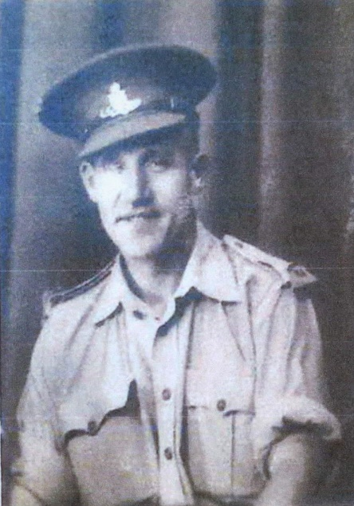

Early life:
Bill (William) came from Birmingham. Before the war he worked for the Levis Motorcycle Company in Birmingham.

Wartime experience:
Bill was called up in 1941 and was based mainly at 7th Coastal Artillery Training Centre, Fort Stamford, Plymouth from March until June 1941. He was posted to the Far East, leaving behind his wife, Gertrude, and daughter, Barbara. He was based in Singapore and was captured there when it fell on 15th February 1942.
Bill was sent to Changi prison camp, then later sent to work on the Thai/Burma railway; in November 1942 he was in Nong Pladuk hospital camp. Following the end of the war, he was briefly in Saigon, French Indochina, before being flown to Rangoon, Burma around 19th September. He recalled how Burmese natives, at great risk to themselves, passed extra food through the camp fences.
Bill sailed home aboard SS Ormonde and, wept for joy, when he was met at his local station by his wife and daughter.

Civilian life after return:
After the war, Bill worked as a packer in Hardy Spicer’s factory, Erdington, Birmingham.
Sadly, he passed away on 29 November 1969.

