SARTIN Ronald John Nicholas

Name: Ronald John Nicholas Sartin  Born: 10 September 1909  Rank: Sergeant (Lieutenant)  Service Number: 1863793  Regiment/Unit/Station:  Royal Engineers (SOE)  Died: 25 November 1989 | 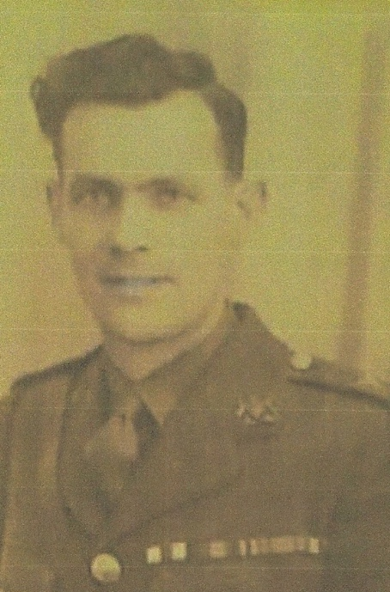

Wartime experience:
John was born on 10 September 1909 in Monmouth, South Wales. He joined the army in 1923 as a sapper. He was posted to Malaya in 1938 where he was to become a demolition instructor at 101 Special Training School on Puala Brami Island. John joined the Special Operations Executive (SOE) in 1941 with the promise of a commission and he went into the Malayan jungle with Freddy Spencer Chapman and Bill Harvey as a ‘stay behind party’, engaged in sabotage behind enemy lines. In two weeks it is amazing what these three men achieved and the damage they inflicted can be read in John’s MC Citation. He was captured on 19 March 1942 at Kuala Kubu on his way out of the Malay peninsular and was held in Pudu Gaol from where two of his comrades, Bill Harvey and Frank van Rennan escaped. Unfortunately, they were both recaptured and executed. John later went to the Thai/Burma railway where he was ultimately liberated. He came home in 1945 and was awarded the Military Cross for his actions in fighting behind enemy lines. Details of John’s experiences in the SOE can be read in the book ‘The Jungle is Neutral’ by Freddy Spencer Chapman.

Civilian life after return:
John remained in the army for another year or two following his liberation and tried to seek another Far East posting with the army, but this didn’t come to fruition. He married Mildred in 1946 in Andover, Hampshire. On his discharge from the army he worked for a company called EK Cole in Southend in Essex not far from where his Mother lived. David was born in 1948 and a few years later, the family moved to Halifax, Yorkshire where Mildred’s family came from. John became a clerk with the Yorkshire Electricity Board (YEB) where he worked until he retired and, during that time, he was also a member of the YEB Rifle Shooting Team. Sadly, he passed away on 25 November 1989 at the age of 80.

