ROWLING Stanley

Name: Stanley Rowling  Born: 17 January 1920  Rank: Gunner  Service Number: 984427  Regiment: 85th Anti-tank Regiment  Died: [Not recorded] | 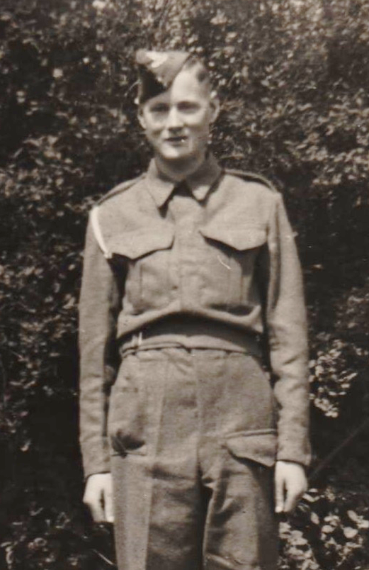

Early life:
Stan, as he was known, came from Nun Monkton, near York.

Wartime experience:
After basic training, Stan sailed from Greenock on 11 November 1941, aboard the Narkunda, destined for Iraq. En route they were diverted to Singapore via Capetown, Durban and the Maldives, arriving on 13 January 1942.
Located with his gun battery up the Mersin Road, Jahore Baru, as part of ‘operation rear-guard’, while the troops retreated over the causeway. Stan suffered a head wound when the area was carpet bombed by Japanese aircraft and was hospitalised for a short time.
Following capture, on the 15 February, Stan cleared bomb damage in Singapore, he also worked on the docks before being sent up country to Thailand via lorry and freight train (thirty men to a truck). They arrived in Bampong, a journey of five or six days, to a camp near Kamburi, then on to Tarso, then on again to Kanu, marching more than a hundred miles.
During captivity, Stan worked 14 to 16 hours a day, creating camps then clearing rock and trees. He moved to Hintok Valley Camp, clearing trees, to make ‘The Pack Of Cards’ Bridge, then further along to Hintok River Camp. He was later sent back to work at Kanchanaburi, a hospital camp, where he met Russell Braddon (Naked Island) and Ronnie Searle (cartoonist). After five weeks he was sent back to Singapore, via the hellish freight trains, to Sime Road Camp, then Changi Jail. He worked on Changi Aerodrome, then Adam Road Camp, digging underground tunnels before the Japanese surrendered.
Stan suffered bad attacks of malaria and had terrible leg ulcers but was lucky enough to survive his ordeal and returned home on the Almanzura, via Colombo, the Suez Canal, Port Said and Gibraltar to Southampton.

Civilian life after return:

