ROBINSON Alfred Richard

Name: Alfred Richard Robinson  Born: 29 May 1917  Rank: Private  Service Number: 5829753  Regiment/Unit: 18th Platoon  D Company 1st Battalion Cambridgeshires  Died: 16 May 2005 | 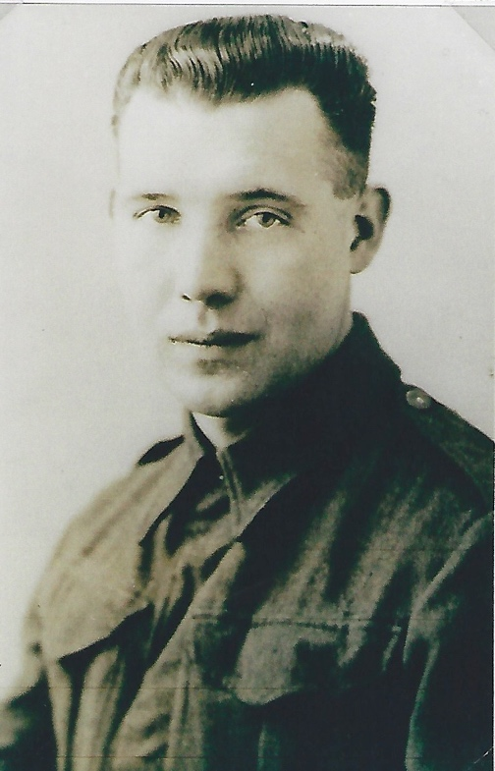

Wartime experience:
Alfred set sail initially from Liverpool aboard the HMS Orcades which sailed during the evening of 29 October 1941 to meet up with the Code portion to form convoy Outward North 30, destined for Halifax, Nova Scotia and arrived on 8 November 1941.
There they boarded the USS West Point and set sail on 10 November. The 17th saw them off Port of Spain, Trinidad and, on 9 December, they docked at Cape Town, where the men were given shore leave.
The convoy sailed on 13 December and reached Bombay on the 27th. From there the Battalion went by train to Ahmadnagar, an old Army Hill station and after three weeks, they were sent back to Bombay, where the USS West Point was waiting for them and they set sail on 9 January 1942 as part of the Convoy BM-11, which docked at Singapore on 29 January 1942, 18 days before Singapore fell on 15 February 1942.
Alfred would have marched to Changi POW Camp and later transferred to Bukit Timah camp where he could have been working on a number of jobs, possibly including the building of the Japanese shrine to their war dead.
At some point he was sent to River Valley Road camp, from where he left, on 10 October 1942, as part of a party of 650 men to go overland to Ban Pong, the transit camp at the start of the Thai-Burma Railway. Alfred was assigned to Work Group 2, the second largest Work Group on the Railway and is known to have been at Chungkai and Tha Khanun camps.

Once the Railway was completed he was sent to Phetchaburi in Thailand, which was under the command of Lt. Davidson of the AIF, there he may have been part of the team building an airfield for the Japanese, and digging supply tunnels.

He was liberated from Thailand at the end of the war.

The above information was provided by K Andrews Trustee and Head of Research

