PRIESTLEY Henry

Name: Henry Priestley  Born: 9 August 1914  Rank: Private  Service Number: 5956691  Regiment: 5th Battalion Bedfordshire and Hertfordshire  Died: June 1943 | 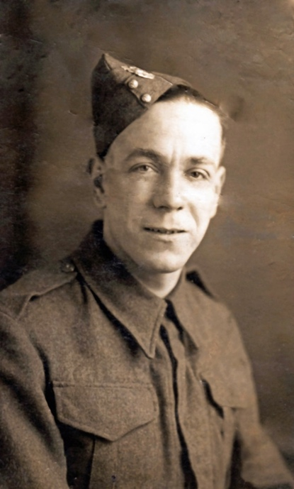

Wartime experience:
Henry entered H.M. Forces in June 1940 and was sent to North Walsham. He embarked at Liverpool in October 1942 and was posted to India. He left India in January 1942 arriving in Singapore the same month and was taken prisoner when Singapore fell in February 1942.
Henry died of Cholera in Sonkrai No. 1 camp in June 1943, aged 29 and is buried in Thanbyuzat War Cemetery, Burma (now Myanmar).

