OLIVER Percy

Name: Percy Oliver  Born: 22 March 1916  Rank: Aircraftsman  Service Number: 1078508  Regiment/Unit/Station: Radio Operator R.A.F. Tenagh  Died: 1992 | 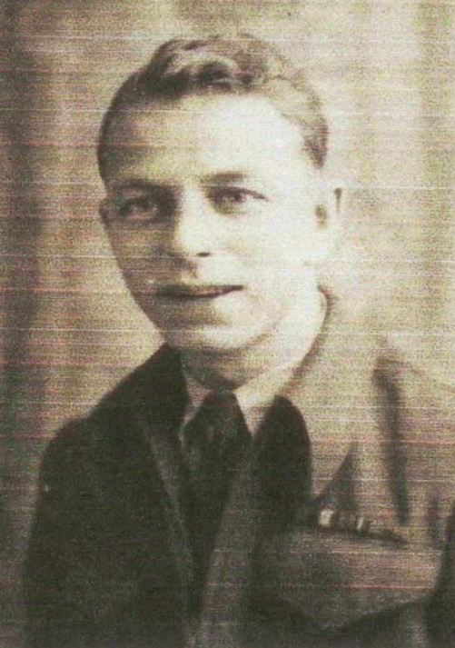

Wartime experience:
Percy came from Barnstaple, Devon but moved to Swansea whilst young.
After joining up he was posted to Singapore where he was to be based at Tenagh airfield. Before Singapore fell he escaped to Sumatra; then, as the Japanese attacked there, he escaped to Java where he was captured on 20 March 1942. He spent time at Glodok and Batavia in Java, then he was sent to Singapore.

Later he was sent by hell ship from Singapore to Japan to be based at Hakodate camp, Hokkaido and there he was eventually liberated.

Civilian Life after return:
Percy survived and returned home. Sadly, he passed away in 1992.

