MOGG HENRY CYRIL

Name: Henry Cyril Mogg  Born: 13 January 1912  Rank: Gunner  Service Number: 961579  Regiment: 155 Field Regiment Royal Artillery  Died: 4 November 1952 | 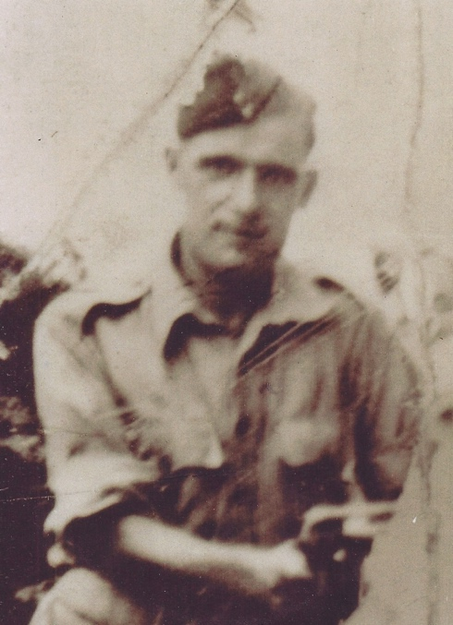

Pre-War:
Henry was born in 1912 in Birmingham, son of Thomas Henry and Mary Sophia Mogg. Henry’s occupation was and Oliver Blacksmith (he used a foot operated hammer called an Oliver).

Wartime experience:
As part of the 155th Field Regiment, Henry would have fought in the Malayan Campaign and would have also taken part in the Battle for Singapore but was still captured at the fall of Singapore on 15 February 1942.

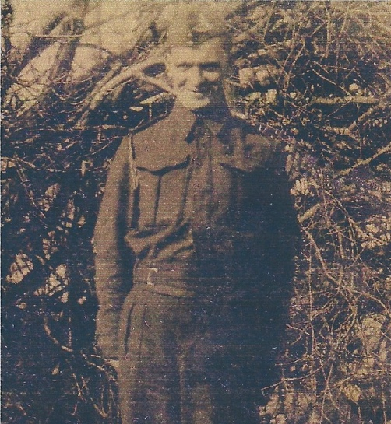
Henry was held prisoner at Changi POW Camp until May 1942 and was moved to the former Great World Amusement Park, which had been turned into a POW Camp. He was then sent to work on the docks and, in particular, the ‘godowns’ where he and others were sabotaging equipment that the Japanese had captured from the British. On 9 November 1942, he was in the party, believed to be under the command of Major C R Coles, 5th Field Regiment, and was transported overland to Thailand, Train 31, World Party, to work on the Thai-Burma Railway. First stop would have been Ban Pong where he would have become part of Work Group 1. This group was engaged in track laying. After the Railway was completed he was transferred to Work Group 4 and was at Tha Muang, the Group 4 HQ. He was liberated from Thailand on 30 August 1945.

Civilian life after return:
Henry returned home and married Mary Anne Winifred Paddock; they had four children – Hazel (1939), Cyril (1940), Linda (1946) and Rita (1950).
Sadly, Henry died on 4 November 1952, at the age of 40, due to an accident at work.

