MERRIMAN Francis

Name: Francis Merriman  Born: 1913  Rank: Gunner  Service Number: 872010  Regiment: 3 HAA Regiment, Royal Artillery  Died: 12 September 1944 | 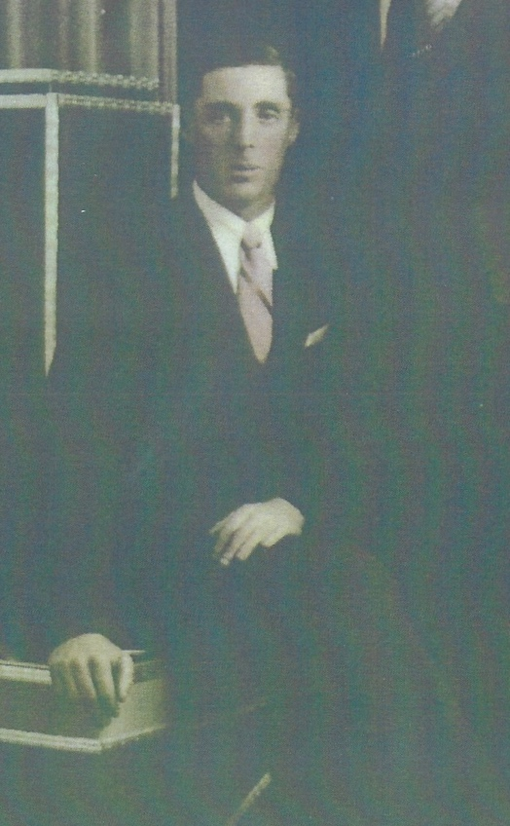

Wartime experience:
Francie, as he was known, was the son of Peter and Esther Merriman, of Inchicore, Dublin, Eire. He served in the 3 HAA Regiment, Royal Artillery. Captured at the fall of Singapore on 15 February 1942. Following the completion of the Thai/Burma Railway he was one of 900 men put on the hell ship, Kachidoki Maru, bound for Japan.

The Kachidoki Maru set sale on 6 September 1944 and was sunk by a torpedo from the USS Pampanito 6 days later on 12 September 1944,

Sadly, Francie died at sea on 14 September 1944 at the age of 31.

Francis is remembered with honour on the Singapore Memorial, Kranji, Singapore – Column 25.

