LONG Leslie Frederick

Name: Leslie Fredrick Long  Born: 2 May 1919  Rank: Corporal  Service Number: 7345948  Regiment/Unit/Station:  3rd Corps, Royal Corps of Signals  Died: 9 June 1984 | 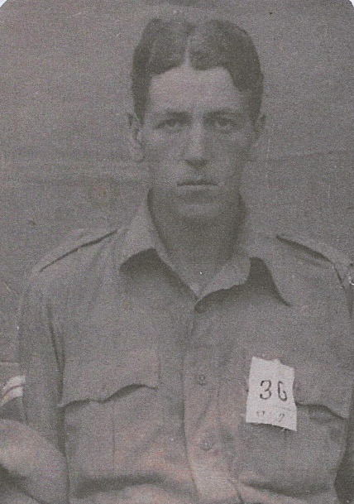

Early life:
Les (Leslie) came from Oxford and was in the R.A.M.C. from September 1938 until February 1939. He signed up fully on 15 July, joining the R.C. of S.

Wartime experience:
After initial training Les was sent to Norway but returned to Scotland after all the equipment was destroyed by German bombing.
He was then sent to Singapore where he was captured when it fell and sent to Changi camp.
He was later went by ‘hell ship’ to Japan, where he worked in a chemical factory in Omi, near Tokyo. He survived captivity and returned home.

Civilian life after return:
Sadly, Les died on 13 August 1997.

