LOCKWOOD Sidney Richard

Name: Sidney Richard Lockwood  Born: 14 December 1919  Rank: Corporal  Service Number: 5831192  Regiment: 2nd Battalion, Cambridgeshire Regiment  Died: 24 July 2010 | 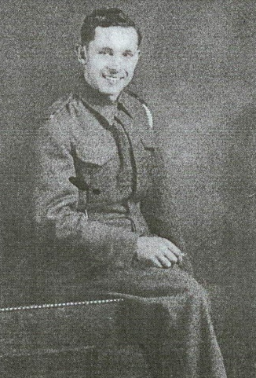

Early life:
Sidney, son of Herbert and Sarah, came from Cockfield, Bury St Edmunds, Suffolk. He worked in farming and the butchery trade.

Wartime experience:
After enlisting into the Suffolk Regiment, Sidney was transferred to the 2nd Cambs. On 31 October 1942 he sailed aboard MV Sobieski from Gourock to Halifax, where he changed ship to USS Mount Vernon and then sailed on for Mombassa via Cape Town. The ship was diverted to Singapore arriving on 13 January 1942, where he was sent into Malaya where he was involved in ferocious fighting at Batu Pahat.
Sidney made it back to Singapore by sea and was captured when it fell on 15 February 1942. He was sent to Changi prison camp, then later sent to work on the Thai/Burma railway. His freedom came whilst at Konkuita.

Civilian life after return:
Sidney returned to his home and married Joyce in 1946.
With war over, he became a family man and drove H.G.V. lorries for a living – a job he loved.
Sidney was a religious man, his faith carried him through his ordeal as a POW. He became very active in his local Chapel and enjoyed working in his garden.
His story is told in his book 'Unbelievable But True'.
Sadly, Sidney passed away on 22 July 2010, at the age of 90.

