JONES Arthur Robert

Name: Arthur Robert Jones  Born: 4 December 1917  Rank: Corporal  Service Number: 5773984  6th Battalion, Royal Norfolk Regiment  Died: 2008 | 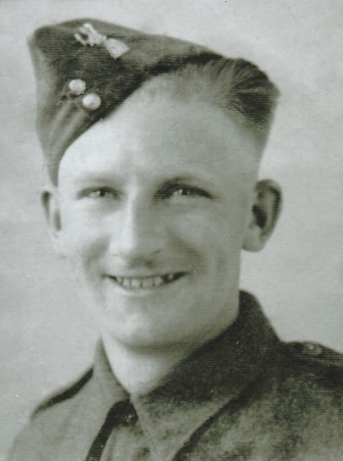

Date of Birth 4/12/1917 East Dereham, Norfolk.
Next of Kin Grandmother Mrs Martha Bush,
7 Scarning Road East Dereham.
Single, lodging with his married aunt, Oak Street Norwich 1939.
Occupation given on enlistment Lorry drivers mate.

Enlistment 15 Januaary1940 6th Battalion Royal Norfolk Regiment.
Army Number 5773984.
Rank Corporal.

Part of 18th Division, 53rd Brigade.
Sailing aboard The Duchess of Atholl, and then aboard the Mount Vernon Captained by Donald B. Beary United States Navy.
Captured Singapore 15/02/1942 following fighting in Malaya.
Singapore, Changi camp, until May 1943, Commanding Officer Brigadier Duke.

25/04/1943 he became part of overseas G Force Letter Party along with 1,500 others who were shipped to Japan. (David Nelson) book The Story of Changi.
He was aboard the Hell ship Kyokko Maru.
Australian Officer in charge of G Force Major R. Glasgow.8 division A.I.F.
The arduous journey of around a month.

Docking in Moji southern Japan then continuing their journey by rail.
Arriving Omi, also known as Aomi, Niigata region, May 1943 until liberation September 1945.

Officer in charge at Omi camp was Lieutenant Stephen S. Abbott 2nd Battalion East Surrey Regiment.
Believed to have travelled home on the Empress of Australia arriving Liverpool October 27th 1945.

After the war dad got married in1947 and lived in Narborough, Norfolk for a few years before moving to King’s Lynn, Norfolk.
He was employed as a Maltster at Narborough and King’s Lynn until the closure of the Whitbread Maltings, working a short while at Foster refrigerator, King’s Lynn until his retirement in December 1982.
He died aged 90 years in 2008.

COFEPOW members Linda-Lee & Kevin Nicholls.

