HAROLD Edgar

Name: Harold Edgar  Born: 14 March 1897  Rank: Gunner  Service Number: 1443424  Regiment/Unit/Station:  78th Battery, 35 LAA, Royal Artillery  Died: 12 February 1943 | 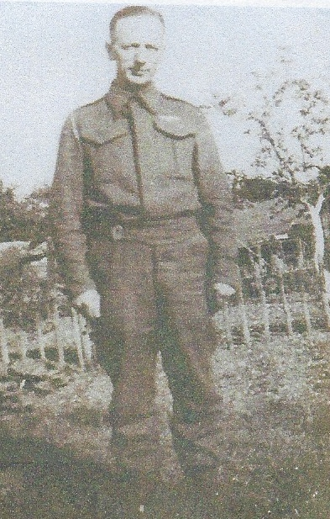

Wartime experience:
Edgar, son of George and Mary, came from Diss in Norfolk. He moved to Hampshire to work as a servant, was called up I 1916 and sent to France in 1918. He married Gertrude in 1919 and was demobbed in 1920.
Edgar joined up again in early 1939 and after several medicals and moving to several different corps he was established with the 35th LAA. Following further training and postings around the country, Edgar left behind his wife Gertrude and four children, he sailed from Greenock aboard SS Empress of Japan o 12 November 1941, destined for the middle east. The ship arrived in Durban on 18 December 1941 via Freetown and Cape Town. On 24 December Edgar changed ship to SS Narkunda destined for Singapore, due to the Japanese invasion of Malaya.
Edgar arrived in Singapore on 13 January 1942, with next to no fighting equipment, and was evacuated to Sumatra to defend the oil refinery at Pladjoe. He was captured in Java on 8 March 1942 and held in Tanjong Priok for seven months before sailing on the hell ship Yoshida Maru to Singapore where he was transferred to another hell ship Singapore Maru destined for Japan which docked in late November 1942. After experiencing the most horrendous conditions on the journey out of 1,081 prisoners only 677 were fit enough to disembark. Out of the 404 who were sick, Edgar was one of the 35 taken to Moji Military Hospital, who eventually died. Sadly, on 12 February 1943 Edgar was the last of the 35 to die.
Edgar’s ashes were interred and re-interred more than once until they finally came to rest in the Yokohama War Cemetery, his name is carved on the memorial wall – panel 3.

