GRAY James Stanton

Name: James Stanton Gray  Born: 25 January 1908  Rank: Corporal  Service Number: 6137250  Regiment: 2nd Battalion, East Surrey Regiment  Died: 12 June 1943 | 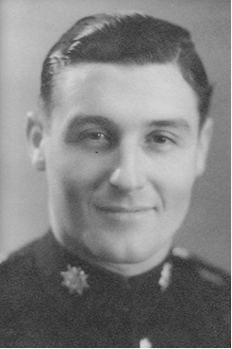

Early life:
James, son of Phillip and Ivy, was born in Barnes, London (Surrey).
He enlisted on 29 January 1926 as a regular soldier and extended his service to twelve years in 1932. He passed a trade test as saddler and harness maker in 1934.

Wartime experience:
Leaving behind his wife Norma, daughter Pamela and son Michael, James was posted to China to be based at Shanghai on protection duties. In August 1940, he and his battalion went to Singapore for combat training, then, early in 1941, they went to Tanjan Pau, North Malaya as part of the 11th Indian Division.
Defending against the Japanese invasion on 7 December 1941, the division suffered severe casualties and, as withdrawal continued, new defensive positions were taken up. James's regiment was reduced to 260 men and 10 officers in the gruelling fight which ensued. On 20 December the remaining 2nd East Surreys and the 1st Leicesters joined forces to form the 'British Battalion'. Fighting continued during the retreat to Singapore, where James was finally captured when Singapore fell on 15 February 1942.
James was sent to Changi prison camp. On 15 October 1942 he went to work on the Thai/Burma railway. At some point he was taken ill and transferred back to Tha Markham. Where, on 12 June 1943, he sadly passed away of dysentery – at the age of 35.

James is buried in Kanchanaburi War Cemetery (Grave 2.H.9) in Thailand.

