GARRATT George William

Name: George William Garratt  Born: 21 February 1916  Rank: Private  Service Number: 4976509  Regiment/Unit/Station:  1/5th Battalion, Sherwood Foresters  Died: 13 August 1997 | 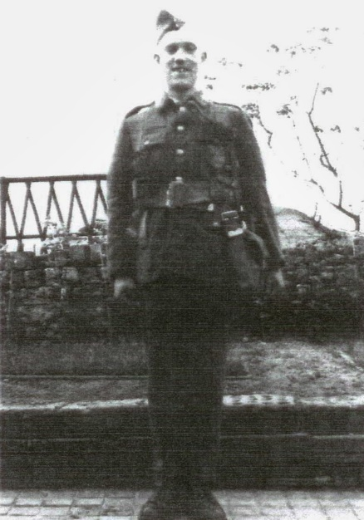

Wartime experience:
Bill, as he was called, came from Swadlincote, Derbyshire and enlisted on 13 April 1939.
He was posted to the Far East, captured at the fall of Singapore and sent to Changi camp. He moved on to River Valley camp where he worked in Keppel harbour and was later sent to work on the Thai/Burma railway where he helped build huts for the use of prisoners and cleared jungle for marshalling yards. After contracting dysentery he was sent to Chungkai hospital camp. When he recovered he was sent to work on constructing a footbridge down river from the main Kwai bridges, then went on to work on building an airstrip, where he contracted malaria.
Bill was evacuated to Nakom Pathon to recuperate, whilst there the war ended and he was liberated. He was flown to Rangoon where he boarded a ship for England

Civilian life after return:
Bill spent much of his civilian life fighting for the rights of ex-POWs and challenging ignorance about what he and his comrades endured during their captivity.
Sadly, he died on 13 August 1997.

