FREEMAN Frederick George

Name: Frederick George Freeman  Born: 28 September 1921  Rank: Aircrafthand General Duties  (Trade Group ‘D’)  Service Number: 916461  Regiment/Unit/Station:  Royal Air Force  Died: 19 April 1987 | 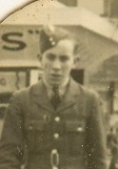

Wartime experience:
Fred, as he was called, was 18 when he joined the Royal Air Force in1940 he became an Aircrafthand General Duties and was 19 when he embarked to the Far East, to relieve those men who had been overseas for three years. He served in Malayan camps, then at Air Headquarters at Singapore in late 1941.
On 12 February 1942 Fred evacuated Singapore on the Empire Star for Java. He and his colleagues were put into a school in Batavia for about two weeks. He was tamong many RAF personnel put on a train at Batavia to go to the docks at Tjilatjap for evacuation to India. Fred later wrote “suddenly we were ambushed by the Japanese to which not a shot was fired in answer, as we had not a round between us.”
Later, just before midnight, Fred was about two-thirds of the way over a bridge when there was a terrific explosion and the bridge started to sway and collapse only about twenty-nine men got over after him. They eventually entrained and were shunted up and down the country until they arrived at Tasikmalaya.
On 8 March, they were marched into a school and were informed they were POWs. After about a week, he was sent to Malang aerodrome to fill in various bomb craters. In May, four tried to escape and were shot.
In September, the Japanese officially recognised them as prisoners and brought in Koreans as guards: then the bashings started. The same day they were moved to another camp, loading ships in the docks with everything from furniture to motor cars.
In early 1943, he was shipped to Haruku, where their job was to take the top off the coral hills and fill in the hollow to make an aerodrome. Eventually the Japanese sent a party of 150 – 200 sick men back to Java. Fred was one of the walking sick and left Haruku in a coal boat. On arrival at Surabaya the was put on a train for Batavia. For about a month he did no work, then was sent to another camp on the outside of Batavia; this was a farm where they worked on the land, growing food for the other POWs and guards.

In September 1944 he was put on another draft, this time for Sumatra – one of about 8,000 (Junyo Maru), but just off Benkoolen (on the west coast of Sumatra) they were torpedoed by the Allies and the ship sank in fifteen minutes.
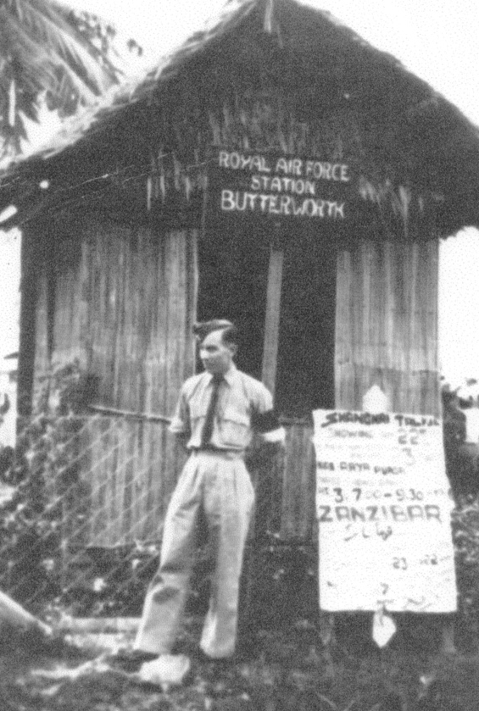
On arrival, in Sumatra, at this point Fred was stark naked, he was given a pair of cotton shorts; he was then sent to a disused jail where he and his comrades were given a half-cup of rice pap and had to sleep on a solid stone slab. The next day they were taken to Pakan Baru where they had to build a railway to join east to west Sumatra. Eventually he was regarded as a permanently sick man and sent to No. 2 Camp with dysentery and malaria. Later he was posted to No. 4 Camp as a tailor. It was from there that he was released on 18 September 1945.

Civilian life after return:
With the majority of the other RAF POWs from across the world, Fred returned to RAF Cosford and was admitted to the hospital. Marie Louise Goddard was a WAAF at Cosford and was the only one of the four medical clerks with the qualifications to take down the doctors' notes so during the summer and autumn of 1945 was on duty 24/7, dozing on her biscuit in her uniform. At some time after Fred’s arrival, she was walking down a grassy slope at Cosford and a guard-dog bumped into the back of her leg, sending her flying and she had to go into the hospital for treatment. She was working on a leather stationery folder in rehab and needed the leather punch, which was being used by the men so she and another girl went across to borrow it. The men swarmed around the girls like honey bees (as she said) and Fred came through to clear a path for them. She said that she saw his gleaming white teeth and that was it! She fell in love. Fred went home to Brighton for some months then returned for more treatment and discharge but before he left, in April 1946. they became engaged. He returned to his parents' home in Brighton and Marie to her home in Exmouth while the wedding was planned. They made their home in Brighton, first with his parents for about 3 years and then in a newly-built council flat. Fred went on a government training scheme for returning servicemen, studying a plumber but as there were too many plumbers and too few positions, he started working on the local buses and trolleybuses as a conductor and driver. In the late 1960s the railways were taking on staff, so he started as a porter, then progressed to a ticket-collector, then a train ticket-collector, where he worked on the Brighton Belle meeting the likes of Sir Laurence Olivier and Dame Joan Plowright and Dora Bryan - all local celebrities, as they returned to their homes in Brighton after appearing in London. Fred always suffered the after-effects of his time as a FEPOW, including malaria and beri-beri. He Joined the London Club and his daughter, Margaret, found a copy of his letter to his MP supporting their appeal for compensation in the early 1950s but he was never known to attend the Club.
At the age of 65, sadly, Fred died on 19 April 1987 of cancer of the liver, which was proven to be linked to his time as a FEPOW so Marie, after an appeal, got her War Widows Pension. This enabled her to live her final years in RAF Sussexdown, near Storrington.

