FOWLER Jack

Name: Jack Fowler  Born: 24 June 1921  Rank: Private  Service Number: 5826799  Regiment/Unit/Station:  4th Suffolk Regiment  Died: 1 February 2011 | 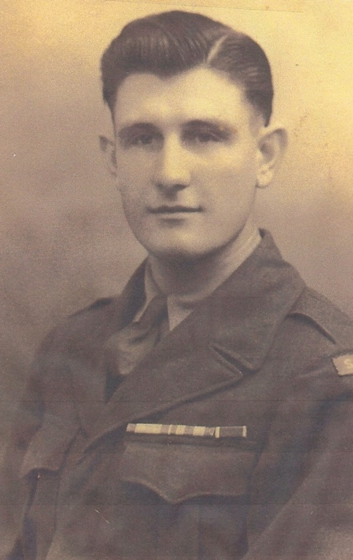

Wartime experience:

Jack arrived in Singapore on 15 January 1942. He volunteered to go ‘up country’ to Malaya and it was there he had his first encounter fighting the Japanese. After many experiences and spending time in a first aid unit recovering from a gunshot wound to his leg, he made his way back to Singapore. He found himself fighting again, but this time on the golf course and in Thomson village and, when the surrender came, he was taken to Changi jail. After a few days in Changi, Jack was taken to work in the River Valley Camp, from there he was taken down to the harbour to board the hell ship Dai Nichi Maru. Jack, together with hundreds of other POWs, endured three horrendous weeks crammed in the hold. The Dai Nichi Maru docked at Keelung harbour, Taiwan (Formosa) and he was sent to the first camp Taichu, diverting a river bed, following that he was sent to the notorious copper mine in Kinkaseki – his number was 733 (nanna san san). From there he was taken on the last ‘Thin Man’ party, with Dr Ben Wheeler, to Shirkowa.
Jack was finally liberated by the Americans, taken to Manilla to sail home into Liverpool.

Civilian life after return:
On returning home, Jack built a speedboat with his friend and ran trips for the holidaymakers. After that, together with his father, he built a Broads sailing boat, known as the Waveney class, and eventually went on to build the Broads hire cruisers. He owned and ran his own Boat Yard named Fowlers in Oulton Broad.
After a long and fulfilling life he passed away on 1 February 2011.

