EVITTS Walter Harold

Name: Walter Harold Evitts  Born: 1918  Rank: Lance Corporal  Service Number: 1892387  Regiment/Unit: 560th Field Company, Royal Engineers  Died: no information | 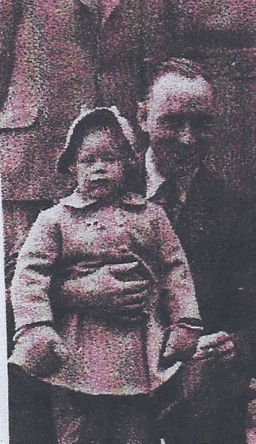

Wartime experience:
Harold, as he was called, came from Oldbury, West Midlands. He enlisted on 21 October 1939 and sailed to the Far East, landing in Singapore just before it’s fall. He was taken prisoner and sent to Changi camp. On 11 November 1942 he was sent to the Thai/Burma railway. He was based at Tarso until 7 January 1943, then Tonchan Central until 2 August 1943. He then went on to Hintock river camp until 20 August 1943 and then returned to Tonchan Central. He was at Rintin from 17 September until l19 December 1943 and finished at Kaorin until the liberation. He was with his mate Donald Yates and recalls saving his life by carrying him during a long march back to camp, although Donald recalls the reverse of this story.
Harold survived captivity and returned home.

