ELLMORE William George

Name: William George Ellmore  Born: 31 August 1921  Rank: Gunner  Service Number: 1807008  Regiment/Unit/Station:  21st Light Ack-Ack, Royal Artillery  Died: 19 August 1989 | 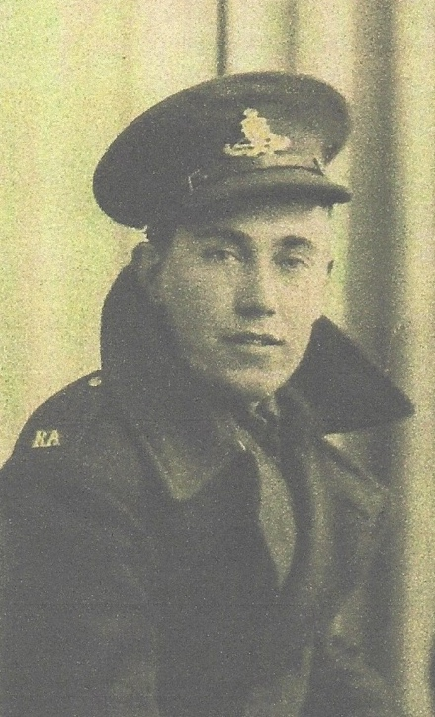

Wartime experience:
William was sent out to the Far East on convoy WS14. He was captured on 8 March 1942 in Java, one month after arriving and spent a year in Tandjong Priok camp, in Batavia, before being taken to Liang in Ambon. William returned to Java in May 1944 on the Tencho Maru. And spent the last year of his captivity in St Vincentius Hospital, Cycle and Bandeong camp in Batavia.. He returned to England via Ceylon on the ship Celicia.

Civilian life after return:
Bill returned to work with his father in their coal merchant business which he continued to run until he retired in 1985. On coming home from the Far East he met Patricia Petre who he married in 1948, they had 3 children and lived in Barking, Essex. Sadly, Bill died on 19 August 1989 just short of his 68th birthday.

Not knowing of her father's wartime experiences, his daughter Lesley started researching FEPOWs in the late 1990s and was lucky enough to meet some of his comrades who he thought had been left in the Far East, and they him.

From 2008 she has been Chair and Treasurer of The Java FEPOW Club 1942 supporting the remaining FEPOWs, wives and widows with welfare and camaraderie. http://www.thejavafepowclub42.org

