EDWARDS Stanley Frank

Name: Stanley Frank Edwards  Born: 28 October 1917  Rank: Sapper  Service Number: 2003076  Regiment: 560 Field Company Royal Engineers  Died: 2004 | 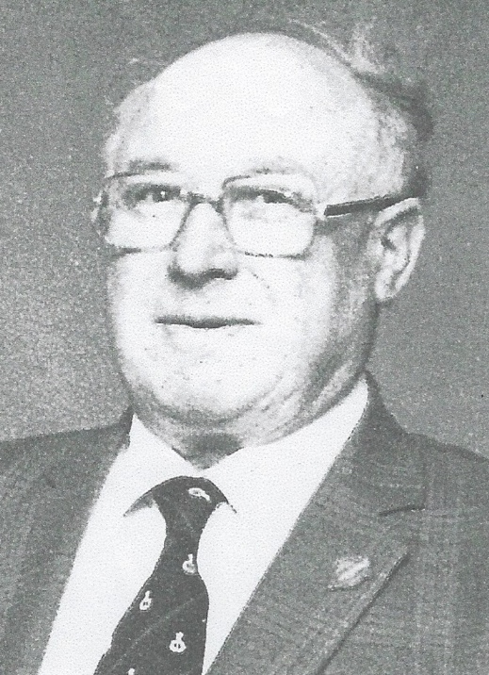

Wartime experience:
Curly, as he was called, was a driver in the 560 Field Company Royal Engineers. He joined up on 16 February 1940 at the age of 23 yrs and was stationed in Cambridge. He helped with the English Coastal defences and drove supplies to bombed-out areas of the country.
He sailed from Liverpool, destination the Middle East on his birthday 28 October. Pearl Harbour fell and the ship was diverted to Singapore. Curly was taken prisoner and worked on the Thai/Burma railway and then sent to Mitsushima, Japan for his last year of captivity. While he was a prisoner, he became very ill from dehydration, malaria, tropical ulcers, beri-beri and dysentery. He arrived home 4 years later on his birthday 28 October.

Civilian life after return:

