DRABBLE William

Name: William Drabble  Born: 22 February 1919  Rank: Private  Service Number: 4860179  Regiment: 1st Battalion, Leicestershire Regiment  Died: 24 October 1969 | 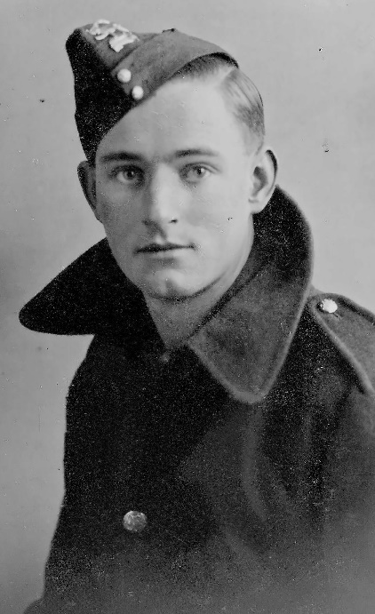

Early life:
Bill, as he was known, was born on 22 February 1919 in North Carlton, Worksop, Nottinghamshire.

Wartime experience:
Bill enlisted on 16 October 1939 and became a private in the 1st Battalion, Leicestershire Regiment. He was posted to India on 20 January 1940 and to Malaya on 13 February 1941.
Bill was captured at the fall of Singapore on 15 February 1942. On his repatriation questionnaire, he listed his camps as:
- Changi from 15 February 1942 to 25 October 1942 - Lt Col Holmes
- Non-Pladuk from 1 November 1942 to 22 February 1945 - Lt Col Toosey
- Ubon from 22 February 1945 to 15 September 1945 - Major Smythe

Bill returned to Liverpool on 19 December 1945 on HMS/RMSP Atlantis hospital ship. His arrival in the UK was delayed due to his being hospitalised in Colombo and Port Said.

Civilian life after return:
Bill suffered ill health for the remainder of his life.
Sadly, he passed away on 24 October 1969 in Leicester, at the age of 50.

There is a tree in his memory at the National Memorial Arboretum, in front of the COFEPOW building.

