COX Hugh Frederick

Name: Hugh Frederick Cox  Born: 6 July 1916  Rank: Private  Service Number: 6140928  Regiment: 2nd Battalion, East Surrey Regiment  Died: 10 January 1991 | 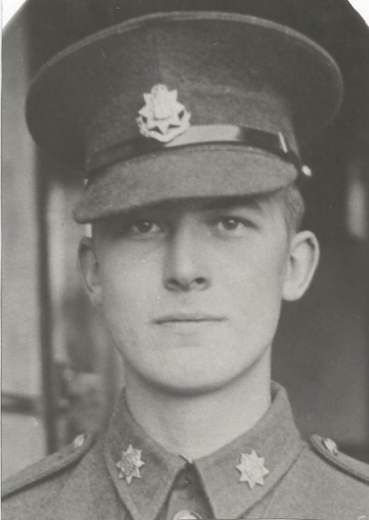

Wartime experience:
Fred, as he was known among his army pals, was taken prisoner at the Fall of Singapore in February 1942. He and the rest of the 2nd Battalion, East Surreys, had been in Malaya when the Japanese invaded but were forced to retreat to Singapore.

He spent the first year of his captivity at Changi and two other camps - MacArthur camp and Pasir Panjang. In March 1943, he was transported to Thailand as part of ‘D’ Force, firstly to Kanchanaburi (or Kanburi, as he referred to it), where he remained until August 1943. He was then sent further up the line to Wang Pho (Wampo) and was held there until February 1945. He was then moved to Tha Makhan (Tamarkan), where he worked on repairs to the steel and concrete bridge, which had been the target of Allied bombing. In May 1945 he was sent to work at a Japanese army transport depot at Kanchanaburi, where he remained until mid-August 1945, when he was moved to Tha Muang (Tamuang); this is where he learned of the Japanese surrender.

Fred began his journey home on the SS Corfu, but by the time she called at Colombo, Ceylon (now Sri Lanka) he was very ill with malaria and was taken to a Royal Naval hospital. Here he met a Nursing VAD who, after a whirlwind courtship, became his wife a few months later. Fred eventually sailed back to England on the SS Strathnaver in mid-November 1945.

Life after return:
Fred’s three and a half years as a prisoner of the Japanese too their toll upon him physically and psychologically. He spent months at a time undergoing treatment for captivity-related ailments at Roehampton Hospital, London, from the late 1940s until the 1960s. It was in an attempt to rid himself of persistent nightmares about his experiences that, with his wife’s help, he put pen to paper in 1946/7 and wrote some notes, which were eventually published as ‘Faith, Hope & Rice’, by Pen & Sword Books, in 2015. Sadly, Fred passed in 1991, at the age of 74.

