CHADBURN Edward Frank

Name: Edward Frank Chadburn  Born: 8 May 1919  Rank: Aircraftsman 1st Class  Service Number: 1222372  Regiment/Unit: Royal Air Force  Died: 23 April 1943 | 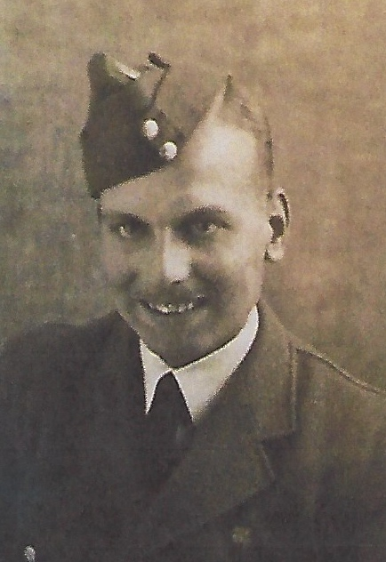

Wartime experience:
Edward originated in Bulwell, Nottinghamshire, the son of Arthur and Ellen Chadburn and brother to Owen and Kathleen. He was married to Ada Annie Lillian.
Edward served with 242 Squadron and was posted to Singapore. On 15 February 1942, when Singapore fell, Edward and his colleagues were diverted to Java where, in March 1942, they eventually fell into the hands of the Japanese.
In September that year, they were all transferred to Changi Jail in Singapore, then, one month later they were shipped out to Jesselton (now known as Kota Kinabalu) in Borneo. There, they were made to work on the airport runway. Living conditions were dreadful and food was scarce. Men began to fall ill and die and, on 18 April 1943, the Japanese decided to move the whole camp to Sandakan by ship. The men who were too ill to move were taken to the civilian hospital in Jesselton, Edward was among them and sadly, he died on 23 April 1943 aged 24. He was one of 51 who died in 1943 and his death is recorded as ‘of amoebic dysentery and beri-beri’. He was buried at Jesselton but all the bodies were removed by the 23rd Australian War Graves Unit and re-buried in the Labuan War Cemetery (HA14) in 1945.

