CARNEY John

Name: John Carney  Born: 6 March 1915  Rank: Sergeant  Service Number: 3524990  Regiment: 1st Battalion Manchester Regiment  Died: 2 January 1972 | 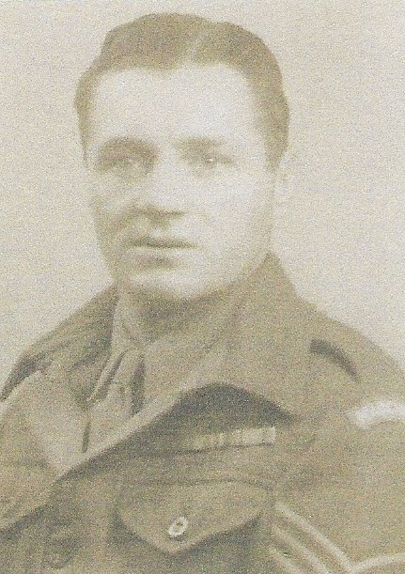

Early life
Jack, as John was known, enlisted on 17th August 1931.

From 1934 he was stationed in the West Indies, Egypt and Palestine, where he suffered a broken leg from an exploded land mine. He sailed to Singapore aboard MV Dilwara in 1938 as part of the 2nd Malaya Infantry Brigade.

Wartime experience:
Jack saw action in the defence of the Malay peninsula as well as in the defence of Singapore, where he suffered shrapnel wounds to his head and legs, as a result of a dive-bombing raid. He was captured on 16 February 1942, after Singapore fell and sent to Changi prison camp where his mates helped his recovery by tending to his wounds and smuggling extra rice for him. Later, Jack was sent to work on the Thai/Burma railway where he came close to losing a leg due to gangrene. Jack survived captivity ad returned home.
Jack was awarded the BEM by The Queen for great devotion to duty, outstanding example of cheerfulness and fortitude to his men.

Civilian life after return:
In 1951, Jack returned to Malaya during the uprising; his family joined him later and another son was born there. He was discharged in 1955 and joined the TA until 1967. He was an active member of a FEPOW association.
Sadly, Jack died on 2 January 1972 at the age of 56 – 2 months short of his 57th birthday.

