Brede Edward Arthur

Name: Edward Arthur Brede (Ted)  Born: 21 April 1921  Rank: Chief Technician  Service Number: 618009  Regiment/Unit/Station:  100 Squadron, LAC  Died: 9 September 2012 | 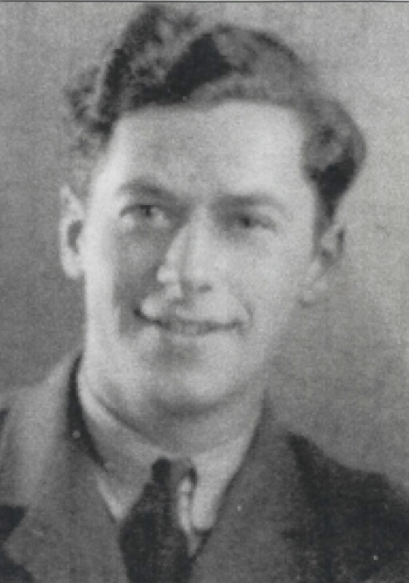

Wartime experience:
Ted enlisted on 17 August 1938 and following training, was posted to Singapore, to service aircraft due to arrive from Australia. As this didn’t happen, he was sent ‘up country’ to guard a radar station. He managed to get back to ports just ahead of the Japanese and got on a ship bound for Australia. The ship was bombed en route and he ended up in Java where he was captured on 24 March 1942. Ted was held in Boei Glodok jail, until 24 October 1942. He was then transported on the hell ship, Dai Nichi Maru, to Japan. From 27 November 1942, Ted was held in Habu, Innoshima for the rest of the war, working on the ship yards.
After liberation on 15 September 1945, Ted went to Dunedin, Australia to a sheep farm. He returned home on HMS Dominion on 17 March 1946.

Civilian life after return:
Following his return home, he went back into the RAF as a Chief Technician at RAF Cranwell. Sadly. Ted passed away on 9 September 2012 at the age of 91.

