ANDREWS Robert Victor
Name: Robert Victor Andrews  Born: 19 May 1912  Rank: Battery Sergeant Major  Service Number: 777379  Regiment/Unit/Station:  11th Coast Regiment (HKSRA) R.A.  Died: 21 July 1986 | 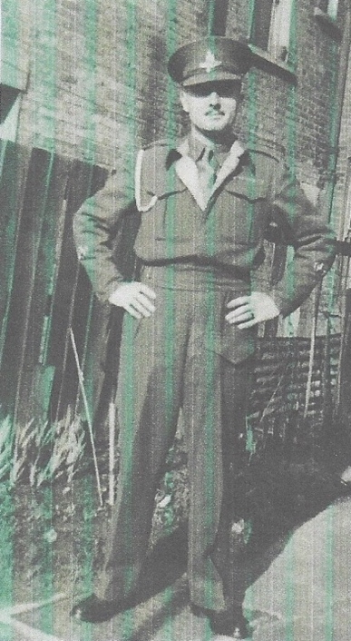
Pre War
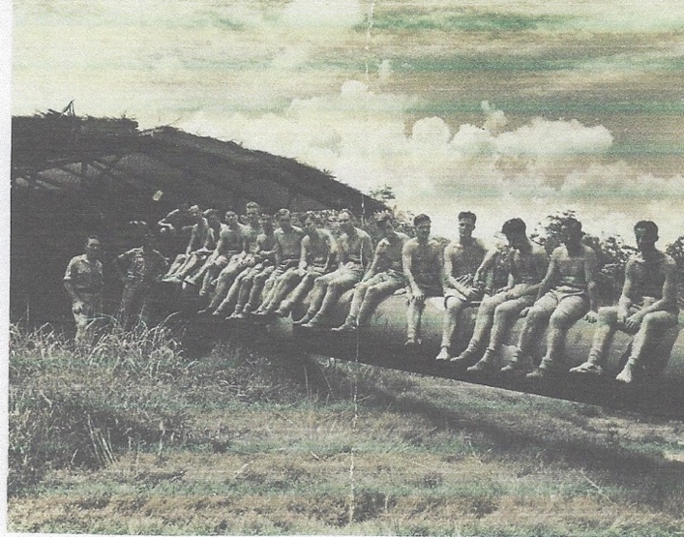
Bob, was born in Woolwich and into an army family. He enlistd in the Royal Artillery at Devizes at the age of 15 yearss and 288 days on 2 January 1928 as a Boy. On 8 October 1928 he was promoted Trumpeter and then Gunner on his 18th Birthday in 1930. He was posted to Malta on 6 December 1929 until 7 May 1932. He served at home being promoted to Lance Bombardier on 8 May 1935; then paid Lance Bombardier on 14 December 1939. On 6 January 1939 he was promoted to WOIII, Troop Sergeant Major and was posted to the 7th Coast Regiment in Singapore. He was posted to the 11th Coast Regiment on 28 December 1940 and promoted to WOII, Battery Sergeant Major on 1 August 1940.
Wartime experience:
Bob, as he was known, was with the 9th Coast Regiment in Singapore, a Forward Artillery Observer for the 15inch guns of Johore Battery, and various 9.2 inch Coast Guns sited around Singapore Island. He was captured at the Fall of Singapore on 15 February 1942. Bob was held at Changi POW Camp and left Singapore for Thailand on 24 October 1942 as part of Y Party. From Ban Pong, he would have marched to Kanchanaburi, Lat Ya, Tha Dan, to Tha Sao under Lt.Col. Knights, where he became part of Work Group 4. On 5 November 1942 he was sent to Tonchan camp as part of the work force building a two tier bridge and left on 10 April 1943 when he was sent to Tha Sao Hospital under Lt.Col. Harvey RAMC. He remained there until May 1943 when he was moved to Tha Makham Hospital, under Major Moon AMS until November 1943.
One of the three guns of the Johore Battery: Bob is on the far left
He was again moved to Chungkai Hospital Camp under Lt.Col. (Weary) Dunlop AMS, until 4 May 1944. From there he moved to Tha Muang Camp until May 1945 and from there to Takli, where he was a hut commander. building an airfield until the Japanese surrender.

Bob's medical record, signed off in the camp, read as follows:

Thailand - Malaria, BT & MT with relapse - 1/43 - 11/44
Ulcers - 1/43 - 8/44
Beri Beri & Oedana of legs - 2/43

Bob survived and returned home on the Chitral from Rangoon to Southampton, arriving on 28 October 1945.

Civilian life after return:
Bob stayed in the Army until he was discharged on 12 November 1951, at which point he had been in the army over 23 years. Bob's father was living in Reading and, through him, he met Rose Cox. Bob and Rose married on 7 April 1946 and went on to have three sons, the first arriving in 1949.

When Bob came out of the Army he went into a job which he did not enjoy but, not long after, he joined Shell in London, where he was a lot happier and worked until he retired. He suffered malaria attacks, in the early years of married life and towards the last few years of his life, the skin on his legs broke open due to the ulcers he had in Thailand. Sadly, Bob passed away on 21 July 1986.

