Welcome to the International Student Learning (ISLearning) Family! We are excited to have you and your school join our network of international educational institutions to connect with students around the world.

ISLearning was created by a team of volunteers to connect children globally to help them learn and grow together, while sharing their cultures, strengths, and struggles.

Technology is a powerful connector, making the world a smaller place and allowing students to share messages, pictures and videos - all while breaking cultural barriers and fostering global friendships.

Beyond education, connected schools can create sponsorship programs for their partner schools through fundraising, service projects, and donations.

To see how we are connecting students around the world, please visit our website and follow us on Facebook and Instagram.

Welcome to our global family!

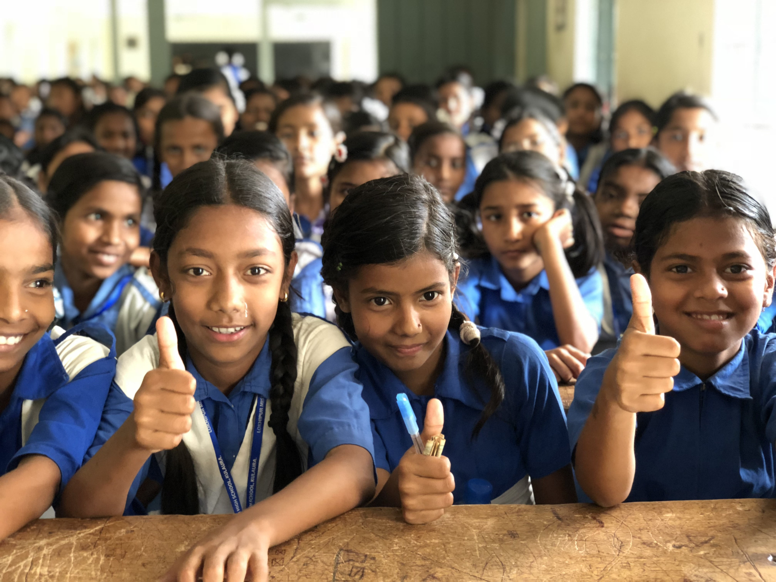
Sincerely,

Clement V. Gomes, PhD.
& The ISLearning Team

International Student Learning, Inc. is a volunteer-run 501(c)(3) non-profit
registered with the New York Secretary of State. The Federal Tax ID for
International Student Learning, Inc. is EIN 36-4856140.

OUR HISTORY

ISLearning began as a project at the Churchill School and Center in New York City in 2012, when each Churchill 8th grader was partnered with a student at the Lokhipur Mission High School in Sylhet, Bangladesh. The students mailed hand-written letters to each other, sharing stories about their favorite subjects, hobbies, and their lives.

As the program grew, so did the relationships between the Churchill students and their friends at the Lokhipur School; they even got the opportunity to video chat with their international pen pals.

As the U.S. students learned about the lives of their friends in Bangladesh, they wanted a way to support them beyond just chatting. Since 2012, the Churchill students and ISLearning have organized school-wide clothing drives, bake sales, and other fundraisers, which have raised nearly $1,000 each year. All donations are sent directly to the Lokhipur School and have been used to bolster the students’ educational journey, with books, uniforms, technology, and more.

In December 2016, ISLearning was incorporated in New York State and recognized as a 501(c)(3) non-profit organization. Since then, we have grown our team of volunteers, expanded our fundraising efforts and invited new schools to our international network.

In 2017, ISLearning held its first official fundraiser as a 501(c)(3), raising more than $5,000.

Today, we’re adding additional schools to our network and are developing new fundraising programs to continue to support our students around the world. Thanks to all the love, generosity, and kindness from supporters like you, we will continue to grow and connect students globally.

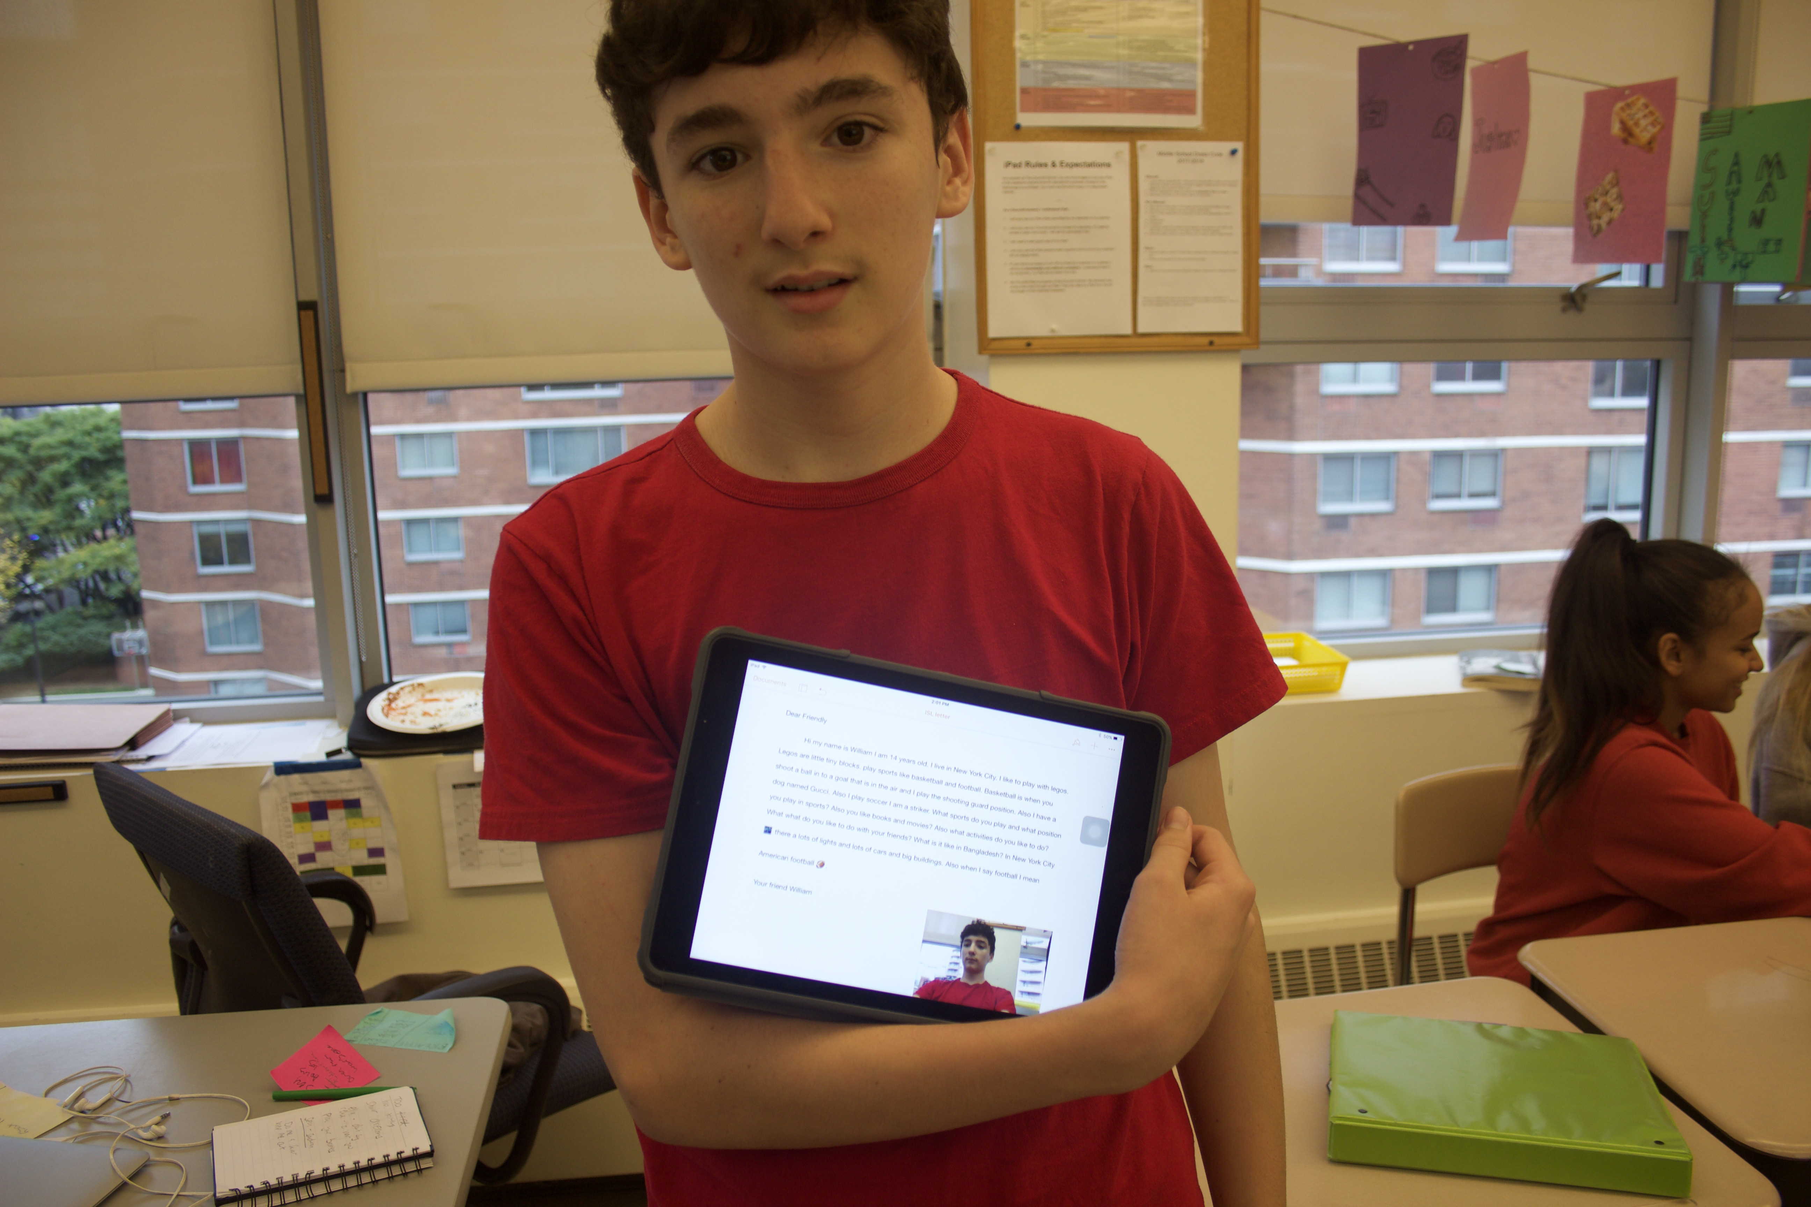

HOW INTERNATIONAL STUDENT LEARNING WORKS

ISLearning is a network of schools and students, teachers and administrators who are dedicated to building a global community. Every ISLearning chapter is different. By working directly with Dr. Gomes and the ISLearning team, we develop a custom program that suits the needs and resources of the participating school.

As a first step, fill out this online form or request a PDF version and email it to us so we can learn more about your school, community, and its members.

Below are common steps each of our chapters take to start the ISLearning Program:
- Establish a Program Leader(s) at your school who will become ISLearning’s main contact and manage the program throughout the year.
- Edit and update the sample slide presentation provided or create your own to share with students, administrators, teachers, and parents.
- Meet with teachers and administrators to determine which classes/grades will participate in the program.
- Build ISLearning into your curriculum; we recommend a period of 10- 12 months to fully execute the program so the students are able to develop strong relationships.

How ISLearning works:
- Time commitment: We know how precious time is for educators. The ISLearning Program can be modified to fit the time and availability of the teachers and their curriculums. We estimate planning for about one hour per week for ISLearning, depending on age and abilities of students and available school resources.
- Communication: Most of our communication is done via email between the lead teachers at each school. Students do NOT directly connect, as this can overcomplicate the process and, depending on age, violate school/education policy.
- Video Calls: Time zone and technology pending, video calling can be done using any video conferencing technology that both lead teachers have access to, and is generally done toward the end of the yearlong ISLearning Program. However, the more connection, the better!
- Fundraising: Fundraising is not mandatory but is a great way to develop stronger connections with our schools. ISLearning will suggest projects so the students can raise funds that directly support their international friends!

Just like any relationship, there will be successes and setbacks, but it is the process itself that will help the students, teachers, and schools to develop stronger global citizenship. And, we’re always open to feedback on ways to improve the process for everyone.

INTRODUCING ISLEARNING TO YOUR ADMINISTRATORS

Everyone can be part of the ISLearning Family, so we encourage you to involve as many teachers and administrators as you can. To announce the new program, we recommend the following:

- Email announcement from the Principal or Program Director with important details

- Holding a faculty/administrator meeting prior to the student announcement
  - At the kickoff meeting, the program leader can use the template slide presentation to introduce the program, noting the following:
    - Explaining project and school connection
    - Projected timeline and time commitment
    - Teachers involved and roles/responsibilities
    - Fundraising (if applicable)
    - Note: If any questions or concerns come up during the presentation that cannot be addressed, connect with the ISLearning team and we’ll respond as soon as possible.

- Posting ISLearning flyers or materials around the school

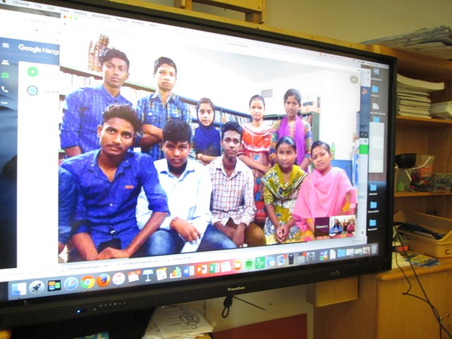

INTRODUCING ISLEARNING TO PARENTS

ISLearning’s success is built around a shared commitment from students, the school community and parents.

We recommend sharing an introductory announcement of the program with parents, including a brief summary of the program and logistics, including:
  - The ISLearning Program history
  - Timeline of the program
  - Location, name, and information of the connecting school
  - Curriculum description/outline
  - Individuals involved at your school
  - Fundraising information (if applicable)
  - ISLearning website
A sample email is provided on the following page. Feel free to connect with the ISLearning team if you need additional support.

Share the slides:
- Once you’ve updated the slide presentation for the students (Lesson #2), feel free to convert it to a PDF and include those slides with the email to all the parents and guardians.

Keeping the students and families engaged and interested in the program throughout the year is key to its success. We recommend the following:
- Routine email updates on the progress of the ISLearning Program, sharing important highlights such as “Next week we’re emailing our letters to our friends in New York!”
- Creating a bulletin board in the classroom or school where you can regularly update it with information, news, pictures, letters, and artwork
- Mentioning ISLearning at teacher-conference night
- Including ISLearning on your school’s website
- Incorporating ISLearning in your social media

Social media pics, website, and picture/video permissions:
- Like and follow the ISLearning social media accounts and share them with teachers, students, and families to follow along with the latest program updates.
- Share any images and videos you take of the students* working on the ISLearning program.

*Please ensure that students in your photographs and videos have a signed release by an adult in countries where that is a requirement. A release issued for your school can be applicable for ISLearning due to affiliation. All footage used by ISLearning is strictly for nonprofit purposes.

SAMPLE PARENTS & GUARDIANS EMAIL

Good Afternoon 8th Grade Parents & Guardians,

I am excited to share that the 8th grade students are embarking on a new global citizen project with International Student Learning, a 501(c)(3) non-profit organization. You may have heard of ISLearning and/or provided support with generous donations in the past since it began at the Churchill School as a small project in 2012. The ISLearning Program partners each 8th grader with a student at the Lokhipur Mission High School in Sylhet, Bangladesh to have a virtual pen pal, to share about their lives and cultures together.

Our students will initially communicate by writing letters sent via email to learn more about the different cultures, lifestyles, education, and environments of the students. At the end of the school year, our students will get an opportunity to meet and directly speak with their friends at Lokhipur via video chat. The entire program is possible thanks to the amazing team of 8th grade teachers, Annita, Gina, Aileen, and two outstanding Churchill HS Seniors, Charlie and Lev.

The Lokhipur School is a boarding school composed of highly motivated, top performing students from the local area - made up of tea and betel leaf plantations. The students are eager to learn and are so happy to share about their lives, and enjoy learning about life in NYC.

For the past five years, as a way to give back and support their friends at the Lokhipur School, the 8th grade students have organized clothing drives, bake sales, and other fundraisers and collected about $900 each year. All the donations and funds were sent directly to the Lokhipur School and were used to buy books, computers, and food, and to make repairs to the school. As you may have heard, this summer Bangladesh has been hit with severe flooding and landslides, killing hundreds of people and making thousands homeless. We hope to send as much support as possible this year to help them rebuild and recover from the devastation.

Please talk to your child about the ISLearning Program as they are well informed and excited to connect with students across the world. If you would like to learn more please feel free to contact me or visit the website: http://www.internationalstudentlearning.org.

And share, like and follow our journey on facebook.com/InternationalStudentLearning and instagram.com/islearninginc.

Have a great day,
CVG

SAMPLE TIMELINE

Time can be a struggle for many teachers, but ISLearning takes that into consideration. Letters can be written during advisement/morning meeting/free time with students, or can be incorporated into subject curriculum. Due to the many differences amongst the schools in the ISLearning Family, it is difficult to provide a set timeline for the program. Below is a sample timeline that has been used at the Churchill School to connect with the Lokhipur School.

- Early September- A couple of weeks after the school year has started, all the 8th grade students are brought together and the ISLearning program is introduced using the slide presentation followed by a questions and answer (Lesson 1 - approximately 1 hour)
- Mid September- The students learn more about the community, school, and students they be writing to and troubleshoot ideas about the connections to their international friends. (Lesson 2 - approximately 1 hour)
- Late September- The students do activities to focus on their own history and culture to better appreciate the diversity within their own school. (Lesson 3 - approximately 1 hour)
- Early October- The students do activities to learn about the history and culture of the students at the partner school. (Lesson 4 - approximately 1 hour)
- Mid October- The students use what they have learned to write their first set of letters to their international friends. (Lesson 5 - approximately 1-2 hours depending on students’ language level)
- Late November- The students receive response letters from their friends and write new letters back. (Lesson 5 - approximately 1-2 hours depending on students’ language level)
- Early December- The students make posters for the Annual ISLearning Fundraiser in Mid-December. (Lesson 8 - approximately 1 hour)
- Late January- The students receive response letters from their friends and write new letters back. (Lesson 5 - approximately 1-2 hours depending on students’ language level)
- Mid March- The students receive response letters from their friends and write new letters back. (Lesson 5 - approximately 1-2 hours depending on students’ language level)
- Late March- The students create art and small crafts for Dr. Gomes to deliver to their friends. (Lesson 9 - dependent on if an ISLearning member is visiting the partner school)
- Early May- The students receive response letters from their friends and respond with video letter clips. (Lesson 6 - approximately 1-2 hours)
- Mid June- The students organize and prepare questions for the video chat. (Lesson 7 - approximately 1 hour)
- Mid June- The students take part in a video chat. (approximately 1-2 hours depending on number of students, language level, and resources)

CURRICULUM IDEAS

Below is the Table of Contents for the ISLearning Lesson Packet which is provided to each school. Once a school has been added to the ISLearning Family, the curriculum packet will be provided to the lead teacher(s). The curriculum is a basic foundation and can be modified, updated, and utilized based on the unique dynamics of the schools involved. Dr. Gomes and the ISLearning team can provide support and guidance to modify a curriculum that is ideal for you and your students.

Table of Contents
- Timeline
- Lesson #1: Introduction to ISLearning Program and the partner school
- Lesson #2: Community and students at the partner school
- Lesson #3: History and culture - Part 1
- Lesson #4: History and culture - Part 2
- Lesson #5: Letters to friends
- Lesson #6: Video letters to friends
- Lesson #7: Preparing for video chat
- Lesson #8: Fundraising - Suggestions & posters
- Lesson #9: Art and/or craft gifts

LETTER WRITING AND VIDEO CHAT

Letter Writing

Letter writing is the main way for the students to stay connected. The process of writing letters allows the educator to teach academic skills that benefit all students. Teachers can use the resources available to have the students compose the letters. If access to technology is convenient, then typed letters are fine. Hand-written letters are also wonderful and can be photographed or scanned by the teacher and sent as images or PDF files.

Including photos is a great way for the students to put a face to the person they are writing to. It’s ideal to include at least one photo of the student with the letter but not mandatory. If resources are an issue at the school, please let the ISLearning team know and we will do our best to provide the necessary means to get images of the students for the school.

Letter writing can be embedded into the curriculum, often History and English, but can even extend to technology and language classes. Recess, lunch, advisement, homeroom, morning meeting, and assembly are a few non-academic times that the ISLearning Program can be incorporated. The possibilities are endless when tailoring your program.

Please refer to Lesson #5 for more information on letter writing.

Video Chat

The culminating experience of video chatting after writing letters is a wonderful opportunity for the students to make a stronger connection. Usually English is the language used to communicate but can vary based on the students and schools. The ISLearning Team will do our best to support video chatting at least once during the program. Teachers may be concerned about a lack of internet, but ISLearning has worked around that problem. Thanks to digital advances, as long as there is access to a cell phone with data/internet, we are capable of video chatting from anywhere in the world!

If students at a school have little exposure to technology, a video chat can potentially be daunting and leave them feeling shy, and it can initially feel awkward on both sides. To help, questions are prepared in advance for certain students and dialogue activities can be done if common language skills are not at conversational level. Video chats are often done in pairs or groups of three and the lead teacher stays near the students to acts as the translator if necessary. This makes the students comfortable and supports the flow of the conversation.

Please refer to Lesson #7 for more information on preparing for the video chat.

FUNDRAISING

Fundraising is not a compulsory component of ISLearning but a great way to develop stronger connections with our schools by providing support for the partner schools in need. The ISLearning Program will propose projects so the students at your school can raise funds that directly support their friends at schools in the ISLearning Family!

Fundraising ideas include:
- Bake sales
- Donation jars
- Selling arts and crafts
- Organizing or participating in a sport or race
- Donation drives for a special event (birthday, holiday, school activity, etc.)
- Tickets for a performance/show/sporting event

Thank you for considering doing a fundraiser for the students in our international family. Please refer to Lesson #8 for more information on preparing for the fundraiser. We are grateful for all your help and support!
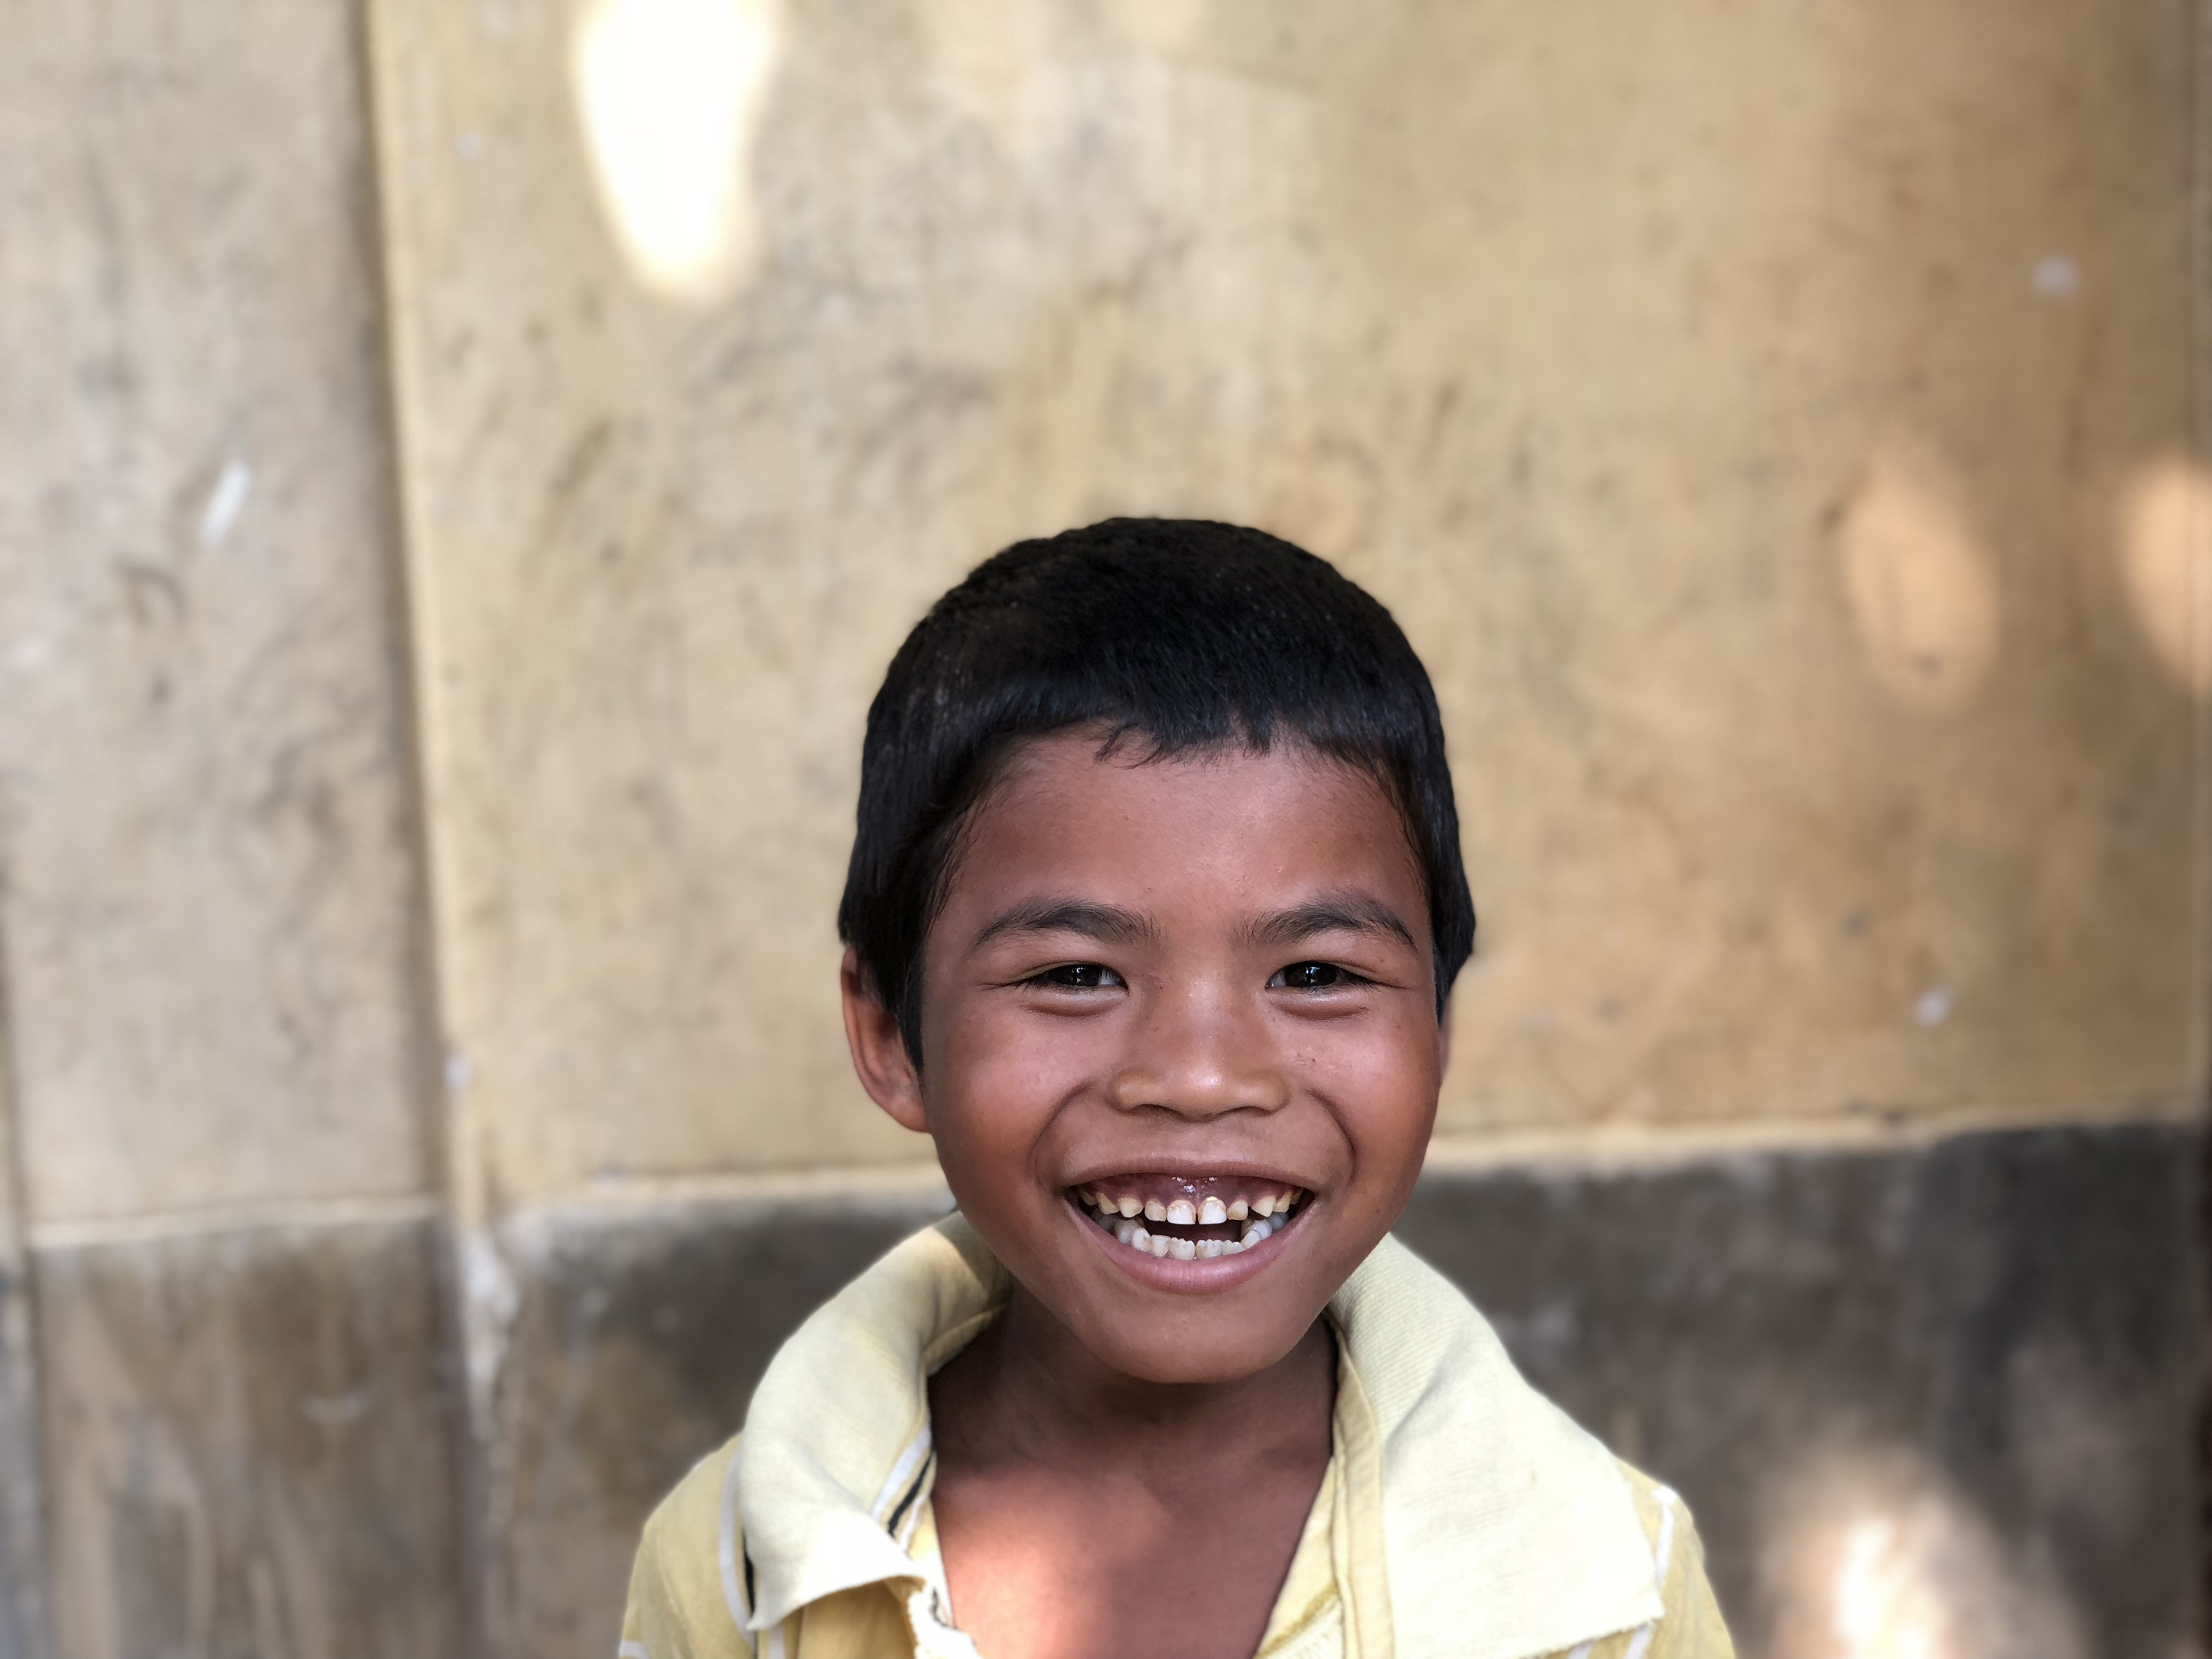

THE TEAM

ISLearning would not be possible without the support and talents of
our dedicated volunteer team:

Clement V. Gomes, Ph.D.
Founder & Director

Jeannine Armbruster
Design & Technology

Stephen Swartz
Marketing

Doug Akay, DPT
Finance & Grants

Melih Bagdatli
Social Media & Design

Ryan Morabito
Events Coordination

Lev Rosenbush & Charlie Heus
Operations

…and from the amazing support of our teachers, administration, and each student involved in the program. We created ISLearning for the students of the world and couldn’t do it without your participation and enthusiasm. Thank you!

If you have any questions, comments, or ideas please reach out to us at info@islearninginc.org.

This program guide is the intellectual property of International Student Learning, Inc. created for the partner schools in the program.

Developed by Dr. Clement V. Gomes and Stephen Swartz.
Edited by Philip Mutz and Lauren Davitt.

