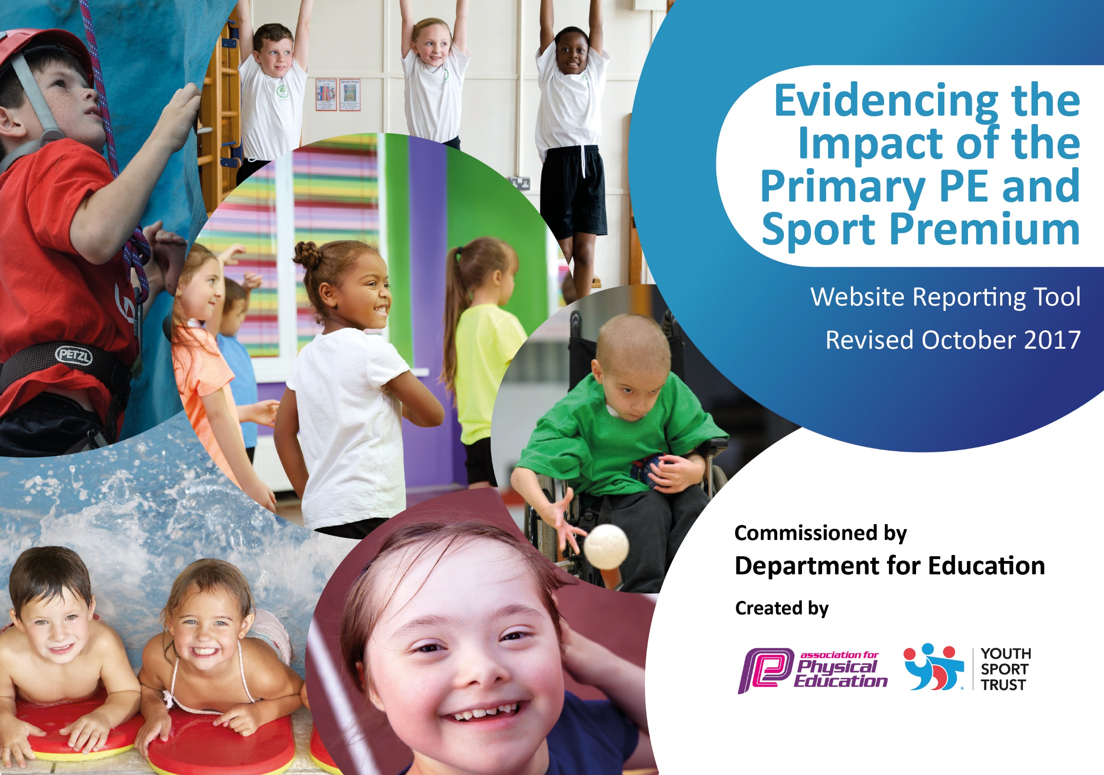

Quainton Church of England School
Primary Sports Funding Impact
November 2018

Rationale
At Quainton, we believe that Sport can play a vital role in the health and wellbeing of all our pupils. It has been proven to be effective in helping pupils to stay mentally alert, more engaged and feel better about themselves. Therefore, we believe that the Sports Premium funding should help every child to be active, stay engaged with Sport and recognise the benefits of a healthy, active lifestyle. For this reason, one of our largest areas of spending is to manage and encourage active lunchtimes and break times across the school and to increase our offer of active clubs before and after school with specific targeted groups in mind. We hope to give a wide range of children the opportunity to represent the school across different disciplines.

Meeting national curriculum requirements for swimming and water safety | Please complete all of the below:
What percentage of your Year 6 pupils could swim competently, confidently and proficiently over a distance of at least 25 metres when they left your primary school at the end of last academic year? | 90%
What percentage of your Year 6 pupils could use a range of strokes effectively [for example, front crawl, backstroke and breaststroke] when they left your primary school at the end of last academic year? | 90%
What percentage of your Year 6 pupils could perform safe self-rescue in different water-based situations when they left your primary school at the end of last academic year? | 90%
Schools can choose to use the Primary PE and Sport Premium to provide additional provision for swimming but this must be for activity over and above the national curriculum requirements. Have you used it in this way? | No

Academic Year: 2018/19 | Total fund allocated: £17500 (£2735 to be allocated) | Date Updated: 30 Jan 2019
Key indicator 1: The engagement of all pupils in regular physical activity – Chief Medical Officer guidelines recommend that primary school children undertake at least 30 minutes of physical activity a day in school |  |  |  | Percentage of total allocation:
 |  |  |  | £6860 39%
School focus with clarity on intended impact on pupils: | Actions to achieve: | Funding allocated: | Evidence and impact: | Sustainability and suggested next steps:
Increase participation in physical activity across the school by using sports funding  Increase participation in physical activity through enrichment days – dance, Skip, rugby  Increase participation in physical activity in Key Stage 2 by using Northampton Rugby to support teaching and learning of rugby.  Improved club provision. Introduce breakfast clubs to encourage more pupils to attend school earlier and get involved in activities  Application for Gold kitemark award. This will involve greater participation in intra and inter school events.  Walk to school week (April)  Healthy schools week – to tie in with rugby enrichment day  Go Noodle assemblies  Purchase/lease of minibus to increase opportunities for clubs, fixtures etc | Children’s survey of current participation in active sport to target the least active children.  Children’s confidence and skills in areas to increase through quality and targeted tutoring.  Children’s confidence and skills in rugby to increase through quality and targeted tutoring. To commence January  Target children with poor participation. Prices to be reduced to increase participation. | £460 (skip£380, dance £80)  £900  £500  £5000 | See survey:  PE SURVEY FOR CHILDREN  87% consider themselves fit  57% represented school in last year  72% participate in sports club out of school  32% in school clubs  11 children participating in rugby club – would like more! | Survey to be taken at end of year to compare data. Attempt to increase club participation by providing more appealing clubs and reducing costs. Provide free clubs?
Key indicator 2: The profile of PE and sport being raised across the school as a tool for whole school improvement |  |  |  | Percentage of total allocation:
 |  |  |  | £250 1%
School focus with clarity on intended impact on pupils: | Actions to achieve: | Funding allocated: | Evidence and impact: | Sustainability and suggested next steps:
JV to develop young leaders within the school, with the specific purpose of leading planned playtime and lunchtime activities  Assemblies to be held to promote clubs and profile of sports. Achievements celebrated in assembly (match results read out and achievements celebrated.  Website and Facebook utilized to share results, fixtures and events  New P.E noticeboard, informing children of the importance and standards expected (eg uniform) of  Noticeboards full of information about fixtures/matches and pupils are keen to get involved. Increased awareness from pupils of what clubs are on offer.  Build on the two assemblies featuring England badminton player player-Elizabeth Cann and first team Northampton rugby player  Trophies and rewards to encourage extra-curricular participation and raise the profile of our successful clubs Impact: Effort of pupils who have put in hours of their free time is recognized and whole school encouraged to celebrate achievements. Supporting | Children’s survey of current sporting participation to target the least active children. Purchase new playtime equipment.  Increased participation  Increased participation  Increased awareness of clubs on offer. Higher profile of sports clubs within the school. Pupils understand the expectations.  Inspire children to participate in sport.  Inspire children to participate in sport. | £250 | New equipment has been bough and play leaders used to run equipment. Less playground incidents? Teacher running dance and sports trials at lunch time.  Newsletter with J Haskell assembly  Website fixtures  https://www.sportsforschools.org/event/hp206/ | Continue provision with more engaging resource
Key indicator 3: Increased confidence, knowledge and skills of all staff in teaching PE and sport |  |  |  | Percentage of total allocation:
 |  |  |  | £360 2%
School focus with clarity on intended  impact on pupils: | Actions to achieve: | Funding  allocated: | Evidence and impact: | Sustainability and suggested  next steps:
Swimming training for JV and MW.  Curriculum map created across the school to ensure time is allowed to plan effective lessons. Coincide with festivals.  Monitoring of PE lessons by JV | Attend course to become up to date with latest swim teaching techniques and training.  Created – to be monitored  JV to allocate time to look into planning and observations. | £360 | AVTP 18-19 Swim proof  PE Curriculum Planning MAP 2018-19.docx

Key indicator 4: Broader experience of a range of sports and activities offered to all pupils |  |  |  | Percentage of total allocation:
 |  |  |  | 4% £750
School focus with clarity on intended  impact on pupils: | Actions to achieve: | Funding  allocated: | Evidence and impact: | Sustainability and suggested  next steps:
Continue to offer a wider range of activities both within and outside the curriculum.  New equipment to allow participation on wider range of sport | Offer varied and wide range of clubs that involve physical activity.  Undertake sporting opportunities offered through the Schools Sport Partnership  New Hockey kit  Top up cricket equipment | As above  £750 | Out of School Activity for Spring Term Revised 6.docx
Key indicator 5: Increased participation in competitive sport |  |  |  | Percentage of total allocation:
 |  |  |  | £6545 37%
School focus with clarity on intended  impact on pupils: | Actions to achieve: | Funding  allocated: | Evidence and impact: | Sustainability and suggested  next steps:
Increase in festival participation through Buckingham School Sports Partnership Competition package  Inter-house competitions run for skipping, fitness (personal challenges) and various athletic events  Y5/6 Participate in football league  KS2 participation in AVPSAA  Purchase/lease of minibus to increase opportunities for clubs, fixtures etc | Exposure to a wide range of fixtures and festivals. Network with PE coordinators across the partnership  Fitness to tie in with sponsored fitness morning with Elizabeth Cann.  Fixtures to be arranged | £1500  £10  £35  As above | Evidence of personal challenges  Fixtures from website

